ICECAPS Weekly Report
April 14 – April 20, 2014
Ward Handley

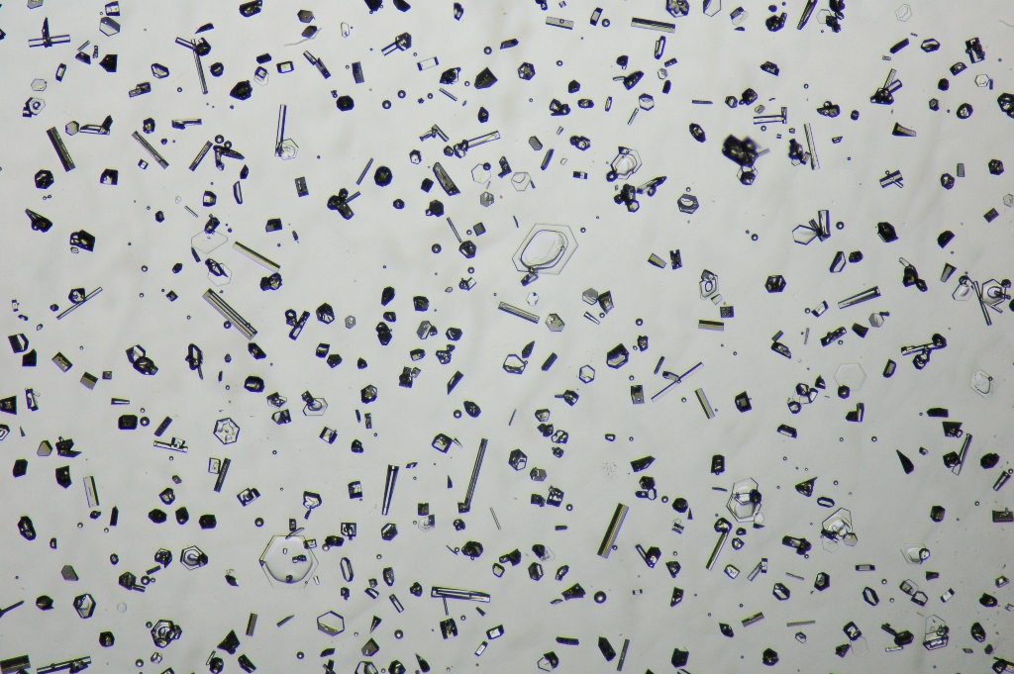
100-400 micron simple prisms, split plates, columns and needles were captured on 4/19

General:
- MSF facility operating normally.
- The carpenter crew and operations support personnel arrived on 4/16.
- Ongoing: Internet transfer rates were poor. ToBoulder did not clear until the evening, or sometimes even the following day. SRI was emailed on 4/16, they said it might be due to mirror synching with the FTP and common drives. They are following up with Harris, the ISP, to determine if our bandwidth has been increased for summer.
- The MSF air handling unit will be getting a new controller soon. The new controller will be identical to the units at TAWO, the SOB, and in the Freshie Shack. Also, an electronic actuator will be installed on the interior air intake louver; currently the exterior and interior louvers are mechanically tied together so they operate simultaneously.

Significant Weather Observations:
- 4/14: Winds 12kn at 97˚, -33C, 68%RH, SCT-FZBR
- 4/15: Winds 7kn at 276˚, -39C, 64%RH, SKC
- 4/16: Winds 8kn at 51˚, -39C, 63%RH, SKC
- 4/17: Winds 40kn at 197˚, -25C, 82%RH, VV025-DRSN-BLSN
- 4/18: Winds 20kn at 2˚, -34C, 70%RH, BKN-BLSN
- 4/19: Winds 11kn at 165˚, -35C, 69%RH, SCT-FZBR
- 4/20: Winds 6kn at 225˚, -35C, 71%RH, SKC

Dataman Account:
- Operating normally.

MWR:
- 4/17: Two communication errors. 90/150 radiometer would not reconnect. Radiometers power cycled.
- HATPRO removal from roof scheduled for 4/21.

SODAR:
- Operating normally.
- 4/18: Equipment ops seen in the data throughout the day.
- 4/19 @ 1655-1710Z: SODAR dished cleared of light snow.

POSS:
- Operating normally.
- 4/17 @1315Z: POSS NOT destroyed by flying debris during high winds.

MMCR:
- Operating normally.
- 4/16 @ 1300Z: daily cal failed due to LabVIEW error and halted data acquisition. Duane restarted the LabVIEW .vi at 0100Z on 4/17.
- 4/18 @ 1430Z: UPS error. System was rebooted.
- 4/19: Daily cal failed and later in the day there was another UPS error. System was rebooted.
- 4/20: Daily cal failed again.

CAPABL:
- No longer operating.

MPL:
- Operating normally.
- 4/17: Four AMCS card errors in high winds. After several in rapid succession I held off on restarting SigmaMPL until the winds subsided.
- 4/18 @ 1236-1404Z: AMCS card error.

VCEIL:
- Operating normally.
- 4/17 @ 2215Z: ceilometer window cleared of snow.

IceCAM:
- Operating normally, very little night left.
- 4/17 @ 0230Z: file created, but no image data written to file.
- 4/19 @ 1045Z: file created, but no image data written to file.

PAERI:
- Operating normally.
- HBB Max Temp Dif continues to creep up. Was 0.06 higher than ideal in early March, now it is ~0.1 to 0.12. Solar heating a contributing factor??
- 4/17: SW and LW Responsivity flags went red when mirror was coated with blowing snow early in the day. In the afternoon the LW and SW HBB NEN flags went red. At 2215Z the winds subsided and the mirror was cleaned. Flags returned to green shortly thereafter.
- 4/18 @ 0755-0810Z: All flags went blue and spectra disappeared simultaneously. The left three AERI display time series graphs stopped updating after 0810, but the spectra were updating and data continued to be saved.
- 4/19: exceptionally high HBB Max Temp Dif, ranging from 0.1 to 0.2 higher than nominal.

ASIA-A:
- Operating normally.
- 4/17: Multiple communications errors. System rebooted and clocks resynched. At 2220Z radiometer displayed “measurement complete” and stopped data acquisition. Pierre logged in at 0145Z and uploaded a new MBF.

TSI:
- Offline for winter

IcePIC:
- 4/19 @ 1740-2140Z: Simple prisms (trigonal and hex) up to 350 microns, some split plates, columns and needles up to 400 microns.

Radiosonde:
- Twice daily sondes.
- ANG flight restrictions: No radiosonde launches 3 hours prior to or 1 hour after ANG flights.
- 4/15 @ 12Z: first radiosonde aborted due to >10% and erratic RH variation; aspiration did not help. Second radiosonde (launched) was similarly erratic, but with lower variation.
- 4/16 @ 12Z: first K-sonde launch of the summer.
- 4/17 @ 12Z: successful launch in high winds (30kn).
- 4/17 @ 24Z: radiosonde closed out late. Second sonde closed out late??
- 4/19 @ 12Z: SGPD tandem launch with Ozonesonde. No red flags raised by Katrine regarding supplies or budget.
- 4/20 @ 12Z: K-sonde profile had multiple data drop outs.
- 4/20 @ 24Z: NOAA Wx page not updating. Raw NOAA data shows: RH=65%, T=-45.0, P=655.5, Wind Spd =10kn, Wind dir = 236

