ICECAPS Weekly Report
April 21 – April 27, 2014
Ward Handley

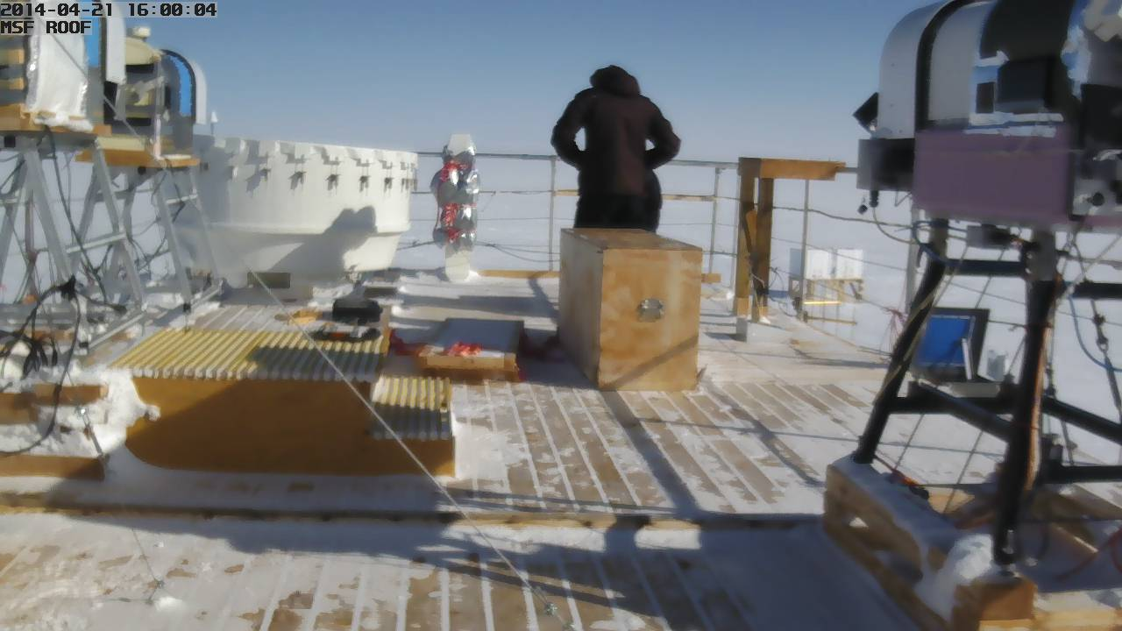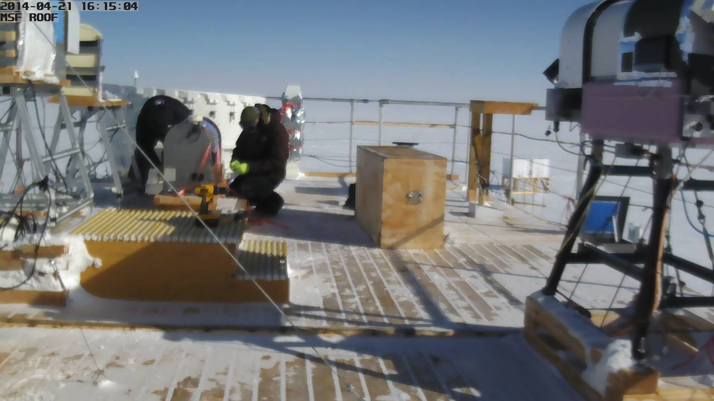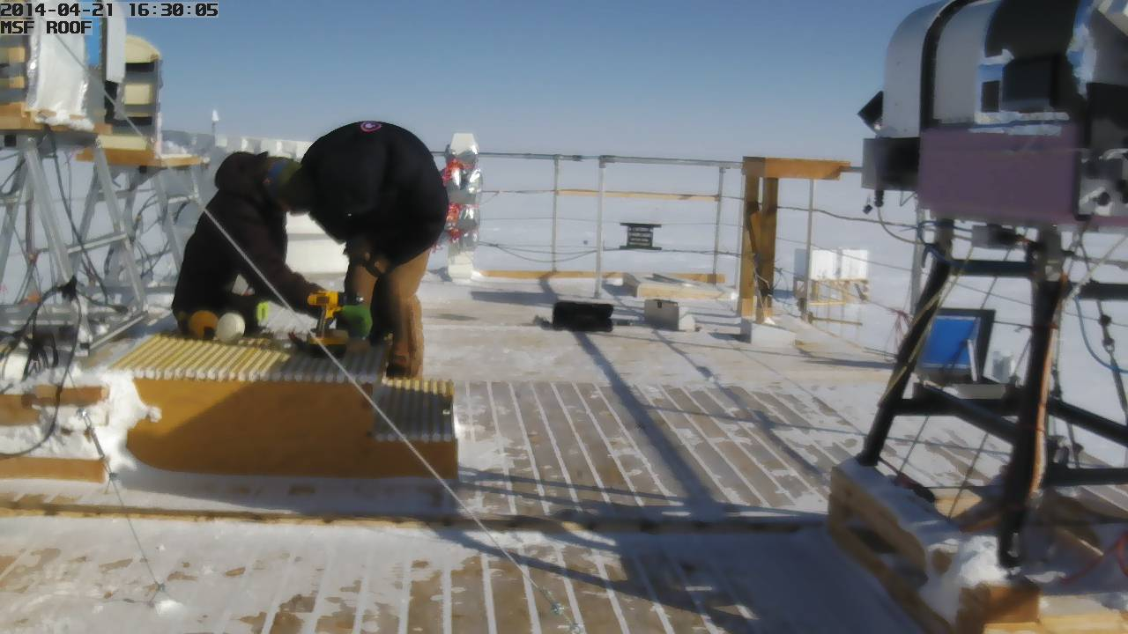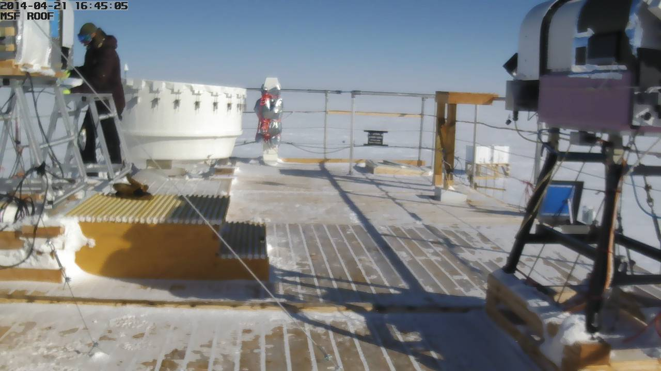
1
2
4
3
4/21: Time lapse of the HATPRO removal as captured by the IceCAM

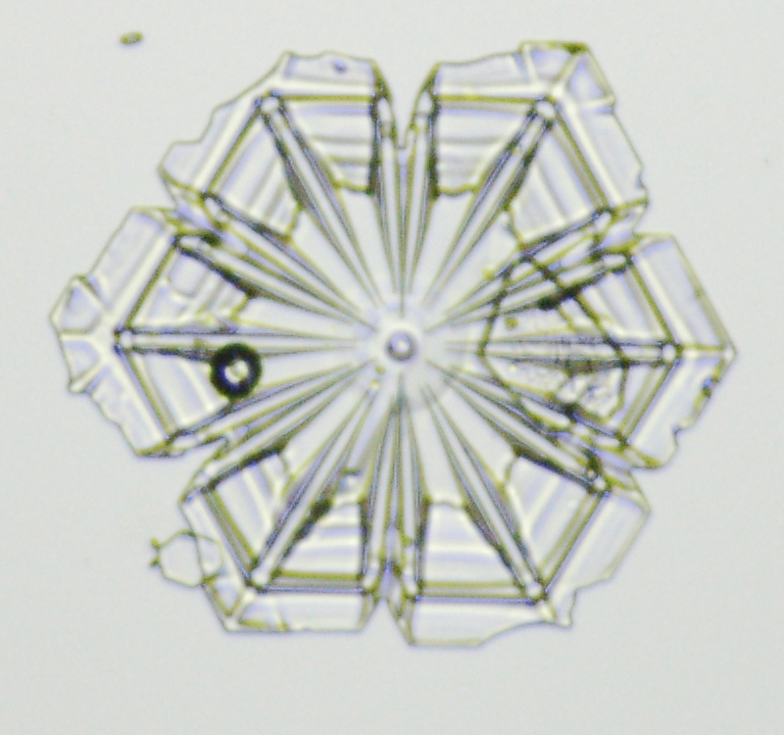
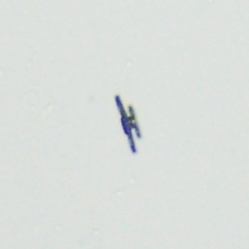


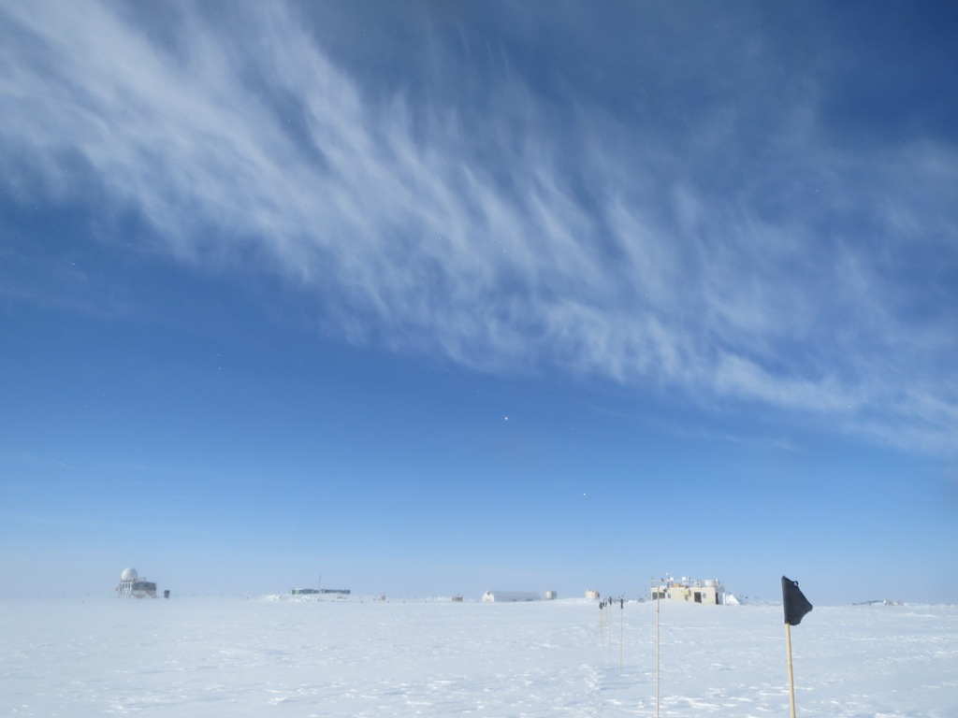
200
microns

4/24 @ 1640Z: Clouds over camp shortly before IcePIC sampling
General:
- MSF facility operating normally.
- Ongoing: nightly upload rates have been poor. Follow up on 4/22 yielded a response from SRI. They are monitoring our network closely, but no root cause has been identified.
- The MSF air handling unit received a new controller. An electronic actuator was also installed on the interior air intake louver. System performance is approximately the same as before the modifications.
- 4/25: Ryan Neely and Mike O’Neill arrived at Summit on a twin otter.

Significant Weather Observations:
- 4/21: Winds 8kn at 199˚, -38C, 65%RH, SKC-FZBR
- 4/22: Winds 34kn at 193˚, -19C, 87%RH, VV020-BLSN-DRSN
- 4/23: Winds 31kn at 192˚, -13C, 92%RH, VV100-BLSN-DRSN
- 4/24: Winds 17kn at 182˚, -14C, 87%RH, SCT-DRSN
- 4/25: Winds 12kn at 187˚, -21C, 86%RH, SCT
- 4/26: Winds 4kn at 215˚, -32C, 76%RH, FEW
- 4/27: Winds 10kn at 214˚, -25C, 82%RH, SCT

Dataman Account:
- Operating normally.

MWR:
- 4/21: HATPRO removed from roof and stored in the SOB prior to retro. Power to the 150-90 was restored at 1700Z. Dave Turner loaded a new MDF and resumed data acquisition with the 150-90.
- 4/25: HATPRO shipped from Summit to Kanger on a twin otter.

SODAR:
- Operating normally.

POSS:
- Operating normally.

MMCR:
- Operating normally.
- 4/21: the MMCR went down around 0600 following a TWTA helix current error. After numerous reboots it came up cleanly at 1430Z.
- 4/23: Duane Hazen remotely logged in to fix a recurring problem with the daily calibrations.
- 4/24 @ 1930-2140: MMCR went down due to another UPS inverter error.

CAPABL:
- No longer operating.

MPL:
- Operating normally.
- 4/22-23: AMCS card error in high winds. Afterpulse calibration delayed.
- 4/25 @ 1933Z: “Out of storage buffers” warning. Data acquisition continued uninterrupted.

VCEIL:
- Operating normally.

IceCAM:
- Operating normally
- 4/24 @ 1600Z: file created, but no data written to file.

PAERI:
- Operating normally.
- 4/21 @ 0750-0803Z: All flags went blue and spectra disappeared simultaneously. The left three AERI display time series graphs stopped updating after 0803, but the spectra were updating and data continued to be saved.
- 4/22-23: windblown snow on the scanning mirror. Multiple red responsivity flags.
- 4/24 @ 1645Z: snow removed from fan tube and scan mirror.

ASIA-A:
- Operating normally.
- 4/22-23: communications error due to high winds.

TSI:
- Offline for winter

IcePIC:
- 4/24 @ 1700-1920Z: Large (up to 1000 micron!) sectored plates. Simple plates up to 400 microns. Small stars, double plates, and triangular crystals to 150 microns.
- 4/25 @ 1750-1930Z: Triangular crystals, capped columns and stars up to 200 microns. Sectored plates up to 250 microns. Simple prisms up to 300 microns. Few columns up to 400 microns. Few irregular crystals up to 600 microns.
- 4/27 @ 1250-1730Z: Bullet rosettes to 600microns. Simple prisms to 250 microns.

Radiosonde:
- Twice daily sondes.
- 4/22: simulated 4/20 24Z sounding and corrected surface obs. Removed sounding files with incorrect surface obs from the archive.
- 4/22 @ 12Z: launch in 36kn winds. First balloon lost, but sonde was recovered. Second launch attempt was successful, but the balloon burst before reaching the tropopause.
- 4/22 @ 24Z: low burst height in high winds.
- 4/23 @ 12Z: low burst height in high winds.
- 4/25 @ 24Z: tandem launch with NOAA ozonesonde.

