ICECAPS Weekly Report
April 28 – May 4, 2014
Ward Handley


5/1: Sundogs at sunset. Photo by Ryan Neely III

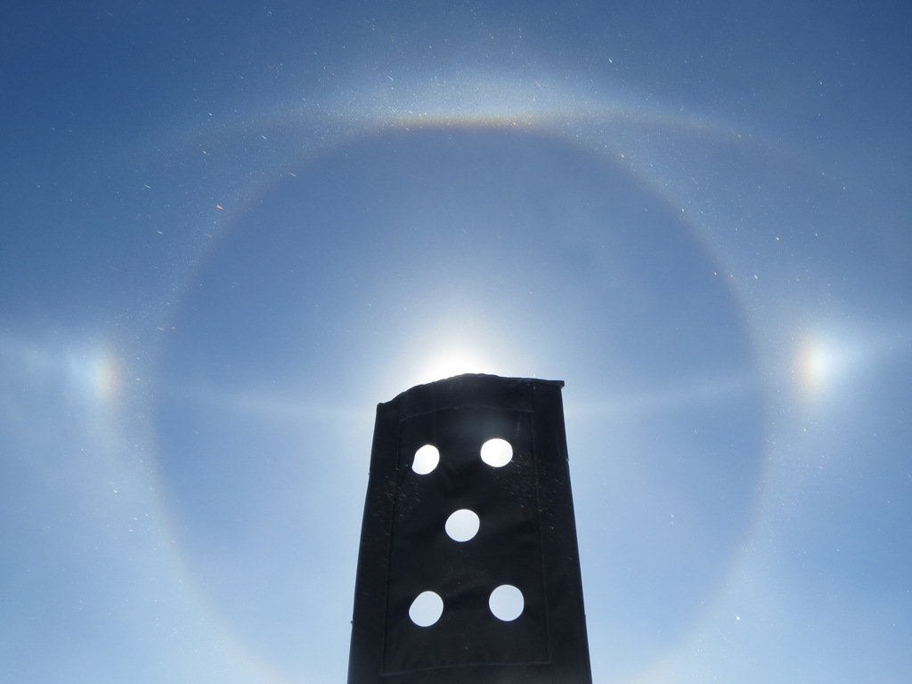
5/1 @ 1450Z: 22˚ halo, 46˚ halo (not pictured), Parry arc, and parhelic circle
General:
- MSF facility operating normally.
- 4/29: Crypto Virus was in the Summit network. MSF was disconnected from the network for several hours.
- Several sources of the weeks old network issues have been identified and addressed. ToBoulder was empty at 1000Z on 5/4.
- MSF UPS settings were modified in an effort to eliminate the MMCR’s periodic auto shutdowns due to false power outages: Bypass was disabled, Bypass Synchronization settings were tightened.
- MSF pad construction is underway. There is still much work to be done.

Significant Weather Observations:
- 4/28: Winds 3n at 176˚, -26C, 82%RH, FZFG
- 4/29: Winds 18kn at 173˚, -25C, 83%RH, SCT-FZBR
- 4/30: Winds 13kn at 162˚, -26C, 82%RH, SCT-FZBR
- 5/1: Winds 20kn at 253˚, -21C, 87%RH, OVC-DRSN (stunning optical phenomena!)
- 5/2: Winds 12kn at 202˚, -22C, 85%RH, BKN
- 5/3: Winds 11kn at 220˚, -19C, 87%RH, OVC
- 5/4: Winds 19kn at 222˚, -16C, 89%RH, BKN

Dataman Account:
- Operating normally.

MWR:
- 150-90: operating normally.
- HATPRO: out for calibration and repairs.
- 4/29: HATPRO cables brought inside and checked for damage.

SODAR:
- Operating normally.
- 4/28: MSF pad construction from 1600-1820Z.
- 4/29: MSF pad construction from 0900-1000, 1440-1540 and 2050-2230Z.
- 4/30: MSF pad construction from 0850-0950, and 1530-1630Z.
- 5/1: MSF pad construction from 1050-1145, 1550-1930, and 2050-2210Z.

POSS:
- Operating normally.
- Awaiting 20+ kn winds to test hypothesis that the guy wires are creating the signal that dominates the low frequency bins during wind events.

MMCR:
- Operating normally.
- Tracking down source of UPS inverter errors. MSF UPS settings updated to provide better conditioned power.
- 4/28 @ 0712-1404Z: MMCR went down due to another UPS inverter error.
- 4/29 @ 0453-1243Z: MMCR went down due to another UPS inverter error.
- 4/30 @ 1042Z: MMCR UPS inverter error led to auto shutdown and auto reboot.

CAPABL:
- Neely and Mike O’Neill are on station working on the CAPABL.

MPL:
- Operating normally.
- 4/29: Afterpulse calibration.

VCEIL:
- Operating normally.

IceCAM:
- Operating normally

PAERI:
- Operating normally.
- 5/3 @ 0705-0722Z: All flags went blue and spectra disappeared. Data acquisition continued afterwards.

ASIA-A:
- Operating normally.
- 4/28-5/3: ASIAA webcam housing opened and window cleaned daily.

TSI:
- Offline for winter.
- Time to install it?

IcePIC:
- 4/30 @ 1740-1940Z: Simple prisms to 200 microns. Few columns to 500 microns.
- 5/2 @ 1135-1405Z: Few crystals collected. Irregular crystals to 600 microns. Remnants of 400 micron simple prisms. Few columns to 200 microns.
- 5/2 @ 1420-1610Z: Few crystals collected. Downwind slide had simple prisms to 300 microns and irregular crystals to 600 microns. Upwind slide had rimed irregular crystals up to 700 microns.
- 5/3 @ 1400-1545Z: Few crystals collected. Simple prisms to 250 microns. Irregular crystals to 900 microns.

Radiosonde:
- Twice daily sondes.
- 4/28 @ 12Z: DigiCORA terminated the sounding shortly before launch due to “Max interpolation time exceeded”. All raw data was captured, but is not flagged as valid flight data.
- 5/1 @ 24Z: Tandem launch with NOAA Ozonesonde.

