ICECAPS Weekly Report
April 7 – April 13, 2014
Ward Handley

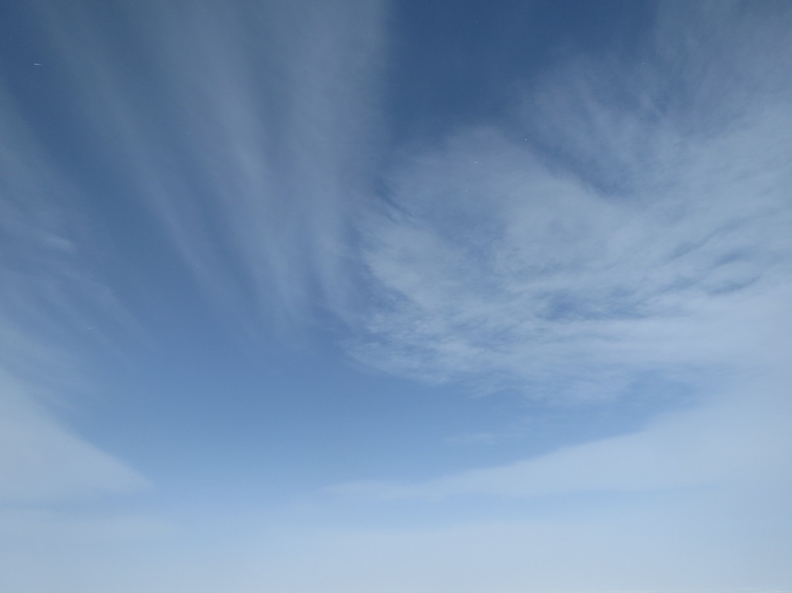
After a week of alternating heavy wind and blue bird skies we finally had clouds on 4/11

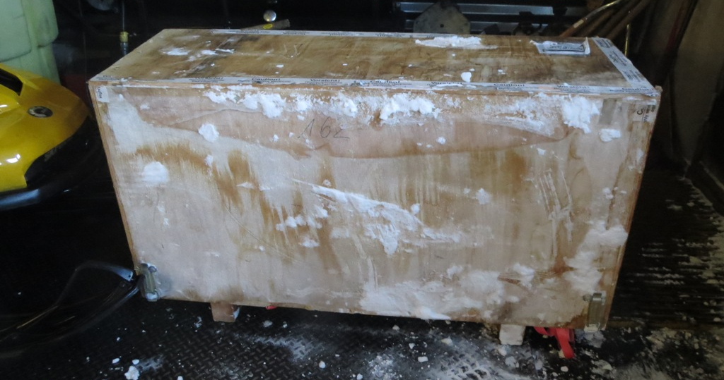
The MWR HATPRO shipping crate was pulled off the berm on 4/9
General:
- MSF facility operating normally.
- 4/10: Email server issues.
- 4/11-13: Internet connectivity was poor. ToBoulder did not clear until the evening, or sometimes even the following day.

Significant Weather Observations:
- 4/7: Winds 33kn at 139˚, -22C, 86%RH, VV011-BLSN
- 4/8: Winds 25kn at 135˚, -27C, 79%RH, BKN-BLSN
- 4/9: Winds 10kn at 216˚, -40C, 63%RH, SCT
- 4/10: Winds 4kn at 211˚, -43C, 64%RH, SKC
- 4/11: Winds 13kn at 202˚, -30C, 74%RH, SCT-FZBR
- 4/12: Winds 5kn at 103˚, -30C, 72%RH, FEW-FZBR
- 4/13: Winds 6kn at 248˚, -34C, 68%RH, SKC

Dataman Account:
- Operating normally.

MWR:
- Operating normally.
- 4/9: HATPRO shipping box retrieved from the berm.
- 4/11-12: Poor 90/150 receiver temperature stability. Possibly a bad sensor connection because there are large instantaneous temperature jumps.

SODAR:
- Operating normally.
- 4/10 @ 1449Z: Operation IceBridge Herc flyover seen in data.
- 4/13: Equipment ops seen in the data starting at 1550Z.

POSS:
- Operating normally.

MMCR:
- Operating normally.
- 4/7: MMCR mount down, no Ethernet connectivity. System rebooted multiple times starting at 1610Z.
- 4/13 @ 0453-1540Z: MMCR found off with UPS alarming. System booted normally.

CAPABL:
- No longer operating.

MPL:
- Operating normally.
- 4/7: Three AMCS card errors in high (30+ kn) winds.
- 4/8: Afterpulse calibration.
- 4/8 @ 1725-2112Z: AMCS card error.
- 4/11 @ 1155-1250Z: AMCS card error.

VCEIL:
- Operating normally.

IceCAM:
- Operating normally.
- 4/11 @ 2115: file created, but no image written.

PAERI:
- Operating normally.
- 4/12 @ 1132-1153Z: data dropped out. All indicators went blue and the spectra disappeared. The indicator and spectra events were offset by a few minutes.

ASIA-A:
- Operating normally.

TSI:
- Offline for winter

IcePIC:
- 4/12 @ 1340-1610Z: Halo and fresh snow accumulation. Hollow columns to 500 microns. Bullet rosettes to 750 microns. Few 750 micron needles. Irregular crystals to 800 microns.

Radiosonde:
- Twice daily sondes.
- 4/7 @ 12Z: RH and temperature sensors destroyed during launch in high winds. Pressure and GPS sensors were functional for the duration of the sounding.
- 4/8 @ 12Z: Descent telemetry captured. The profile was nicely symmetric.
- 4/9 @ 24Z: Balloon burst at 11010m.
- 4/10 @ 12Z: Tandem launch with NOAA ozonesonde. >10% RH variation. No change when aspirated.

