# ICECAPS Weekly Report

Aug 11 – Aug 17, 2014

Lana Cohen

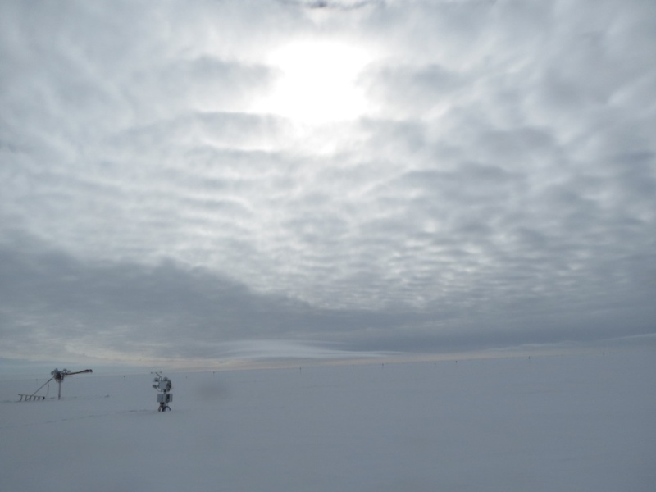

Clouds and radiometers, 8/15 1230Z.

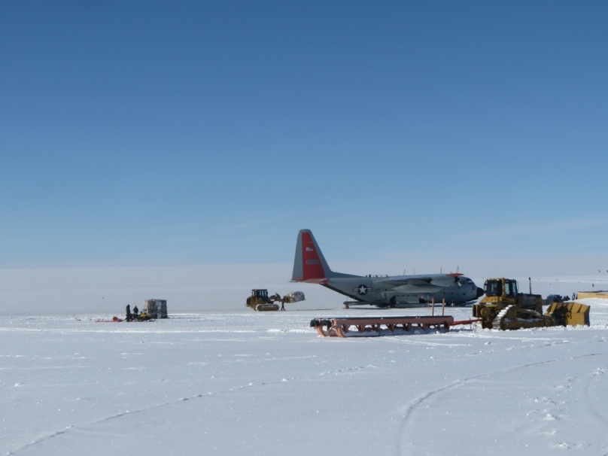

Flight arrival on 15th.

**General:**

* 8/11, 12, & 14: Brief station-wide power outages (< 5min) to switch back and forth from emergency-generator; internet down ~20min on 8/11.
* 8/12: MSF HRV system starts being used; monitored X-300 temp loggers.
* New tech Jennie Mowatt arrived on 15th—turnover tasking.

**Significant Weather Observations:**

* 8/11: overcast
* 8/12: overcast early, clearing late
* 8/13: overcast, blowing snow
* 8/14: mostly clear skies
* 8/15: fog in morning, mostly cloudy
* 8/16: morning fog, overcast, late blowing snow
* 8/17: blowing snow, overcast

**Dataman Account:**

* 8/11: MPL, Ceilometer, and MASC mounts down during overnight data transfer; mounts are up in the morning, and data transferred fine on 8/12.

**MWR:**

* 150-90: operating normally
* HATPRO: shipped back, but didn’t arrive on 15th as scheduled, will arrive on flight on 18th.
* LN2 arrived on 15th.

**SODAR:**

* Operating normally.

**POSS:**

* Operating normally.

**MMCR:**

* Ongoing troubleshooting of MMCR—Duane arrived on 15th.

**CAPABL:**

* Robert arrived on 15th.

**MPL:**

* Operating normally; afterpulse calibration 8/17.

**VCEIL:**

* Operating normally.

**Hotplate:**

* Hotplate stopped logging data at 15.13UTC 8/10 due to Labview error (timeout error). Restarted acquisition at 13.30UTC 8/11.

**IceCAM:**

* Operating normally

**PAERI:**

* Operating normally

**ASIA-A:**

* Operating normally.

**TSI:**

* Operating normally

**IcePIC:**

* No images this week.

**MASC:**

* 8/13: Taken down and packed up; retro’ed on 15th.

**Radiosonde:**

* Twice daily sondes.