# ICECAPS Weekly Report

Aug 18 – Aug 24, 2014

Lana Cohen and Jennie Mowatt

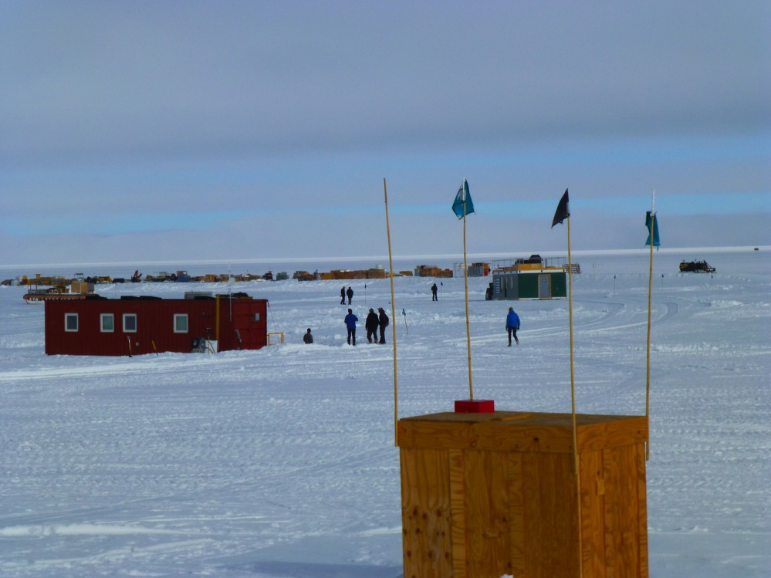

*Moving buildings to the berm before the summer crew leaves.*

**General:**

* 8/18 & 8/19: Work on MSF temperature stabilization completed.
* 8/20: Found a burnt outlet on north wall (CKT 12) stemming from an incorrectly wired plug on HATPRO heater transformer box. Electrician replaced the wall outlet and plug on transformer. Everything appears to be functioning normally again. Will continue to monitor all transformer plugs for heat and functionality.
* Raised solar instrument suite stand on 8/20.
* Last C-130 flight out of Summit, including Lana Cohen, left on 8/22.

**Significant Weather Observations:**

* 8/18: overcast, blowing snow
* 8/19: overcast, light precip in morning
* 8/20: overcast, light precip and fog in afternoon
* 8/21: morning fog, overcast
* 8/22: overcast, light precip in afternoon
* 8/23: overcast, light precip in morning
* 8/24: broken skies, some sun

**Dataman Account:**

* 8/23: MPL mount down during overnight data transfer and in morning. Resolved itself and transferred all files on 8/24.

**MWR:**

* HATPRO: brought online on 8/19. Two LN2 calibrations were completed, spaced ~ 1 hour apart on 8/20.
* 150-90: operating normally. LN2 calibrated on 8/20 after first HATPRO cal.

**SODAR:**

* Operating normally.

**POSS:**

* Operating normally.
* 8/18, 13:57Z: Stopped and restarted POSS data acquisition as turnover training.

**MMCR:**

* Operating normally.
* Error with Health log (+28V and +15V values consistently higher than acceptable) due to loose connection, reported by Duane on morning of 8/21. Will continue to monitor. Looking into sending replacements parts during Oct turnover.
* Desiccant changed on 8/21. Next due at beginning of January.

**CAPABL:**

* CAPABL shut down and offsite as of 8/19.
* Will continue to monitor water storage system during winter.

**MPL:**

* Operating normally.
* 8/22: found to be erroring out on AMCS Timeout since 8/19. Rebooted program, running normally after.
* MPL mount down on 8/23, no data transferred. Resolved on 8/24, all data successfully transferred.

**VCEIL:**

* Operating normally.

**Hotplate:**

* Operating normally.

**IceCAM:**

* Operating normally

**PAERI:**

* Operating normally
* 8/18, 1340Z: rebooted PAERI computer as turnover training.
* 8/22, 1550Z PAERI program randomly shut down after daily check; was rebooted.

**ASIA-A:**

* Operating normally.
* Performed LN2 calibration on 8/20.

**TSI:**

* Operating normally

**IcePIC:**

* IcePICs taken 8/19, 1240Z.

**MASC:**

* Offline and offsite as of 8/13.

**Radiosonde:**

* Twice daily sondes.
* Missed closing out morning balloon on time on 8/21.