# ICECAPS Weekly Report

Aug 25 – Aug 31, 2014

Jennie Mowatt

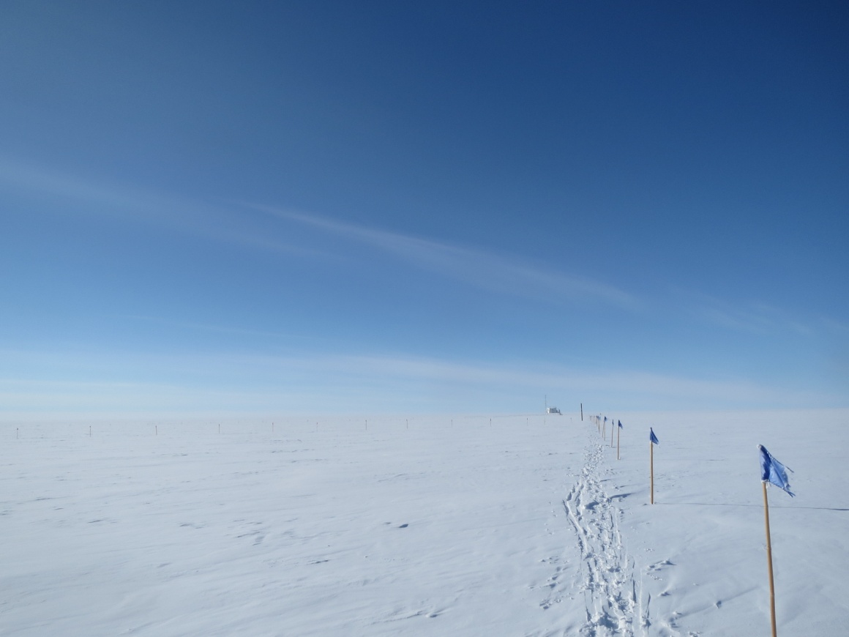

*Fair skies were prominent this week.*

**Significant Weather** Observations**:**

* 8/25: Broken clouds
* 8/26: Broken clouds leading into sun
* 8/27: Fog on the horizon, sun, light wind, -33C
* 8/28: Clear skies and sun, light wind, -29C
* 8/29: Broken skies, 16kt winds, -12C
* 8/30: Scattered clouds, some sun, -13C
* 8/31: Morning fog, clearing into scattered clouds and sun, -16C

**Dataman Account:**

* Operating normally.

**MWR:**

* HATPRO: operating normally.
* 150-90: operating normally.

**SODAR:**

* Operating normally.

**POSS:**

* Operating normally.
* 8/27, 1210Z: Restarted POSS data acquisition after accidentally closing window.
* Plans to raise box and cables when weather permits.

**MMCR:**

* Operating normally.
* 8/30: During rounds found a Helix Overcurrent Fault. Still working through getting the MMCR back online.
* 8/31: MMCR mount down for daily data transfer

**CAPABL:**

* Offsite as of 8/19.
* Continuing to monitor water storage system during winter.

**MPL:**

* Operating normally.

**VCEIL:**

* Operating normally.

**Hotplate:**

* Operating normally.
* Plans to raise box and cables when weather permits.

**IceCAM:**

* Operating normally

**PAERI:**

* Operating normally

**ASIA-A:**

* Operating normally.
* 8/28: Found screen frozen at 1847Z from prior day. Rebooted computer and cycled radiometer at 1210Z.
* 8/29: Missing time readout in R2CH. Rebooted computer and cycled radiometer.

**TSI:**

* Operating normally

**IcePIC:**

* No IcePICs taken this week due to ample sun.

**MASC:**

* Offsite as of 8/13.

**Radiosonde:**

* Twice daily sondes.
* 8/28: Found expended radiosonde and balloon on runway after dinner. Could not identify serial number or launch date.