# ICECAPS Weekly Report

Aug 4 – Aug 10, 2014

Lana Cohen

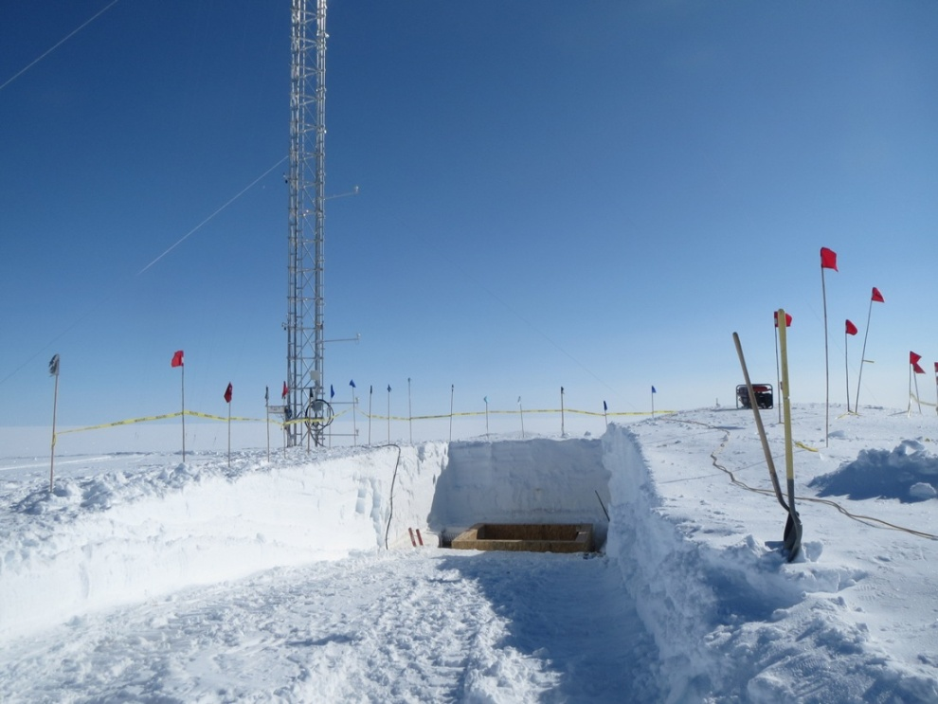

Noone vault removal, Aug 5-9th.

**General:**

* 8/5: Planned power outage 12-13.00UTC for Noone vault removal. Most instruments off from ~ 11.30-13.15UTC. (50 m tower and solar instruments moved to separate circuit so that they can be shut down independently of MSF in the future.)
* 8/7 1900-1945UTC: internet outage (running on e-gen during primary generator maintenance).
* 8/8, 8/9: Brief station-wide power outages (< 5min) to switch back and forth from emergency-generator.

**Significant Weather Observations:**

* 8/4: overcast
* 8/5: fog throughout day, clearing late
* 8/6: clear
* 8/7: clear, fog overnight
* 8/8: clear, fog overnight
* 8/9: clear, fog overnight
* 8/10: overcast, blowing snow, light precip

**Dataman Account:**

* As of 8/4, all data is again being transferred overnight.
* 8/5: Dataman down ~12.25-12.50UTC

**MWR:**

* 150-90: operating normally—repaired insulation blanket, 8/5.
* HATPRO: out for calibration and repairs; planned how to get HATPRO onto roof with HEOs—will have to build ramp at front of MSF for equipment.
* 8/5: 150-90 down ~11.30-13.15UTC.

**SODAR:**

* Operating normally; remained powered throughout outage on 8/5.

**POSS:**

* Operating normally.
* 8/5: POSS down ~12.20-13.00UTC.

**MMCR:**

* Ongoing troubleshooting of MMCR—Duane is coming up next week.
* 8/5: MMCR down ~11.30-14.15UTC.
* 8/7: Replaced up/down converter. MMCR off 11.50-12.55UTC.

**CAPABL:**

* 8/5: CAPABL shut down ~11.30UTC (laser water pumps still running); will remain off until Robert arrives.

**MPL:**

* Operating normally.
* 8/5: MPL down ~12.20-12.50UTC.

**VCEIL:**

* Operating normally; remained powered throughout outage on 8/5.

**Hotplate:**

* Operating normally.
* 8/5: Hotplate down ~11.40-13.10UTC.

**IceCAM:**

* Operating normally; icecam down ~12.20-12.50UTC.

**PAERI:**

* Operating normally; remained powered throughout outage on 8/5.

**ASIA-A:**

* Operating normally.
* 8/5: ASIA-A down ~11.30-13.15UTC. iBootBar (remote device controller) not connecting—power cycled it at 17.15UTC.

**TSI:**

* Operating normally; remained powered throughout outage on 8/5.

**IcePIC:**

* No images this week.

**MASC:**

* Operating normally; remained powered throughout outage on 8/5.
* 8/8: Had to reboot laptop because touch-pad not working.
* 8/8: Meeting with Claire & John—details on MASC retro

**Radiosonde:**

* Twice daily sondes.
* Boxed up k-sondes (136 sondes) for retro to Von.
* 20 He cylinders swapped out.