# ICECAPS Weekly Report

Dec 1-7, 2014

Jennie Mowatt

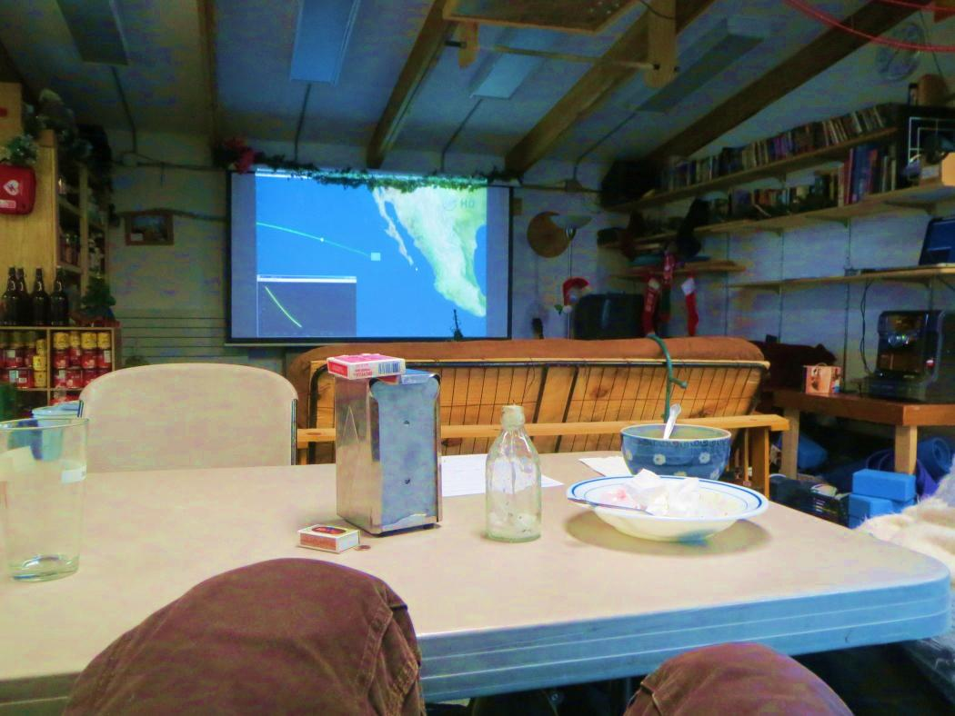

*Unrelated to ICECAPS, we were all very excited to watch the successful Orion test flight. JM*

**Significant Weather Observations:**

* 12/1: Broken clouds, 16 kts, -33C
* 12/2: Broken clouds, 12 kts, -39C
* 12/3: Broken clouds, 16 kts, -31C
* 12/4: Overcast and drifting snow, 17 kts, -31C
* 12/5: Scattered skies, 10 kts, -44C
* 12/6: Scattered clouds, 4 kts, -41C
* 12/7: Overcast, 9 kts, -41C

**Dataman Account:**

* Operating normally.

**MWR:**

* HATPRO: operating normally.
* 150-90: operating normally.

**SODAR:**

* Operating normally.

**POSS:**

* Operating normally.

**MMCR:**

* Operating normally.

**CAPABL:**

* Offsite as of 8/19.
* Continuing to monitor water storage system during winter.

**MPL:**

* Operating normally.

**VCEIL:**

* Operating normally.

**Hotplate:**

* Operating normally.

**IceCAM:**

* Operating normally.

**PAERI:**

* Operating normally
* 12/3: Partial blue flags found during morning rounds.

**ASIA-A:**

* Operating normally.
* 12/3: Time frozen at 0749Z on 12/3. Communication error message present. Power cycled computer and radiometer at 1252Z. Data collection restarted at 1257Z.
* 12/7: Communication error reported. Powercycled computer and radiometer at 1309Z. Data collection restarted at 1316Z.

**TSI:**

* Offline and stored in MSF for winter.

**IcePIC:**

* No pictures taken this week.

**Radiosonde:**

* Twice daily sondes.