# ICECAPS Weekly Report

Dec 15-21, 2014

Jennie Mowatt

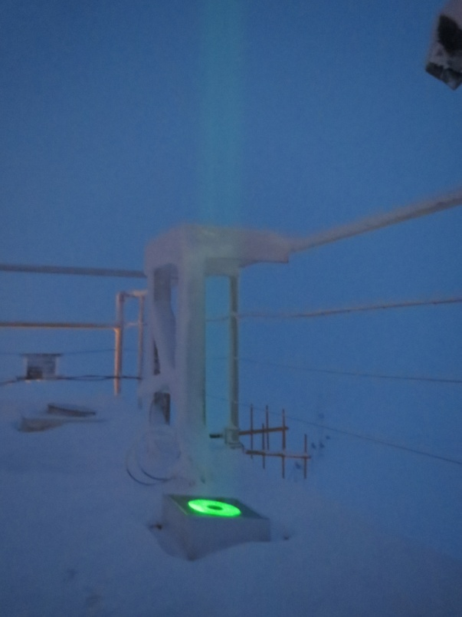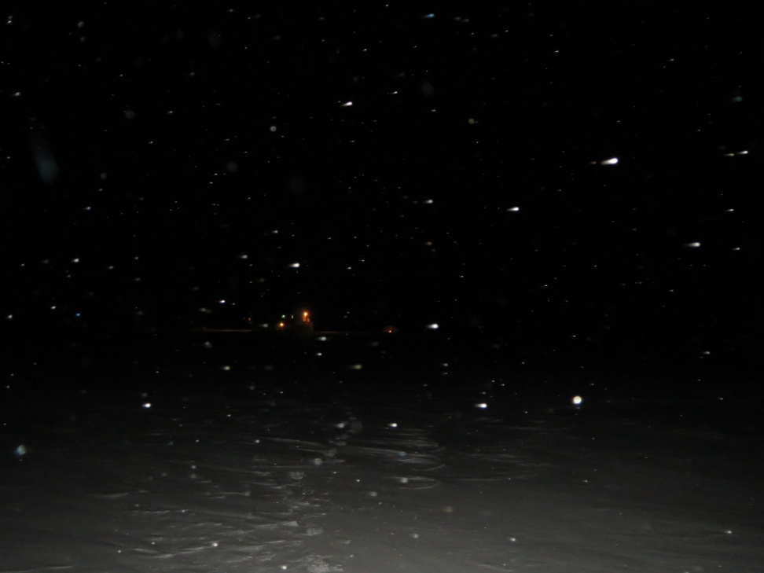

*12/21/14- Winter solstice and the darkest day of the year. Luckily the MPL is lighting up the skies in the absence of the sun.*

**General:**

* 12/19: The MSF was re-leveled in accordance with the MMCR.

**Significant Weather Observations:**

* 12/15: Freezing fog, 16 kts, -49C
* 12/16: Freezing fog, 11 kts, -41C
* 12/17: Broken clouds, 15 kts, -40C
* 12/18: Blowing snow, 28 kts, -30C
* 12/19: Broken clouds, 12 kts, -37C
* 12/20: Broken clouds, 11 kts, -33C
* 12/21: Broken clouds, 7 kts, -34C

**Dataman Account:**

* Operating normally.

**MWR:**

* HATPRO: operating normally.
* 150-90: operating normally.

**SODAR:**

* Operating normally.
* 12/21: Dishes cleaned from 1337-1418Z.

**POSS:**

* Operating normally.

**MMCR:**

* Operating normally.

**CAPABL:**

* Offsite as of 8/19.
* Continuing to monitor water storage system during winter.

**MPL:**

* Operating normally.
* 12/16: AMCS card timeout error. Computer restarted and data collection resumed at 1244Z.
* 12/17: MPL mount down overnight. Data did not transfer.
* 12/18: Data did transfer successfully overnight. AMCS card timeout error found during rounds, computer rebooted. Data collection resumed at 1235Z.

**VCEIL:**

* Operating normally.

**Hotplate:**

* Operating normally.

**IceCAM:**

* Operating normally.

**PAERI:**

* Operating normally.

**ASIA-A:**

* Operating normally.
* 12/18: Three comm errors due to high winds.
* 12/19: Small fan next to blower failed. Blower remains operational.
* 12/21: Comm error, radiometer rebooted.

**TSI:**

* Offline and stored in MSF for winter.

**IcePIC:**

* 12/21: Pictures taken at 1440Z and uploaded to server.

**Radiosonde:**

* Twice daily sondes.