# ICECAPS Weekly Report

Dec 22-28, 2014

Jennie Mowatt

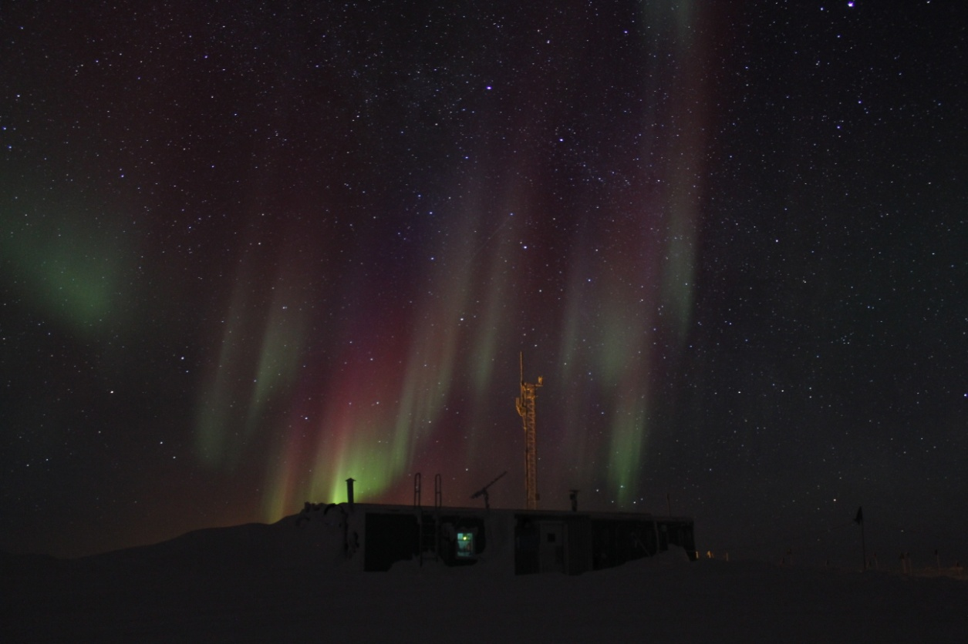

*Festive colored auroras seen the day before Christmas. JM*

**Significant Weather Observations:**

* 12/22: Broken clouds, 5 kts, -38C
* 12/23: Few clouds, 4 kts, -53C
* 12/24: Few clouds, 5 kts, -51C
* 12/25: Broken clouds, 11 kts, -43C
* 12/26: Few clouds, 0 kts, -44C
* 12/27: Blowing snow, 26 kts, -31C
* 12/28: Blowing snow, 21 kts, -23C

**Dataman Account:**

* Operating normally.

**MWR:**

* HATPRO: operating normally.
* 150-90: operating normally.

**SODAR:**

* Operating normally.

**POSS:**

* Operating normally.

**MMCR:**

* Operating normally.
* 12/25: Error noted with config file.

**CAPABL:**

* Offsite as of 8/19.
* Continuing to monitor water storage system during winter.

**MPL:**

* Operating normally.
* 12/22: Afterpulse calibration performed. Data collection resumed at 1346Z.
* 12/23: MPL mount down overnight, data did not transfer. Data successfully transferred on 12/14.
* 12/28: Data missing from overnight transfer for 12/27 starting at 1500Z due to AMCS card timeout.

**VCEIL:**

* Operating normally.

**Hotplate:**

* Operating normally.

**IceCAM:**

* Operating normally.

**PAERI:**

* Operating normally.
* 12/28: Partial blue flags during rounds (due to high winds overnight?).

**ASIA-A:**

* Operating normally.
* 12/28: Rebooted radiometer at 1311Z due to comm error (likely caused by high wind).

**TSI:**

* Offline and stored in MSF for winter.

**IcePIC:**

* No pictures taken this week.

**Radiosonde:**

* Twice daily sondes.