# ICECAPS Weekly Report

Dec 8-14, 2014

Jennie Mowatt

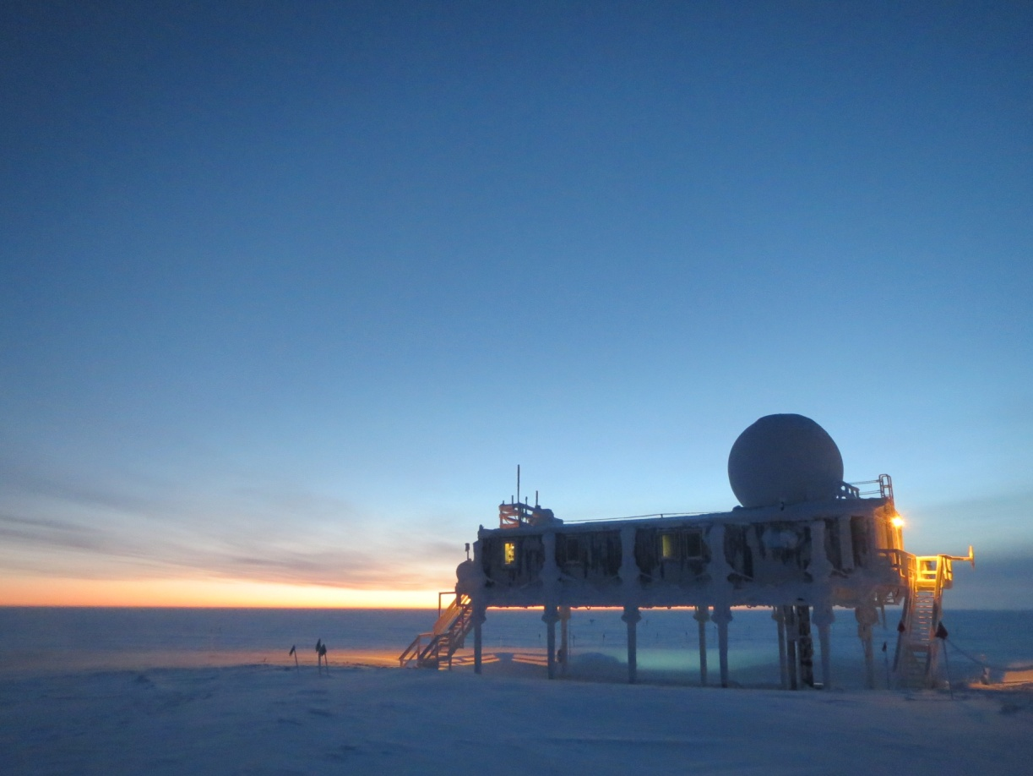

*With clear skies came cold temperatures this week. JM*

**Significant Weather Observations:**

* 12/8: Scattered skies, 9 kts, -46C
* 12/9: Overcast skies, 2 kts, -41C
* 12/10: Broken skies, 9 kts, -46C
* 12/11: Few clouds, 7 kts, -52C
* 12/12: Blowing snow, 24 kts, -30C
* 12/13: Few clouds, 6 kts, -51C
* 12/14: Broken clouds, 15 kts, -51C

**Dataman Account:**

* Operating normally.
* 12/13: 436 items did not transfer overnight. Started manual transfer at 1250Z but did not work. Restarted computer at 1302Z. Restarted transfer at 1310Z. Did not transfer due to server maintenance on NOAA side.
* 12/14: Some data did transfer overnight although 406 items did not. Remaining data was manually transferred (successfully) starting at 1308Z. Some drives had to be remounted manually as well.

**MWR:**

* HATPRO: operating normally.
* 150-90: operating normally.

**SODAR:**

* Operating normally.
* 12/8: Dishes cleaned from 1339-1400Z.

**POSS:**

* Operating normally.
* 12/13: Closed program and restarted computer at 1302Z. Data collection restarted at 1308Z.

**MMCR:**

* Operating normally.

**CAPABL:**

* Offsite as of 8/19.
* Continuing to monitor water storage system during winter.

**MPL:**

* Operating normally.
* 12/8: Afterpulse calibration performed at 1256Z. Data collection resumed at 1322Z.
* 12/12: AMCS card timeout error, last data collection at 0900Z. Restarted computer and program. Data collection resumed at 1232Z.

**VCEIL:**

* Operating normally.
* 12/14: Some data did not transfer overnight due to backlog and mount being down. Mount was corrected and data manually transferred at 1315Z.

**Hotplate:**

* Operating normally.
* 12/14: Some data did not transfer overnight due to backlog and mount being down. Mount was corrected and data manually transferred at 1315Z.

**IceCAM:**

* Operating normally.

**PAERI:**

* Operating normally.
* 12/10: Fan making grating noise. Removed and brought inside at 1340Z. Replaced fan and returned outside at 1500Z.
* 12/14: Some data did not transfer overnight due to backlog and mount being down. Mount was corrected and data manually transferred at 1315Z.

**ASIA-A:**

* Operating normally.
* 12/12: Communication error reported. Restarted computer and radiometer. Data collection resumed at 1239Z.

**TSI:**

* Offline and stored in MSF for winter.

**IcePIC:**

* No pictures taken this week.

**Radiosonde:**

* Twice daily sondes.