# ICECAPS Weekly Report

July 14 – July 20, 2014

Lana Cohen

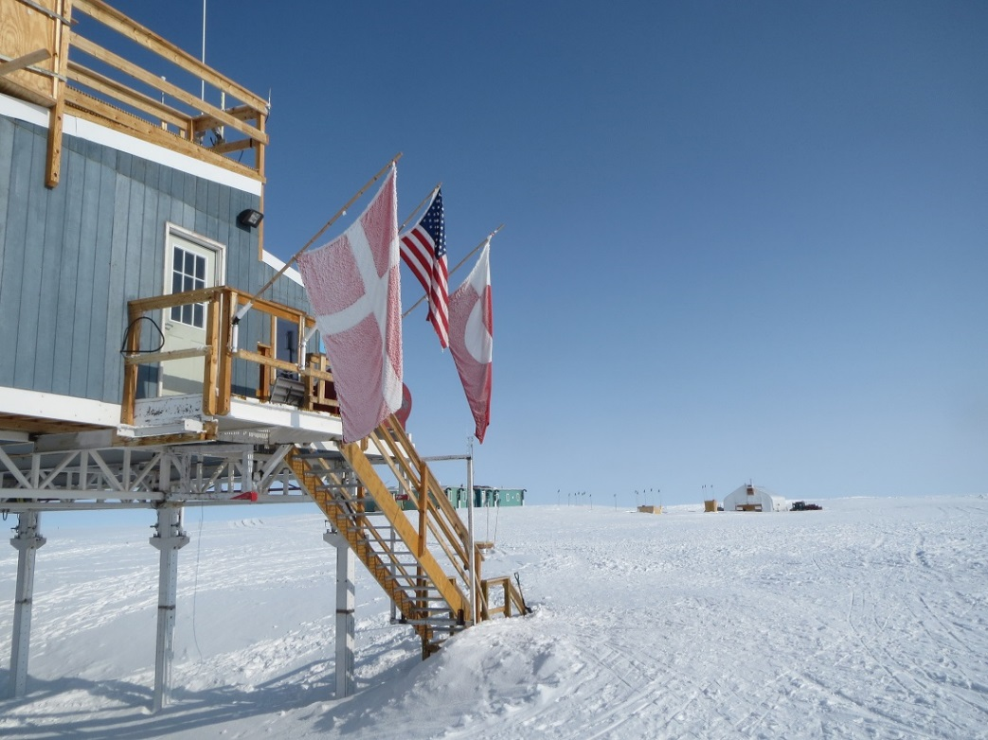

**General:**

* DV tour on 7/16 (DVs included US Ambassador to Denmark, Greenland govt representatives, and NSF managers).
* Noone group sharing space in MSF—left on 7/17.
* 7/18: work on MSF HRV system.

**Significant Weather Observations:**

* 7/14: overcast, light precip throughout the day
* 7/15: scattered cloud, some ice crystals in morning
* 7/16: overcast, precip w/15-20kt winds, clearing in afternoon
* 7/17: overcast, precip
* 7/18: overcast, light precip in morning
* 7/19: clear
* 7/20: morning fog, clear

**Dataman Account:**

* 7/19: No radiosonde and many MWR files didn’t get transferred—“No such file or directory” errors; all files transferred on 7/20.

**MWR:**

* 150-90: operating normally.
* HATPRO: out for calibration and repairs.

**SODAR:**

* Operating normally.

**POSS:**

* Operating normally.

**MMCR:**

* Ongoing troubleshooting of radar systems.
* 7/18: Transferred spectrum file to Duane for troubleshooting (can create smaller spectrum files for transferring).

**CAPABL:**

* Ongoing troubleshooting of CAPABL data issues—Robert coming up in Aug.

**MPL:**

* Operating normally.
* 7/15: Afterpulse calibration

**VCEIL:**

* Operating normally.

**Hotplate:**

* Operating normally.

**IceCAM:**

* Operating normally.

**PAERI:**

* Operating normally.

**ASIA-A:**

* Operating normally.

**TSI:**

* Operating normally.

**IcePIC:**

* 7/14: Images taken—bullet rosettes, prisms, irregular crystals.
* 7/18: Images taken—bullet rosettes, needles, plates, dendrites.

**MASC:**

* 7/18: MASC not automatically triggering; power cycled MASC, still not triggering
* 7/19: rebooted and restarted MASC with laptop connected at instrument to try to troubleshoot triggering issue; MASC was able to capture images of objects dropped through and continued to work when computer brought back inside (and connected via cat5 extensions); later in the day MASC software was giving numerous microcontroller errors—rebooted everything, now not auto-triggering again.

**Radiosonde:**

* Twice daily sondes.
* 7/16, 12Z sonde launched early for flight ops. Closed out late due to DV tour.