# ICECAPS Weekly Report

July 21 – July 27, 2014

Lana Cohen

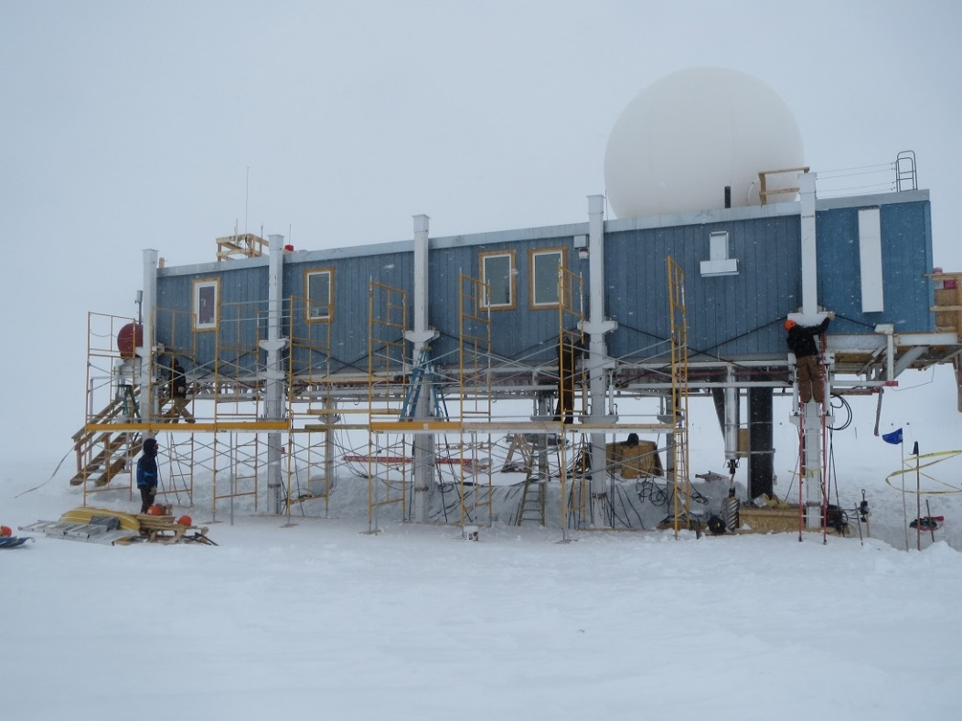

Big House being raised.

**General:**

* 7/22: Electrician installed new power line to precipitation instruments; swapped power for MASC, POSS, & Hotplate to new line on 7/24.
* VSAT overhaul postponed until next week (28-29 July).
* Big House raise—power & water out intermittently (internet outage for ~1hr on 7/24).

**Significant Weather Observations:**

* 7/21: scattered thin cloud 4-5km agl
* 7/22: mostly clear, some v. thin cloud at 4-5km agl
* 7/23: partly cloudy
* 7/24: overcast, fog
* 7/25: overcast, light precipitation all day
* 7/26: morning fog, scattered thin cloud, light precip in afternoon
* 7/27: morning fog, overcast

**Dataman Account:**

* 7/22: Data transfer problems traced to full USB archive disk; swapped out USB disk; Nate changed paths in transfer scripts to point to new disk. All data transferred by 7/24.
* 7/25: Data not all transferred overnight due to low bandwidth issues following yesterday’s planned internet outage.

**MWR:**

* 150-90: operating normally.
* HATPRO: out for calibration and repairs.
* Found all Hatpro components, and inspected other MWR cables & connectors; communicated with Erik about sending up replacement cabling, connectors,etc.

**SODAR:**

* Operating normally.

**POSS:**

* Operating normally.
* 7/24: POSS unplugged from ~1700-1900UTC while swapping power to new line.

**MMCR:**

* Ongoing troubleshooting of MMCR…

**CAPABL:**

* Ongoing troubleshooting of CAPABL data issues…

**MPL:**

* Operating normally.

**VCEIL:**

* Operating normally.
* 7/24, 2045UTC: Computer rebooted due to Hotplate software errors.
* 7/25: Ceilometer mount down during data transfer; caught up on 7/26.

**Hotplate:**

* 7/24: Hotplate unplugged from ~1700-1900UTC while swapping power to new line; Labview errors when tried to reconnect; rebooted computer and restarted ~2045UTC.

**IceCAM:**

* Operating normally.

**PAERI:**

* 7/24: No data 5.57-6.16UTC.

**ASIA-A:**

* Operating normally.

**TSI:**

* Operating normally.

**IcePIC:**

* 7/25-26: Wasn’t able to collect any flakes during precipitation event.

**MASC:**

* 7/25: Troubleshooting MASC—is taking images again as of ~1300UTC.
* 7/25-26: Took images during precipitation event.

**Radiosonde:**

* Twice daily sondes.
* 7/21, 24Z sounding failed soon after launch—wasn’t discovered until close-out.