# ICECAPS Weekly Report

July 7 – July 13, 2014

Lana Cohen

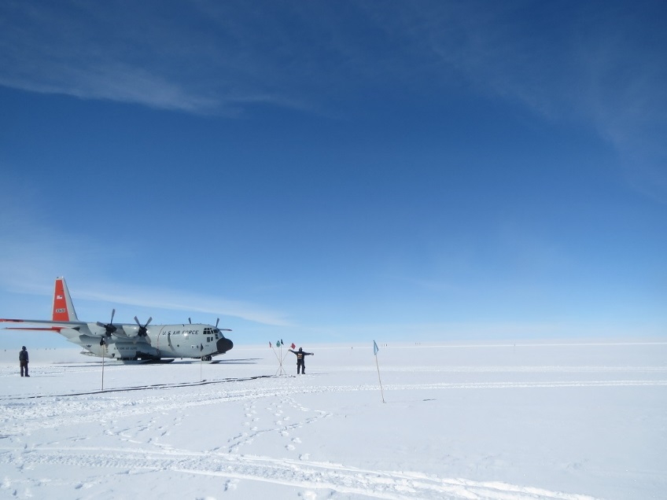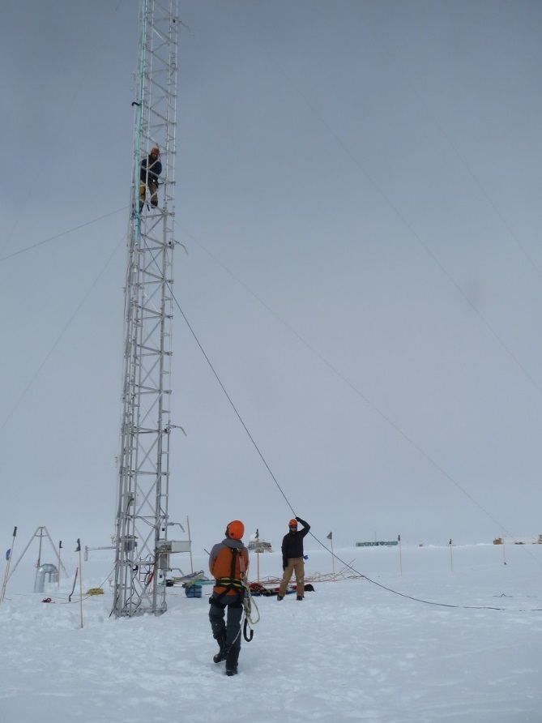

Photos: Noone group removing instruments from 50-m tower, and flight arrival on the 11th with JSEP students and teachers.

**General:**

* Noone group sharing space in MSF.
* USB temperature sensor comparison for Stillwell.
* Tour and activities with JSEP students—radiosondes & icepics.

**Significant Weather Observations:**

* 7/7: overcast, wind 15-20kts
* 7/8: morning fog; partly cloudy, calm
* 7/9: partly cloudy, precip from ~11.00UTC
* 7/10: morning fog, clear/ice crystals
* 7/11: clear
* 7/12: clear
* 7/13: morning fog

**Dataman Account:**

* 7/11: MMCR-radar mount down during data transfer; problem with radar network switch.
* 7/12: Data transfer didn’t go due to work director full errors (same problem as on 6/25); ran Icecaps.bash and ArchiveToBoulder.bash manually (15.50 & 18.10UTC) and data went fine.

**MWR:**

* 150-90: operating normally.
* HATPRO: out for calibration and repairs.
* HATPRO transformer returned

**SODAR:**

* Operating normally.

**POSS:**

* Operating normally.

**MMCR:**

* Duane doing ongoing troubleshooting of radar systems.
* 7/7: Emailed Duane about intermittent TWTA fan noise.
* 7/10: MMCR shutdown and restart (several times to get TWTA back up) per Duane’s request.
* 7/11: Radar computer network link down; power cycled network switch and came back up fine.

**CAPABL:**

* Ongoing troubleshooting of CAPABL data issues.

**MPL:**

* Operating normally.

**VCEIL:**

* Operating normally.

**Hotplate:**

* Operating normally.

**IceCAM:**

* Operating normally.

**PAERI:**

* 7/8: Computer hang; Chris Cox rebooted and restarted data acquisition.
* 7/12: Computer hung twice (~21.45 & 22.30UTC); Chris rebooted and restarted data acquisition.
* 7/13: Computer hang/reboot—no data 2.10-2.25UTC.

**ASIA-A:**

* 7/7: Data acquisition program found stopped again—seems to be going through only 1 measurement cycle; reloaded batch file and restarted acquisition.

**TSI:**

* 7/10: Not taking good images since midnight (alternating images of green screen and reflection of instrument superimposed on sky?); power cycled TSI and restarted acquisition—images are good now.

**IcePIC:**

* No flakes/crystals captured this week.
* Took photos of snow (mostly rime) as activity for JSEP students.

**MASC:**

* 7/7: Rebooted computer and jiggled cat5 extender and repeater cables. All 3 cameras are connected again and operating normally.
* 7/9: No images taken during precip event (1100-1130UTC).

**Radiosonde:**

* Twice daily sondes.
* 7/12 12Z launch done with JSEP students.
* 7/13 0Z launch: lost a balloon due to bad clip on radiosonde/parachute (may start taping sonde to parachute as a precaution?).