# ICECAPS Weekly Report

June 16 – June 22, 2014

Lana Cohen

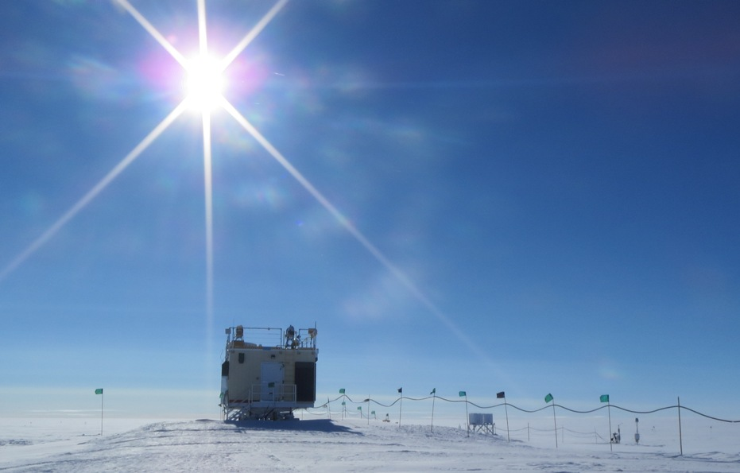

**General:**

* 6/18: Camp-wide internet outage, 15.30-~18.30 due to state-side problems.

**Significant Weather Observations:**

* 6/16: mostly clear sky, some cirrus, calm
* 6/17: intermittent fog, clear sky becoming overcast in evening
* 6/18: light precip overnight; overcast, warm
* 6/19: light precip overnight; partially cloudy
* 6/20: mostly clear sky, ice crystals in morning
* 6/21: mostly clear sky, winds > 10kts; precip starting ~2100Z
* 6/22: overcast, winds 20kts, precip & blowing snow

**Dataman Account:**

* Transfers went well this week (data transfers now take 8-10hrs during good connectivity).

**MWR:**

* 150-90: operating normally.
* HATPRO: out for calibration and repairs.

**SODAR:**

* Operating normally.

**POSS:**

* Operating normally.
* 6/19: Buried and protected cabling between POSS and electronics enclosure.

**MMCR:**

* 6/18: Radar monitor error; shut down and restarted @16.00Z.
* 6/19: Radar monitor error; shutdown/restarted 0920Z.
* 6/20: Radar monitor error; shutdown/restarted 0950Z.

**CAPABL:**

* 6/19: Moved power to network switch from the usb-power strip to a wall outlet to see if intermittent problems with dataman mount (due to network disconnect?) are resolved.

**MPL:**

* 6/18: afterpulse calibration

**VCEIL:**

* Operating normally.

**Hotplate:**

* Operating normally; possible ambient temp sensor issues.

**IceCAM:**

* Operating normally.

**PAERI:**

* Operating normally.

**ASIA-A:**

* Operating normally.

**TSI:**

* Operating normally.

**IcePIC:**

* No flakes/crystals captured this week.

**MASC:**

* Images taken on 6/18.
* 6/19, 18.30Z—6/20, 9.40Z: Microcontroller error; stopped and restarted MASC data acquisition.
* 6/21-6/22: precip with winds >15kts—no images taken

**Radiosonde:**

* Twice daily sondes; no dual launches with ozonesondes.