# ICECAPS Weekly Report

June 2 – June 8, 2014

Ward Handley and Lana Cohen

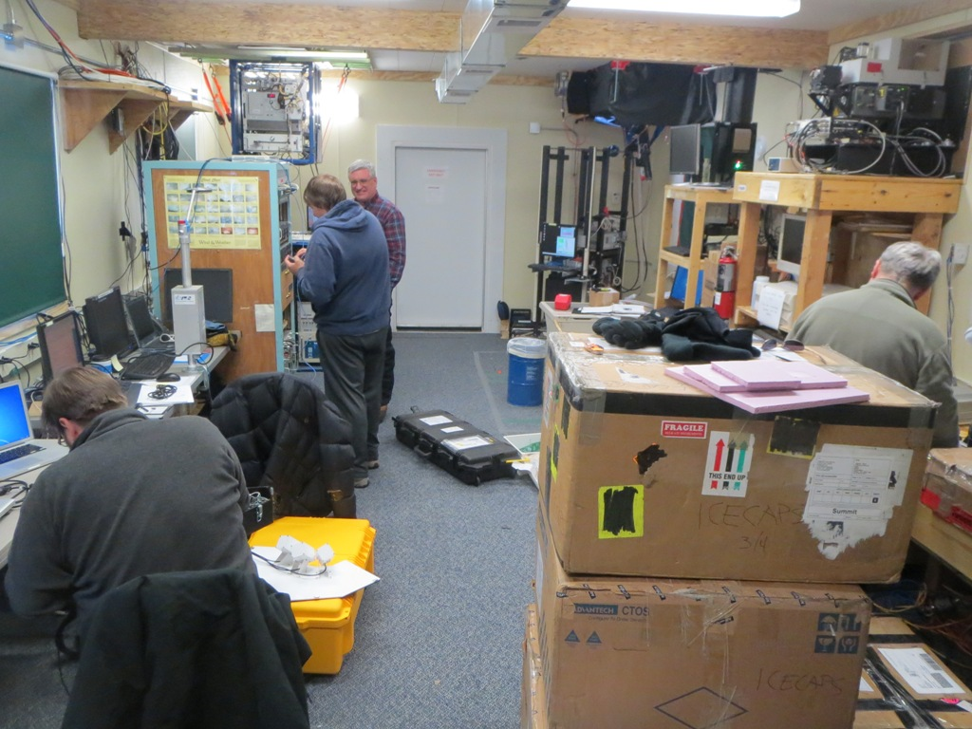

**6/5: A very busy MSF.**

**General:**

* MSF facility operating normally.
* FP3 has begun. Ben C., John R., Duane H., and Pierre all arrived on the first flight.
* The new ICECAPS tech Lana Cohen arrived. Turnover has been ongoing all week.
* Ben and John are working on the precipitation sensors (POSS, Hot Plate, MASC).

**Significant Weather Observations:**

* 6/2: Winds 7kn at 124˚, -19C, 89%RH, FEW
* 6/3: Winds 7kn at 129˚, -17C, 74%RH, FEW
* 6/4: Winds 6kn at 220˚, -14C, 90%RH, SKC
* 6/5: Winds 11kn at 165˚, -14C, 91%RH, FEW
* 6/8: Winds 13kn at 245˚, -19C, 77%RH, BKN

**Dataman Account:**

* Operating normally.

**MWR:**

* 150-90: operating normally.
* HATPRO: out for calibration and repairs.
* Turnover: HATPRO install and shortening of all MWR cables.
* HATPRO transformer lent to Magnetometer group at TAWO, they are purchasing their own and will return the HATPRO transformer as soon as possible.

**SODAR:**

* Operating normally.
* 6/7: Visiting PIs bumped the SODAR amplifier and shut it off. It was powered on at 1015Z on the morning of 6/8.
* 6/8: SODAR frame leveled and dishes leveled.

**POSS:**

* POSS removed from roof and installed at ground level ~100’ to the south east of the MSF.

**MMCR:**

* Duane arrived to upgrade the MMCR. The pulse controller, Receiver/Modulator, Interface, and both computers were replaced.
* 6/5 @ 1745Z: daily MMCR files manually transferred to ToBoulder. MMCR shutdown for upgrade. Matt Shupe later had to move them to their appropriate locations.

**CAPABL:**

* Operating normally.
* 6/3: First night that CAPABL data was included in the nightly ICECAPS uploads.
* 6/4: Robert Stillwell departed Summit.

**MPL:**

* Operating normally.

**VCEIL:**

* Operating normally.
* 6/5 @ 1350Z: Ceilometer computer rebooted to complete installation of the Precip Hot Plate software.

**IceCAM:**

* Operating normally.

**PAERI:**

* Operating normally.
* 6/2 @ 1250Z: hresd and hresdd daemons crashed causing the system to reboot (source of the blue flag events).
* 6/6: hresdd deamon crashed three times. System rebooted.

**ASIA-A:**

* Operating normally.
* 6/4: Pierre arrived to work on the ASIAA.
* Overheating problems with the new transformer persist so the issue is likely with the heater/blower itself, or with back EMF.

**TSI:**

* Operating normally.
* 6/8: Replaced the TSIs Ethernet cable. The old one was functional, but the sheath was destroyed in many places.

**IcePIC:**

* Attempted to collect crystals on multiple days with heavy precipitation, but the slides were always blown clear despite efforts to shield them.

**Radiosonde:**

* Twice daily sondes.
* 6/3: No more K-sondes will be launched after this date because of they are unreliable and a large percentage is simply unusable. The remaining K-sondes will be retroed at some point.
* 6/5 @ 24Z: launched half hour early due to tandem launch with NOAA Ozonesonde. GTS message created, but was not transferred for some reason.
* 6/6 @ 12Z: No NOAA Met data at the time of launch due to maintenance on the TAWO tower. Values from 1 hour after the launch used to simulate the launch later in the day.
* 6/6 @ 24Z: Radiosonde training for turnover. All subsequent launches were done by the incoming techs.