# ICECAPS Weekly Report

June 23 – June 29, 2014

Lana Cohen

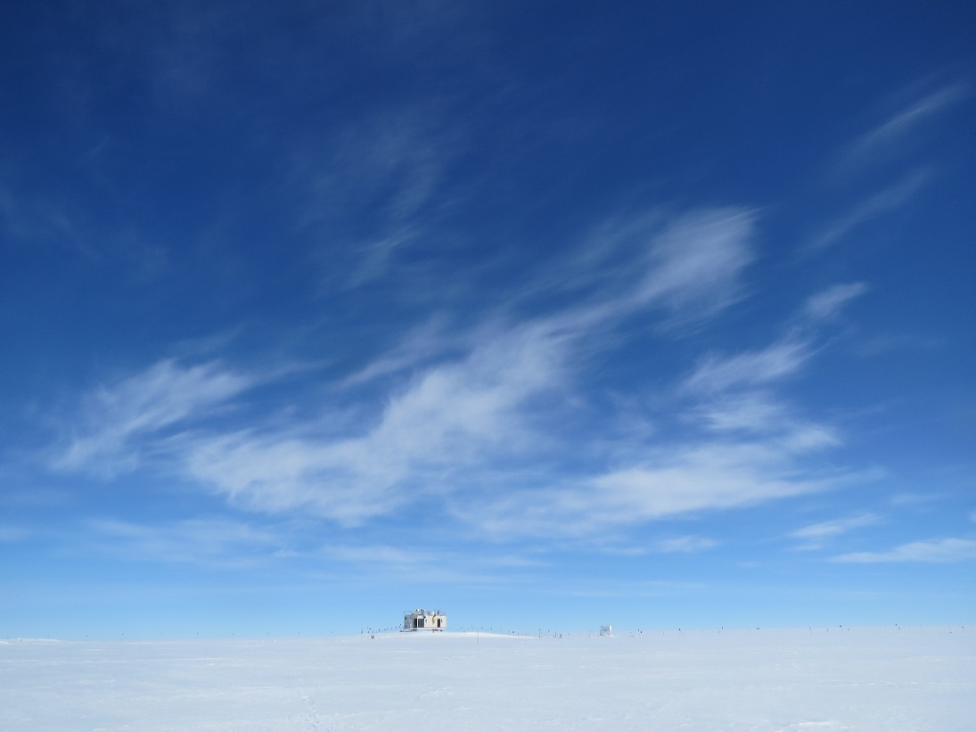

**General:**

* Flight scheduled for Sat was cancelled; flight arrived on Sunday.

**Significant Weather Observations:**

* 6/23: Partly cloudy, cirrus
* 6/24: mostly cloudy
* 6/25: mostly cloudy, snow flurries from ~19.30Z
* 6/26: mostly cloudy, snow flurries in morning
* 6/27: partly cloudy, fog and ice crystals in morning
* 6/28: clear, calm; winds increasing to 15kts later day
* 6/29: partly cloudy, calm

**Dataman Account:**

* Dataman transfer didn’t go on 6/25 due to dataman work directory full error; Matt manually ran scripts on 6/25 and they went fine.

**MWR:**

* 150-90: operating normally.
* HATPRO: out for calibration and repairs.

**SODAR:**

* Operating normally.

**POSS:**

* 6/23-24: POSS data acquisition was accidentally shut down on 23rd; restarted on 24th.

**MMCR:**

* Duane working on radar system--daily calibrations & radar monitor program.
* Helped Duane with ongoing troubleshooting of radar systems; 6/26: replaced noise source.

**CAPABL:**

* No mount issues this week.
* 6/26: Opened CAPABL iris slightly to increase field of view as per PI request.

**MPL:**

* Operating normally.

**VCEIL:**

* Operating normally.

**Hotplate:**

* Operating normally.

**IceCAM:**

* Operating normally.

**PAERI:**

* 6/28: Multiple data dropouts.

**ASIA-A:**

* Operating normally.

**TSI:**

* 6/23: several glitchy images at 0050, 0057, 0432, 1230 each lasting 2 frames.

**IcePIC:**

* No flakes/crystals captured this week.

**MASC:**

* No images taken this week.

**Radiosonde:**

* Twice daily sondes.