# ICECAPS Weekly Report

June 9 – June 15, 2014

Lana Cohen

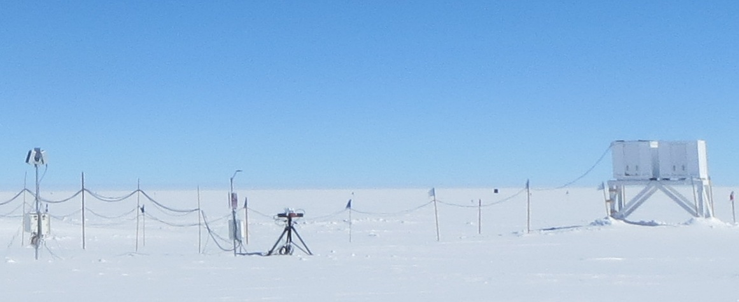

**New instruments installed near SODAR (left to right: POSS, Hotplate, MASC, SODAR).**

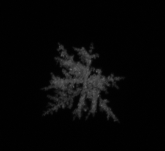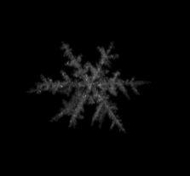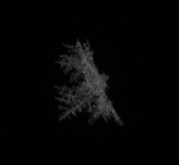

2014.06.13_04.10.05_flake29

cam_0 cam_1 cam_2

**Snowflake image captured by the MASC.**

**General:**

* Two LC-130 flights out on the 11th, with 33 folks leaving camp.
* New instruments installed and running (Hotplate sensor and MASC imager).

**Significant Weather Observations:**

* 6/9: mostly clear, 10-15kts
* 6/10: overcast, blowing snow 15-20kts
* 6/11: low cloud in morning lifting; high cirrus
* 6/12: no cloud; fog/low cloud from ~1800Z
* 6/13: morning fog, lifted in afternoon, calm
* 6/14: mostly clear skies, with high cirrus moving in through the day, calm
* 6/15: clear skies, calm

**Dataman Account:**

* 6/11: Many lost connection messages during the overnight transfer. File still transferring throughout the day.
* 6/12: Many lost connection messages during the overnight transfer. File still transferring throughout the day.
* 6/13: Many lost connection messages during the overnight transfer. File still transferring throughout the day.
* 6/14: Data transfer went last night with no dropped connections (don’t think SRI actually changed anything).
* 6/15: Most data not transferred last night—no dropped connections, just very slow?

**MWR:**

* 150-90: operating normally.
* HATPRO: out for calibration and repairs.

**SODAR:**

* Operating normally.

**POSS:**

* Operating normally.

**MMCR:**

* Operating normally.

**CAPABL:**

* Operating normally.
* 6/11: Intermittent problems with dataman mount (due to network disconnect?) results in “not enough free space on disk” error.
* 6/12: Filled Laser 2 water and tightened hose clamps (there was a slight leak).

**MPL:**

* Operating normally.

**VCEIL:**

* Operating normally.

**Hotplate:**

* Seems to be operating fine, transferring data. (Question: The ambient temperature reported by sensor seems to be ~5-10C higher than NOAA data and pressure is ~sea-level. Is this ok?)

**IceCAM:**

* Operating normally.

**PAERI:**

* Operating normally.

**ASIA-A:**

* Operating normally.

**TSI:**

* Operating normally.

**IcePIC:**

* No flakes/crystals captured this week.

**MASC:**

* Several images captured on 6/13 during a very light precip event.

**Radiosonde:**

* Twice daily sondes (no longer using K-sondes).
* 6/11: Changed desiccant on sonde reconditioning unit.
* Two sondes this week had RH sensor that were out of spec (RH after reconditioning > +/- 0.2%).
* There have been several days this week during low-wind conditions (< 5kts) when the RH measured by sonde is up to 20% different than the NOAA-measured RH (which is ~1/2 mile away). I used the Kestral to measure RH right next to the sonde, and they have matched up w/in 5%.
* Questions: Do we still want to do dual launches with ozonesondes when they switch over to the iMets (which have GPS included)? Retro K-sondes?