ICECAPS Weekly Report
May 12 – May 18, 2014
Ward Handley

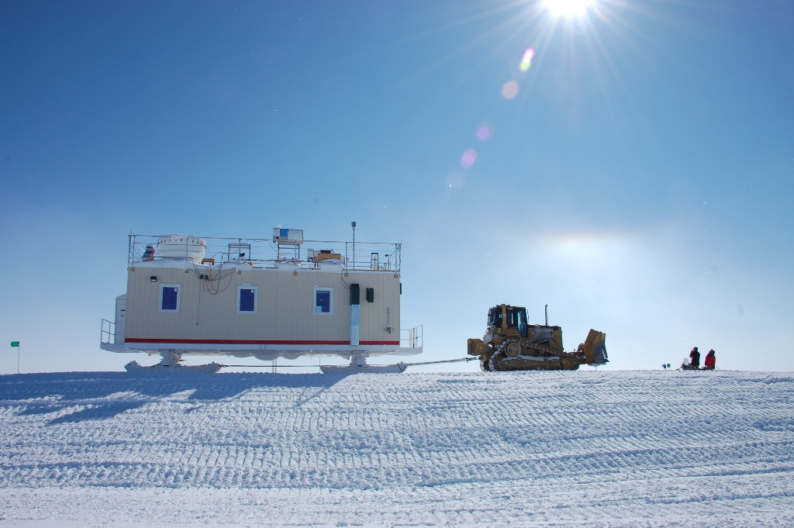
5/15: Carps Nick and Tera spot “Smooth Operator” LT as the MSF is pulled into final position. Photo credit: Von Walden

General:
- MSF move completed on 5/15. Many thanks to carpenters Nick and Tera, HEO LT, electrician G, Von, Robert, and Mike! All experiments and equipment were shut down for the move, with the exception of the PAERI Sterling Cooler.
- Big temp swings by PAERI and CAPABL persist. I will try to tune the HVAC system with incremental changes.

Significant Weather Observations:
- 5/12: Winds 10kn at 76˚, -28C, 80%RH, FEW
- 5/13: Winds 3kn at 208˚, -29C, 78%RH, SKC
- 5/14: Winds 8kn at 208˚, -26C, 81%RH, BKN-FZBR
- 5/17: Winds 11kn at 297˚, -25C, 83%RH, FEW-FZBR
- 5/18: Winds 8kn at 251˚, -26C, 82%RH, FEW

Dataman Account:
- Operating normally.

MWR:
- 150-90: operating normally.
- HATPRO: out for calibration and repairs.

SODAR:
- Operating normally.
- New SODAR frame by MSF and a small pad was built.
- There was the following error upon boot up of the SODAR computer: “Pri Master Hard Disk:S.M.A.R.T. Status BAD, Backup and Replace”

POSS:
- Operating normally.
- Awaiting 25+ kn winds to test hypothesis that the guy wires are creating the signal that dominates the low frequency bins during wind events.

MMCR:
- Operating normally.
- Still having mysterious UPS line fault errors. Source is not building power.
- 5/16: MMCR leveled following the MSF move.

CAPABL:
- Neely and Mike O’Neill have left Summit. Robert Stillwell is on station working on the CAPABL.

MPL:
- Operating normally.
- Von hypothesizes that the AMCS card errors are caused by static build up on the telescope tube and subsequent discharge. This would explain why the problem is worse in high winds. Our electrician installed a grounding lug near the MPL for further testing.

VCEIL:
- Operating normally.

IceCAM:
- Operating normally.
- 5/16: IceCAM clock was corrected after the time was reset in the MSF move power outage.

PAERI:
- Operating normally.
- Von was on-site all week.
- Von tracked down the source of the intermittent blue flags and data cutouts.

ASIA-A:
- Operating normally.
- 5/16: ASIAA leveled following MSF move.

TSI:
- Offline for winter.
- Waiting for temp to be >-30C for 18+ hours a day.

IcePIC:
- No IcePICs were taken this week.

Radiosonde:
- Twice daily sondes.
- 5/12 @ 12Z: closed out late.
- 5/14 @ 12Z: launched 1.5 hours early due to flight ops.
- 5/15 @ 12Z: computer time incorrect during sounding. Matt Shupe corrected the dataset.
- 5/16 @ 24Z: tandem launch with NOAA Ozonesonde.
- 5/17 @ 12Z: launched 0.5 hours early due to flight ops. Sonde RH variation was >10% and would have been aborted if not for a rapidly closing launch window.
- 5/18 @ 12Z: launched 0.75 hours early due to anticipated flight ops.

