ICECAPS Weekly Report
May 19 – May 25, 2014
Ward Handley

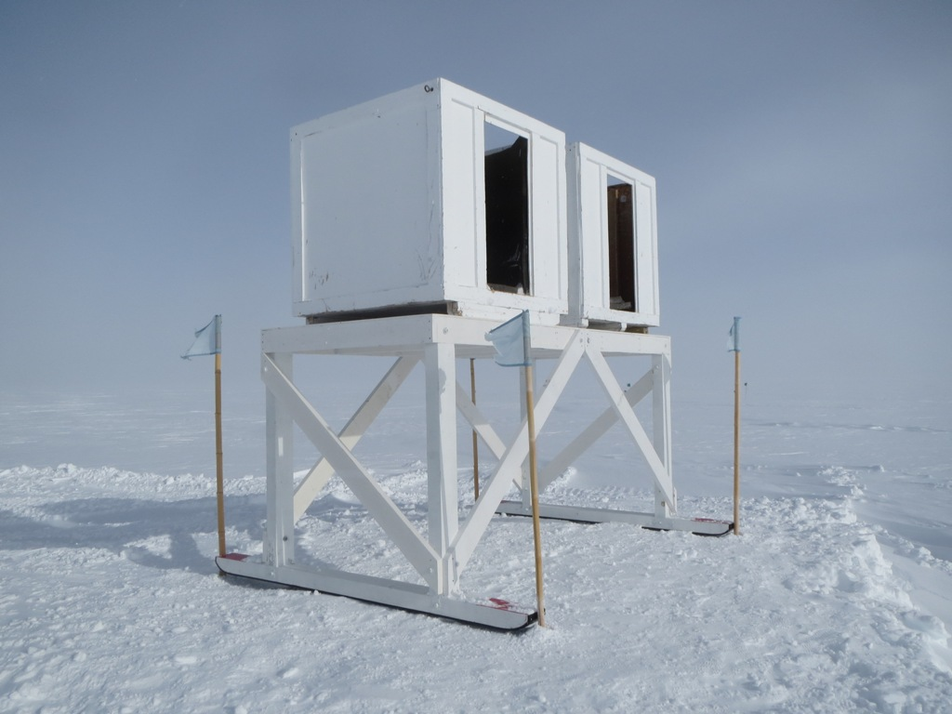
5/19: The SODAR on its new frame – with very slippery skis!

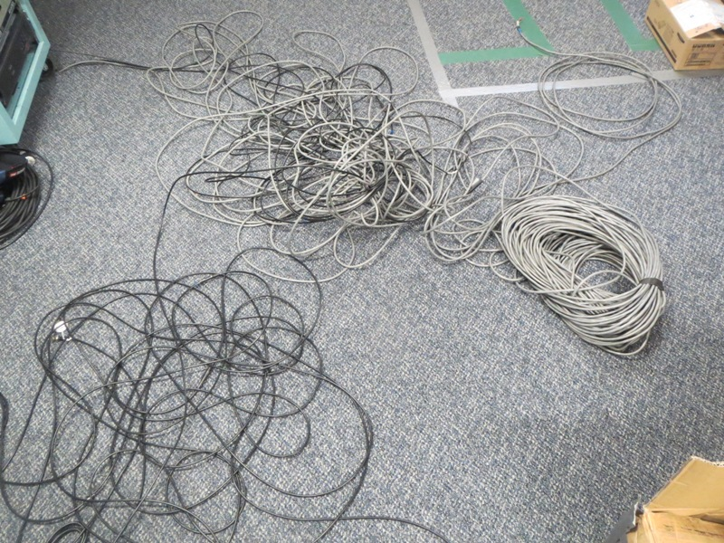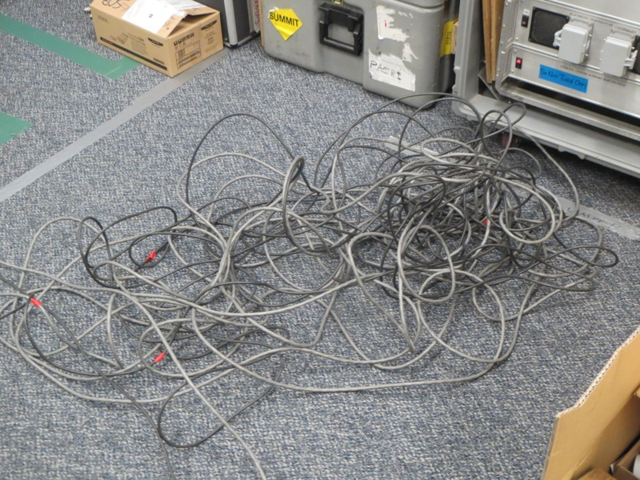
The trials and tribulations of working on the SODAR: old rat’s nest and new rat’s nest
General:
- MSF facility operating normally.
- Flag lines to MSF adjusted.

Significant Weather Observations:
- 5/19: Winds 22kn at 272˚, -18C, 90%RH, -BLSN
- 5/20: Winds 13kn at 165˚, -31C, 77%RH, SKC
- 5/21: Winds 12kn at 235˚, -15C, 91%RH, BKN
- 5/22: Winds 12kn at 320˚, -22C, 87%RH, OVC
- 5/24: Winds 11kn at 124˚, -21C, 84%RH, SCT
- 5/25: Winds 21kn at 123˚, -19C, 79%RH, SCT-DRSN

Dataman Account:
- Operating normally.

MWR:
- 150-90: operating normally.
- HATPRO: out for calibration and repairs.

SODAR:
- 5/19: new SODAR frame moved into position, and SODAR boxes were transferred to the new frame. Flag line to SODAR put in to keep cables out of the snow.
- 5/22 @ 2230Z: SODAR back on-line!
- Old microphone packaged for retro.
- What to do with the old SODAR cables?

POSS:
- Operating normally.
- Awaiting 25+ kn winds to test hypothesis that the guy wires are creating the signal that dominates the low frequency bins during wind events.

MMCR:
- Operating normally.
- Discrepancy between electronic and physical levels.

CAPABL:
- Robert Stillwell is on station working on the CAPABL.

MPL:
- Operating normally.
- Afterpulse calibration missed on 5/13.

VCEIL:
- Operating normally.

IceCAM:
- Operating normally.

PAERI:
- Operating normally.
- 5/24: electronic PAERI log created.

ASIA-A:
- Operating normally.

TSI:
- Offline for winter.
- For the past week we have been >-30C for 18+ hours a day.

IcePIC:
- 5/21: Very few crystals collected. Irregular crystals to 500 microns.

Radiosonde:
- Twice daily sondes.
- Late close outs: I will verify that the balloon is closed out each night. Ozonesonde launches will be moved up to 2130Z so the balloon can be closed out in time for GTS.
- RH sensor offsets and surface observations: the K sondes are consistently 10-15% lower than the NOAA Met data. Should these sondes be aborted?
- 5/20 @ 12Z: first sonde aborted – no PTU telemetry. Sonde tried twice with the same result. Second sonde successfully launched.
- 5/21 @ 24Z: closed out late.
- 5/22 @ 24Z: tandem launch with NOAA Ozonesonde. Closed out late.

