ICECAPS Weekly Report
May 26 – June 1, 2014
Ward Handley

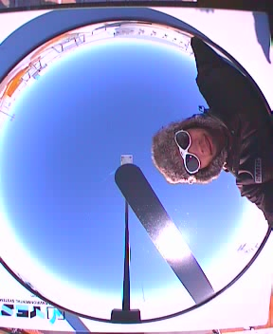
5/30 @ 1249Z: Posing for the newly installed TSI.

General:
- MSF facility operating normally.
- Temperature sensors have been deployed throughout the MSF to build a data set that will be used to tune (or modify) the HVAC system.

Significant Weather Observations:
- 5/27: Winds 22kn at 46˚, -21C, 87%RH, BKN
- 5/28: Winds 10kn at 227˚, -23C, 84%RH, SCT
- 5/29: Winds 2kn at 16˚, -26C, 80%RH, SCT-FZBR
- 5/30: Winds 9kn at 190˚, -22C, 76%RH, FEW
- 5/31: Winds 8kn at 234˚, -19C, 82%RH, FEW
- 6/1: Winds 5kn at 113˚, -17C, 90%RH, SKC

Dataman Account:
- Operating normally.
- There are two old RAID hard drives for retro with Duane or Ben.

MWR:
- 150-90: operating normally.
- 5/27 @ 1810Z: 150-90 leveled. Pictures sent to Dave and Erik.
- HATPRO: out for calibration and repairs.

SODAR:
- Operating normally.
- 5/27: SODAR frame 0.5” off level in E-W direction (short side). Boxes are separated by 7.5”, which could be increased to 12”.
- 5/28: Old SODAR microphone and cables prepared for retro.

POSS:
- Operating normally.
- 5/27: winds 22kn at 46˚, found vibrating panel on the POSS roof-top electronics box. Panel was secured at 1830Z, but was NOT the source of the low frequency signal.

MMCR:
- Operating normally.

CAPABL:
- Robert Stillwell is on station working on the CAPABL.

MPL:
- Operating normally.
- 5/27: Afterpulse calibration.

VCEIL:
- Operating normally.

IceCAM:
- Operating normally.

PAERI:
- Operating normally.
- 5/27: PAERI cooler ITAR licenses added to PAERI documentation.
- 5/30: data dropped out (flags blue) four times during the day. PAERI rebooted at 1930Z.

ASIA-A:
- Operating normally.
- 5/26-27: Heater/blower transformer started going bad (smelled like burning electronics and case was too warm). Transformer unplugged and heater/blower plugged directly into line power, which will allow it to run at ~25% power until a replacement transformer arrives at Summit.

TSI:
- 5/28: TSI installed!

IcePIC:
- 5/28: slides set out, no crystals collected.
- It was very clear for most of the week so there was little opportunity for IcePICs.

Radiosonde:
- Twice daily sondes.
- 5/29 @ 12Z: two bad K-sondes in a row with erratic or square wave RH profiles. The first was aborted; the second was not because the launch window had passed.
- 5/29 @ 24Z: tandem launch with NOAA Ozonesonde. Balloon launched early so it could be closed out in time for GTS.
- 6/1 @ 12Z: first K-sonde was aborted due to a bad temperature sensor (reading +85C). Second sonde was normal.

