ICECAPS Weekly Report
May 5 – May 11, 2014
Ward Handley

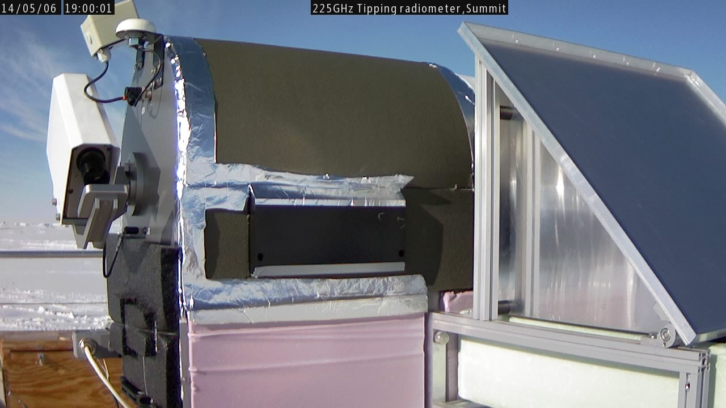
5/6 @ 1900Z: ASIAA absolute LN2 calibration underway

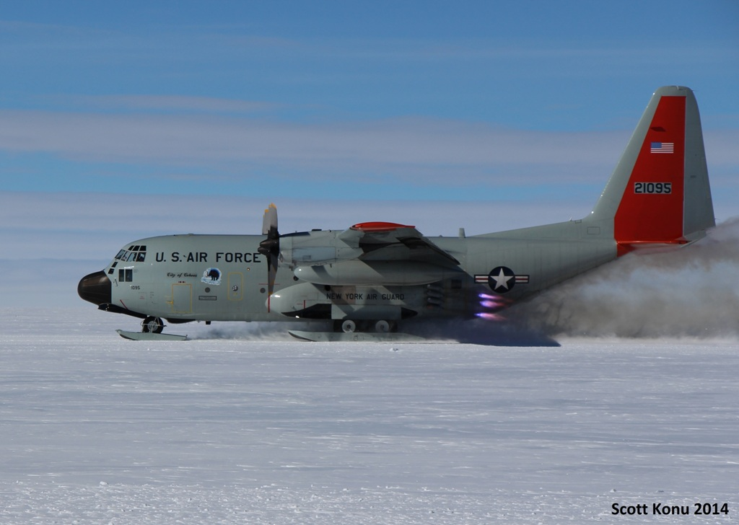
5/8: Skier 095 uses JATO to get off of the sticky skiway. Photo credit: Scott Konu
General:
- MSF facility operating normally.
- MSF pad construction is underway. There is still much work to be done.

Significant Weather Observations:
- 5/5: Winds 20kn at 195˚, -27C, 81%RH, VV500-BLSN
- 5/6: Winds 13kn at 165˚, -31C, 77%RH, SKC
- 5/7: Winds 14kn at 141˚, -22C, 86%RH, SCT-FZBR
- 5/8: Winds 10kn at 203˚, -18C, 87%RH, SCT
- 5/9: Winds 13kn at 343˚, -16C, 89%RH,SCT
- 5/10: Winds 4kn at 294˚, -21C, 88%RH, SCT
- 5/11: Winds 3kn at 243˚, -22C, 85%RH, FEW

Dataman Account:
- Operating normally.
- 5/5: RAID mount not found and nightly uploads did not occur. ICECAPS was rebooted and the RAID mount reestablished. External hard drive #1 swapped out with #4. #3 would not mount.
- 5/6: ArchiveToBoulder did not grab the PAERI, Ceilometer, or the MPL data from 5/5. Mounts were down. Sudo mount –a mounted all three. Then I ran Icecaps.bash followed by ArchiveToBoulderManual.bash

MWR:
- 150-90: operating normally.
- HATPRO: out for calibration and repairs. Did the shipping ever get sorted out?
- 5/6: Absolute Calibration with LN2 completed.

SODAR:
- Operating normally.
- 5/6: MSF pad construction from 0745-0845, 1100-1230Z.
- 5/8: MSF pad construction from 0845-0950, 1115-1220Z.

POSS:
- Operating normally.
- Awaiting 20+ kn winds to test hypothesis that the guy wires are creating the signal that dominates the low frequency bins during wind events.
- 5/5: POSS was down due to ICECAPS computer reboot from 1354-1421 and 2135-2145Z.

MMCR:
- Operating normally.
- 5/7 @ 1925 - 5/8 @ 0511Z: LapXM subprogram crashed. RF transmitter stopped. At 0511 LapXM restarted the crashed subprogram and the MMCR returned to normal operation.

CAPABL:
- Neely and Mike O’Neill are on station working on the CAPABL.

MPL:
- Operating normally.
- 5/10 @ 0505-1227Z: AMCS card error.
- 5/11 @ 0100Z: extra files created: 0059, 0100_01.

VCEIL:
- Operating normally.

IceCAM:
- Operating normally.

PAERI:
- Operating normally.
- 5/8 @ 1634-1652Z: All flags went blue and spectra disappeared. Powerware message generated at 1647Z.

ASIA-A:
- Operating normally.
- 5/5: ASIAA webcam housing opened and window cleaned. Desiccants added to webcam box.
- 5/6: ASIAA webcam housing opened and webcam was refocused.
- 5/6: Absolute Calibration with LN2 completed.

TSI:
- Offline for winter.
- Time to install it? The last cold night (-43C) was on May 5th/6th.

IcePIC:
- 5/7 @ 1255-1630Z: Bullets and irregular crystals to 700 microns. Simple prisms to 500 microns.
- 5/8 @ 1330-1900Z: Few crystals collected. Simple prisms to 200 microns. Irregular crystals to 700 microns.

Radiosonde:
- Twice daily sondes.
- Resupply received: balloons, parachutes, sondes, and He.
- 5/5 @ 12Z: sonde launched 5 minutes early due to LC130 flight ops.
- 5/6 @ 12Z: sonde launched ½ hour early due to LC130 flight ops.
- 5/7 @ 12Z: sonde aborted shortly before launch due to LC130 off deck in Kanger.
- 5/7 @ 24Z: incorrect surface observations entered before launch. Sounding was simulated using the correct surface observations: 13kn @ 165deg, T=-23.3, RH=85, P=671.5.
- 5/8 @ 12Z: sonde launched 10 minutes early due to LC130 flight ops.
- 5/8 @ 24Z: tandem launch with NOAA Ozonesonde.
- 5/10 @ 12Z: questionable sonde.
- 5/11 @ 12Z: sonde launched 1 hour early.

