# ICECAPS Weekly Report

Nov 10-16, 2014

Jennie Mowatt

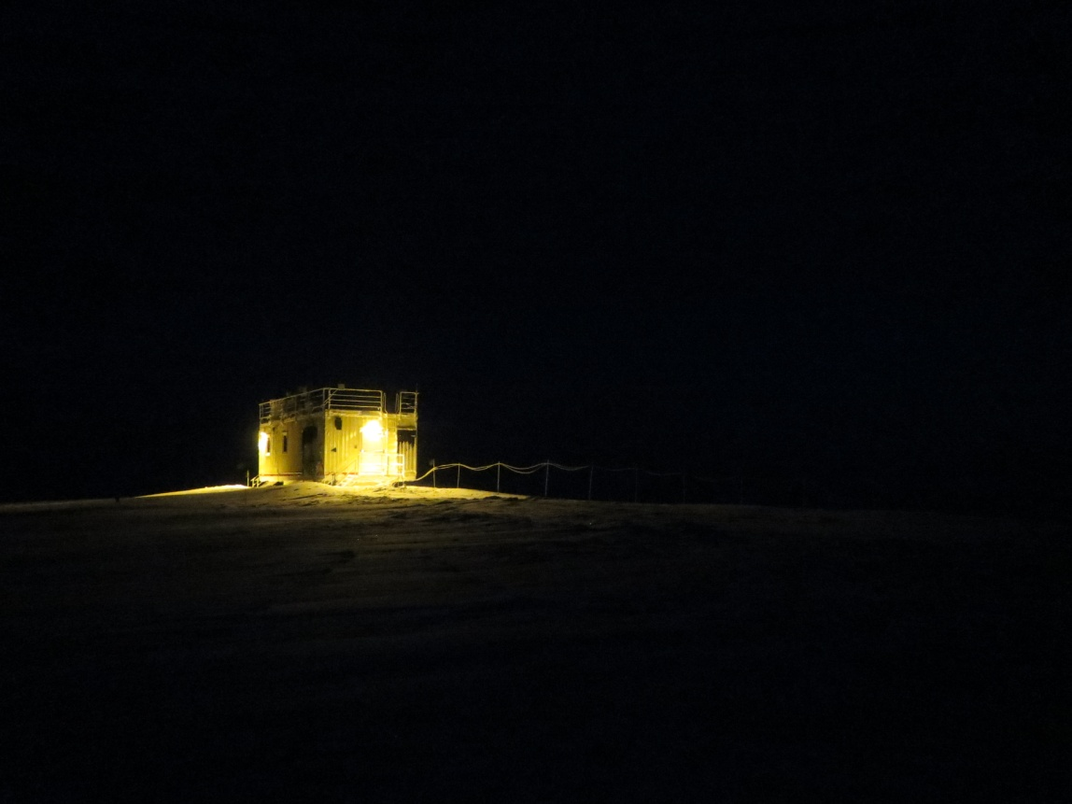

*The MSF stands alone. JM*

**General:**

* 11/10: There was a stationwide power outage from 0705-0709Z due to a failure of Gen 2.
* 11/11: There was another planned stationwide swap between Gen 1 and the E-Gen from 1259-1301Z and 1303-1305Z
* 11/14: Another stationwide power swap occurred from 1257- 1300Z.

**Significant Weather Observations:**

* 11/10: Broken skies, 5 kts, -46C
* 11/11: Clearing skies, 10 kts, -52C
* 11/12: Overcast skies, 12 kts, -37C
* 11/13: Overcast and blowing snow, 12 kts, -25C
* 11/14: Overcast with drifting snow, 12 kts. -23C
* 11/15: Overcast skies, 11 kts, -24C
* 11/16: Overcast skies, 18 kts, -18C

**Dataman Account:**

* Operating normally.
* 11/14: MWR, radiosonde and Icecam files failed to transfer, possibly due to onrush of MMCR data after bringing radar back online. Manually transferred later in the afternoon successfully.

**MWR:**

* HATPRO: operating normally.
* 150-90: operating normally.

**SODAR:**

* Operating normally.
* 11/14: Dishes cleaned from 1309-1323Z.

**POSS:**

* Operating normally.

**MMCR:**

* 11/11: Reinstalled TWTA.
* 11/12: System brought online.
* 11/13: Data did not transfer overnight due to mount being down. Manually reset. Data transferred fine on 11/14.

**CAPABL:**

* Offsite as of 8/19.
* Continuing to monitor water storage system during winter.

**MPL:**

* Operating normally.
* 11/10: Afterpulse calibration performed.
* 11/11: MPL mount down during overnight data transfer.
* 11/12: MPL back online, all data from 11/10 and 11/11 transferred successfully.

**VCEIL:**

* Operating normally.

**Hotplate:**

* Operating normally.

**IceCAM:**

* Operating normally.
* 11/14: Some data was not transferred overnight. Transferred later in the afternoon.

**PAERI:**

* Operating normally
* 11/10: Set off blue flags while cleaning mirror (1400Z). Returned to normal at 1412Z.

**ASIA-A:**

* Operating normally.
* The camera focus still needs to be adjusted.

**TSI:**

* Offline and stored in MSF for winter.

**IcePIC:**

* No pics taken this week.

**MASC:**

* Offsite as of 8/13.

**Radiosonde:**

* Twice daily sondes.
* 11/14: Some data was not transferred overnight. Transferred later in the afternoon.