# ICECAPS Weekly Report

Nov 17-23, 2014

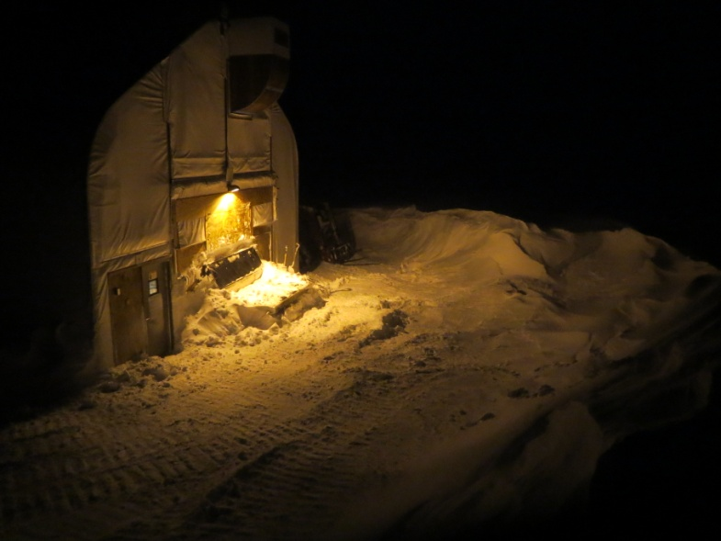Jennie Mowatt

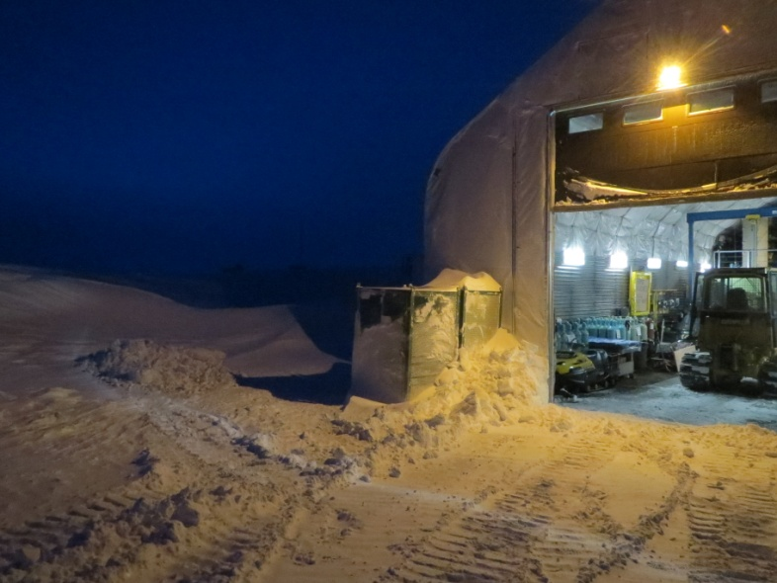

*High winds built up the bowl around the shop this week. JM*

**Significant Weather Observations:**

* 11/17: Overcast skies and blowing snow, 17 kts, -18C
* 11/18: Broken skies, 7 kts, -29C
* 11/19: Overcast and blowing snow, 30 kts, -22C
* 11/20: Overcast and blowing snow, 18 kts, -21C
* 11/21: Overcast and blowing snow, 33 kts, -18C
* 11/22: Overcast, 10 kts, -22C
* 11/23: Overcast and blowing snow, 23 kts, -21C

**Dataman Account:**

* Operating normally.

**MWR:**

* HATPRO: operating normally.
* 150-90: operating normally.
* 11/21: Power cycled radiometers due to comm error. Restarted data collection program at 1455Z. Likely caused by high winds.
* 11/22: Power cycled radiometers due to comm error. Restarted data collection program at 1257Z.

**SODAR:**

* Operating normally.
* Dishes cleaned at 1342-1348Z.

**POSS:**

* Operating normally.

**MMCR:**

* Operating normally.

**CAPABL:**

* Offsite as of 8/19.
* Continuing to monitor water storage system during winter.

**MPL:**

* Operating normally.

**VCEIL:**

* Operating normally.

**Hotplate:**

* Operating normally.

**IceCAM:**

* Operating normally.

**PAERI:**

* Operating normally
* 11/17: Partial blue flags found during rounds, graphs reading Data is null. Rebooted computer at 1304Z.
* 11/22: Partial blue flags during rounds.
* 11/23: Solid blue flags on all. Restarted computer at 1302Z. Data collection restarted at 1306Z. Flags still solid blue at that time.

**ASIA-A:**

* Operating normally.
* 11/18: Time absent from data collection window. Rebooted computer at 1235Z. Data collection restarted at 1241Z.

**TSI:**

* Offline and stored in MSF for winter.

**IcePIC:**

* No pics taken this week.

**MASC:**

* Offsite as of 8/13.

**Radiosonde:**

* Twice daily sondes.
* 11/21: AM balloon failed during launch due to 40 kt winds.