# ICECAPS Weekly Report

Nov 24-30, 2014

Jennie Mowatt

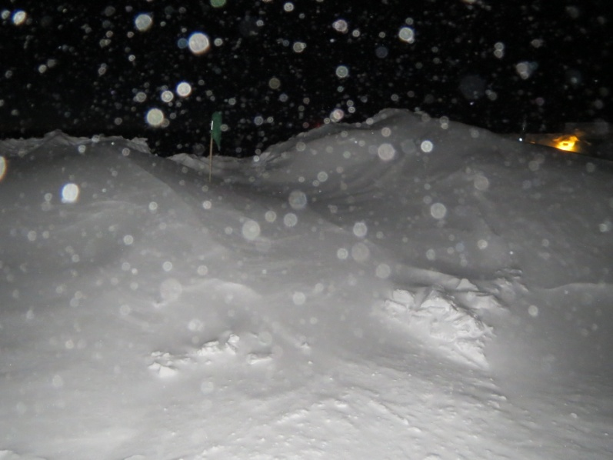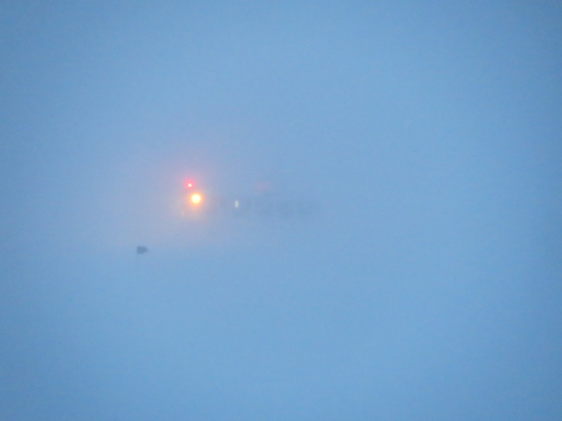

*Heavy winds continued to plague Summit this week. The Green House will require a bit of digging out. JM*

**Significant Weather Observations:**

* 11/24: Overcast and blowing snow, 24 kts, -19C
* 11/25: Broken clouds, 7 kts, -31C
* 11/26: Freezing fog, 13 kts, -38C
* 11/27: Clear skies, 6 kts, -50C
* 11/28: Overcast and blowing snow, 24 kts, -25C
* 11/29: Overcast and blowing snow, 31 kts, -19C
* 11/30: Broken clouds, 12 kts, -40C

**Dataman Account:**

* Operating normally.

**MWR:**

* HATPRO: operating normally.
* 150-90: operating normally.
* 11/25: Small fans on underside of both MWRs found non-functional.

**SODAR:**

* Operating normally.

**POSS:**

* Operating normally.

**MMCR:**

* Operating normally.

**CAPABL:**

* Offsite as of 8/19.
* Continuing to monitor water storage system during winter.

**MPL:**

* Operating normally.
* Afterpulse calibration performed. Data collection restarted at 1306Z.
* 11/25: MPL mount down overnight. Data did not transfer. Data fully transferred on 11/26.

**VCEIL:**

* Operating normally.

**Hotplate:**

* Operating normally.

**IceCAM:**

* Operating normally.

**PAERI:**

* Operating normally

**ASIA-A:**

* Operating normally.
* 11/29: Found time frozen on data collection window. Restarted computer and radiometer at 1250Z. Data collection restarted at 1302Z.

**TSI:**

* Offline and stored in MSF for winter.

**IcePIC:**

* No pictures taken this week.

**MASC:**

* Offsite as of 8/13.

**Radiosonde:**

* Twice daily sondes.
* 11/28: The evening balloon did not go off due to a buried garage door and high winds.