# ICECAPS Weekly Report

Nov 3-9, 2014

Jennie Mowatt

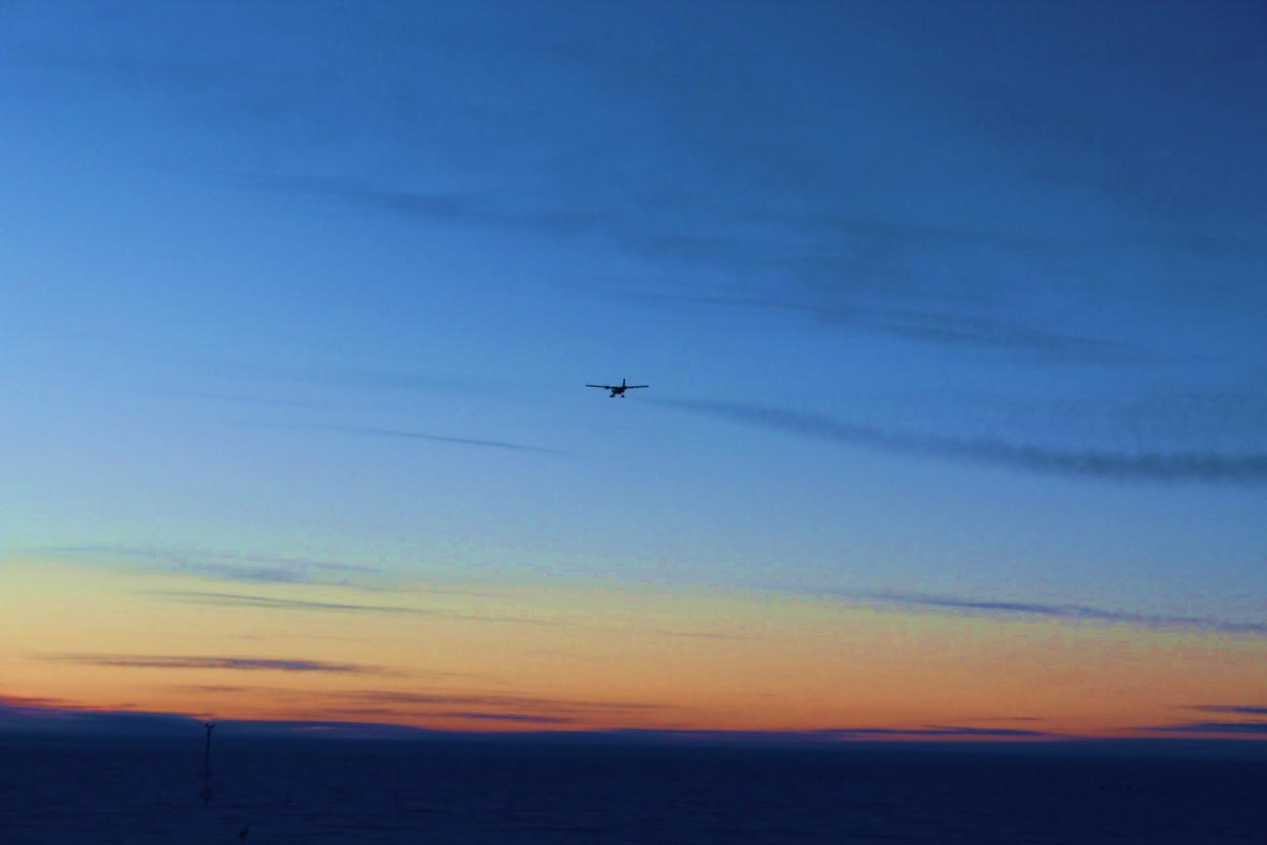

*Twin Otter departs on 11/8 after dropping off repaired TWTA component. JM*

**General:**

* The repaired TWTA arrived via Twin Otter on 11/7. It will be reinstalled and brought back online next week.

**Significant Weather Observations:**

* 11/3: Clear skies, 12 kts, -41C
* 11/4: Few clouds, 14 kts, -39C
* 11/5: Scattered clouds, 8 kts, -46C
* 11/6: Few clouds, 9 kts, -50C
* 11/7: Scattered clouds, 12 kts, -45C
* 11/8: Clear skies, 8 kts, -48C
* 11/9: Scattered skies, 7 kts, -42C

**Dataman Account:**

* Operating normally.

**MWR:**

* HATPRO: operating normally.
* 150-90: operating normally.

**SODAR:**

* Operating normally.

**POSS:**

* Operating normally.

**MMCR:**

* Offline as of 9/6.

**CAPABL:**

* Offsite as of 8/19.
* Continuing to monitor water storage system during winter.

**MPL:**

* Operating normally.

**VCEIL:**

* Operating normally.

**Hotplate:**

* Operating normally.

**IceCAM:**

* Operating normally

**PAERI:**

* Operating normally

**ASIA-A:**

* Operating normally.
* The camera focus needs to be adjusted but temperatures remain too cold so this is being put on hold until it warms back up to the -40s.

**TSI:**

* Offline and stored in MSF for winter.

**IcePIC:**

* No pics taken this week.

**MASC:**

* Offsite as of 8/13.

**Radiosonde:**

* Twice daily sondes.