# ICECAPS Weekly Report

Oct 13-19, 2014

Jennie Mowatt

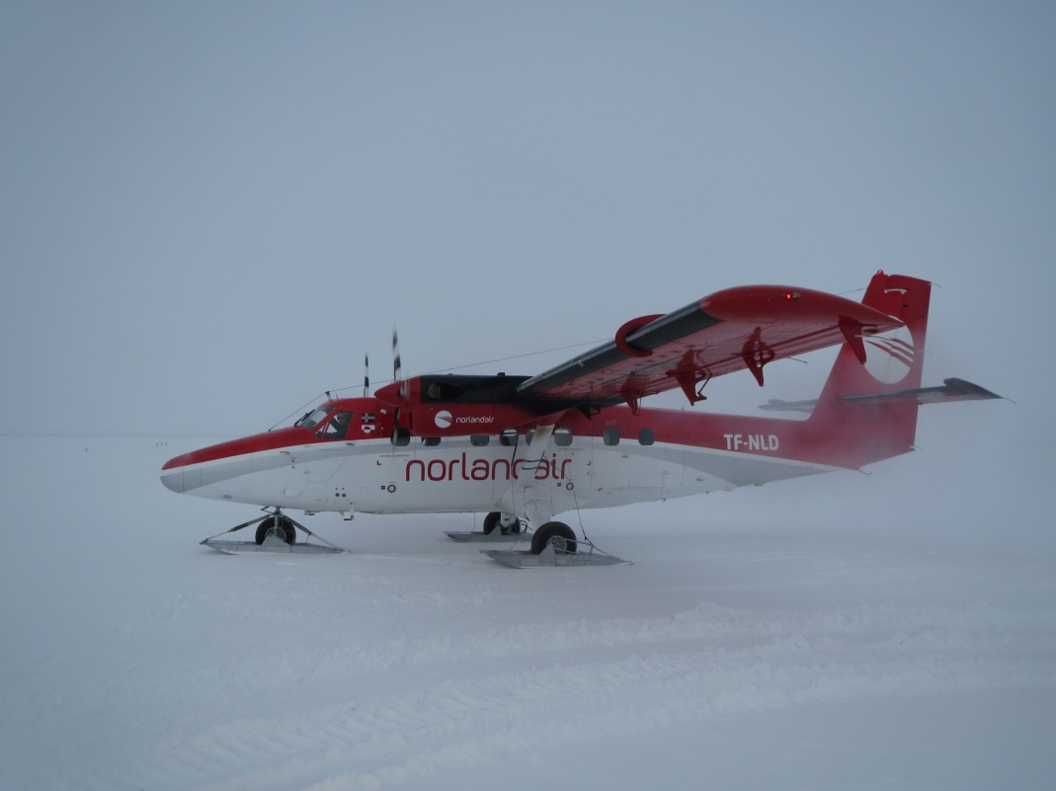

*Outgoing summer crew flight. 10/17/14*

**General:**

* 10/15: Station wide power outage/switch to E-Gen performed for mechanic turnover. Started at 1212Z, completed at 1226Z. Brief data interruptions to POSS during that window.

**Significant Weather Observations:**

* 10/13: Freezing fog, 8kts, -35C
* 10/14: Overcast, 6kts, -27C
* 10/15: Some freezing fog on the horizon, 3kts, -35C
* 10/16: Light freezing fog, 0kts, -45C
* 10/17: Freezing fog, 12kts, -40C
* 10/18: Freezing fog, 8kts, -34C
* 10/19: Few clouds, 1kts, -40C

**Dataman Account:**

* Operating normally.
* Irregularities noted during routine check of spot_check_archive.sh. File appears to have dropped off after Sodar, despite all data to have seemingly transferred (To Boulder file is empty). Data was also transferred a day late i.e. 10/11 data transferred on 10/13, 10/12 was not added in as well.
* Error found in scripts and corrected by Shupe on 10/13. Any remaining data was pushed through at that time.
* 10/15, 1640Z: Dataman hard drive #1 swapped with #3. #1 packaged up in Pelican case to be sent back to Boulder with Matt O.

**MWR:**

* HATPRO: operating normally.
* 150-90: operating normally.

**SODAR:**

* Operating normally.

**POSS:**

* Operating normally.
* 10/13: Data collection stopped at 1224Z due to computer reboot. Restarted at 1248Z.
* 10/15: Brief data outages due to mechanic turnover of E-gen (1212-1226Z).

**MMCR:**

* Offline as of 9/6.

**CAPABL:**

* Offsite as of 8/19.
* Continuing to monitor water storage system during winter.

**MPL:**

* Operating normally.
* Afterpulse calibration performed on 10/15. AMCS card timeout initiated after screwing lid onto laser. Resolved by rebooting computer.

**VCEIL:**

* Operating normally.

**Hotplate:**

* Operating normally.

**IceCAM:**

* Operating normally

**PAERI:**

* Operating normally
* 10/15: Fan found dead during rounds due to seized bearings. Replaced entire fan assembly and reinstalled at 1258Z.
* 10/15: New 1A fuse replaced old 1A fuse (was not burnt out but done as a precautionary). Fan offline from 1905-1910Z.

**ASIA-A:**

* Operating normally.

**TSI:**

* Offline and stored in MSF for winter.

**IcePIC:**

* No pics taken this week.

**MASC:**

* Offsite as of 8/13.

**Radiosonde:**

* Twice daily sondes.