# ICECAPS Weekly Report

Oct 20-26, 2014

Jennie Mowatt

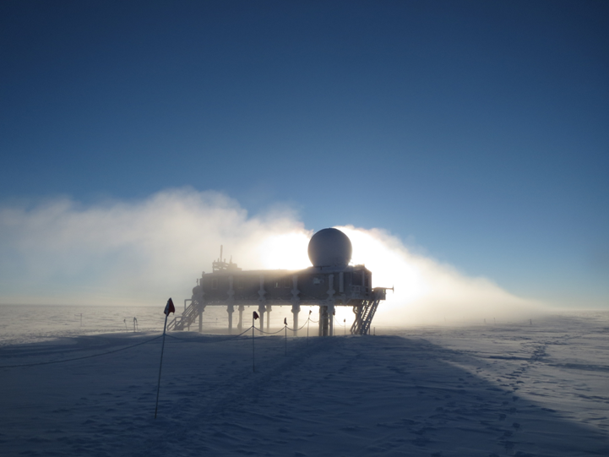

*North winds were prominent this week.*

**Significant Weather Observations:**

* 10/20: Clear skies, 8 kts, -43C
* 10/21: Clear skies, 14 kts, -52C
* 10/22: Broken skies, 8 kts, -34C
* 10/23: Few clouds, 10 kts, -42C
* 10/24: Few clouds, 6 kts, -45C
* 10/25: Overcast and fog, 6 kts, -29C
* 10/26: Scattered skies, 14 kts, -35C

**Dataman Account:**

* Operating normally.

**MWR:**

* HATPRO: operating normally.
* 150-90: operating normally.
* 10/21: “Slave elevation mirror does not respond! Timeout period (15 seconds) expired…” message appeared during rounds. Terminated running batch and power cycled 150-90 (1215Z). Restarted data collection at 1217Z.

**SODAR:**

* Operating normally.

**POSS:**

* Operating normally.

**MMCR:**

* Offline as of 9/6.

**CAPABL:**

* Offsite as of 8/19.
* Continuing to monitor water storage system during winter.

**MPL:**

* Operating normally.

**VCEIL:**

* Operating normally.

**Hotplate:**

* Operating normally.

**IceCAM:**

* Operating normally

**PAERI:**

* Operating normally

**ASIA-A:**

* Operating normally.

**TSI:**

* Offline and stored in MSF for winter.

**IcePIC:**

* No pics taken this week.

**MASC:**

* Offsite as of 8/13.

**Radiosonde:**

* Twice daily sondes.
* 10/26: Daylight savings for Greenland. Balloons now launched at 0815 and 2015 Summit time.