# ICECAPS Weekly Report

Oct 27- Nov 2, 2014

Jennie Mowatt

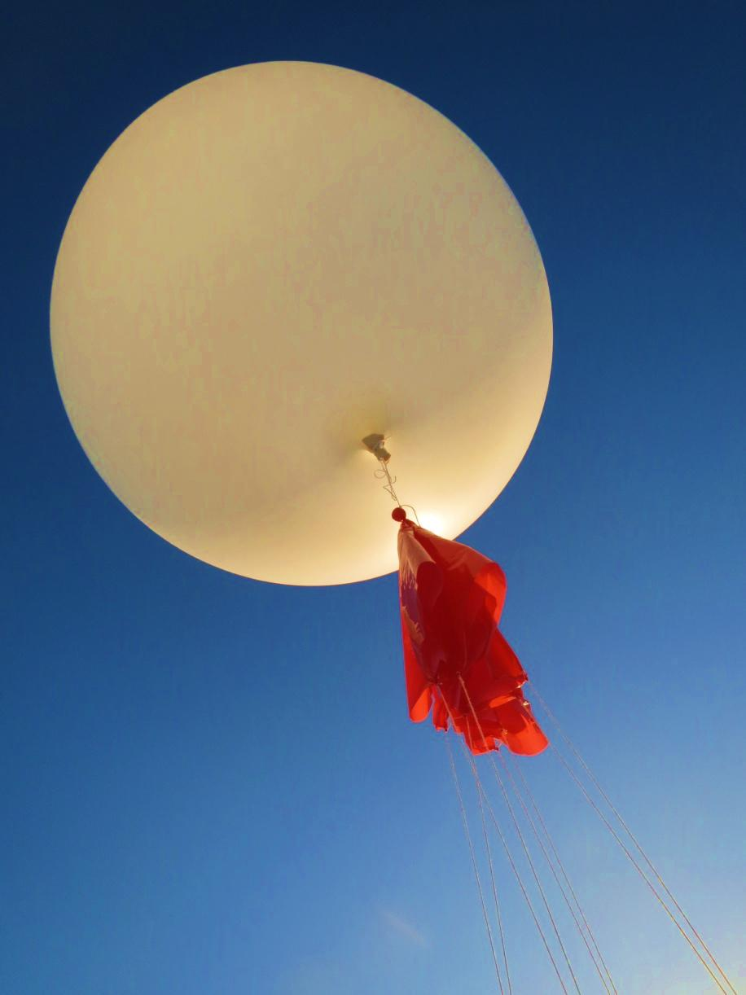

*Launches during daylight are dwindling. JM*

**Significant Weather Observations:**

* 10/27: Freezing fog, 14 kts, -26C
* 10/28: Scattered skies, some fog, 4 kts, -36C
* 10/29: Freezing fog, 0 kts, -30C
* 10/30: Scattered skies, 4 kts, -40C
* 10/31: Broken skies, 4 kts, -37C
* 11/1: Freezing fog on the horizon, 0 kts, -38C
* 11/2: Few clouds, fog on the horizon, 0 kts, -38C

**Dataman Account:**

* Operating normally.

**MWR:**

* HATPRO: operating normally.
* 150-90: operating normally.

**SODAR:**

* Operating normally.

**POSS:**

* Operating normally.

**MMCR:**

* Offline as of 9/6.

**CAPABL:**

* Offsite as of 8/19.
* Continuing to monitor water storage system during winter.

**MPL:**

* Operating normally.
* 10/27: Afterpulse calibration started at 1327Z. Data collection restarted at 1340Z.
* 11/1: “Out of storage buffers” message appeared during morning rounds. Rebooted computer at 1300Z and error was cleared.

**VCEIL:**

* Operating normally.

**Hotplate:**

* Operating normally.

**IceCAM:**

* Operating normally

**PAERI:**

* Operating normally
* 10/29: Partial blue flags found on all windows.
* 10/31: Mirror required cleaning and Encoder Scene Confirm flag was set off. Following protocol fan was removed until green flag reappeared, then returned to enclosure. PC was rebooted at 1412Z. Data collection returned at 1419Z. Partial blue flags were also present during rounds but may be been due to errors with Summit server.

**ASIA-A:**

* Operating normally.

**TSI:**

* Offline and stored in MSF for winter.

**IcePIC:**

* No pics taken this week.

**MASC:**

* Offsite as of 8/13.

**Radiosonde:**

* Twice daily sondes.