# ICECAPS Weekly Report

Oct 6-12, 2014

Jennie Mowatt

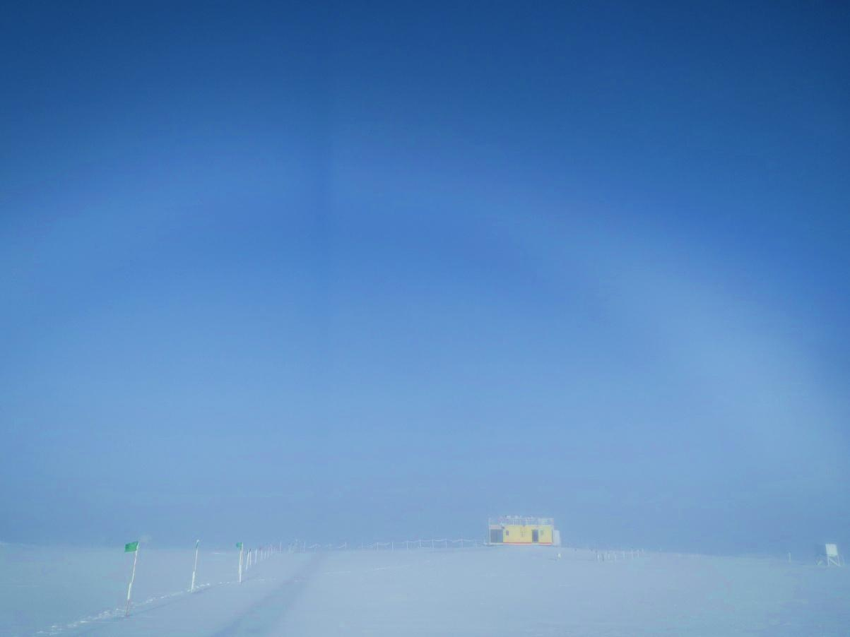

*Fogbow with the shadow of Swiss Tower intersecting it. 10/12/2014*

**Significant Weather Observations:**

* 10/6: Overcast skies and blowing snow, 17 kts, -19C
* 10/7: Overcast skies, 15 kts, -18C
* 10/8: Freezing fog, 10 kts, -27C
* 10/9: Freezing fog on the horizon, 9 kts, -27C
* 10/10: Overcast, 7kts, -21C
* 10/11: Some freezing fog on the horizon, 8 kts, -31C
* 10/12: Freezing fog, 10kts, -30C

**Dataman Account:**

* Operating normally.

**MWR:**

* HATPRO: operating normally.
* 150-90: operating normally.

**SODAR:**

* Operating normally.

**POSS:**

* Operating normally.

**MMCR:**

* Offline as of 9/6.
* TWTA shipped out on Oct. 9.

**CAPABL:**

* Offsite as of 8/19.
* Continuing to monitor water storage system during winter.

**MPL:**

* Operating normally.

**VCEIL:**

* Operating normally.

**Hotplate:**

* Operating normally.

**IceCAM:**

* Operating normally

**PAERI:**

* Operating normally

**ASIA-A:**

* Operating normally.
* Spares heaters arrived on Oct. 10.

**TSI:**

* Offline and stored in MSF for winter.

**IcePIC:**

* No pics taken this week.

**MASC:**

* Offsite as of 8/13.

**Radiosonde:**

* Twice daily sondes.
* Auxilary sonde sensors arrived on Oct. 10.