# ICECAPS Weekly Report

Sep 15 – Sep 21, 2014

Jennie Mowatt

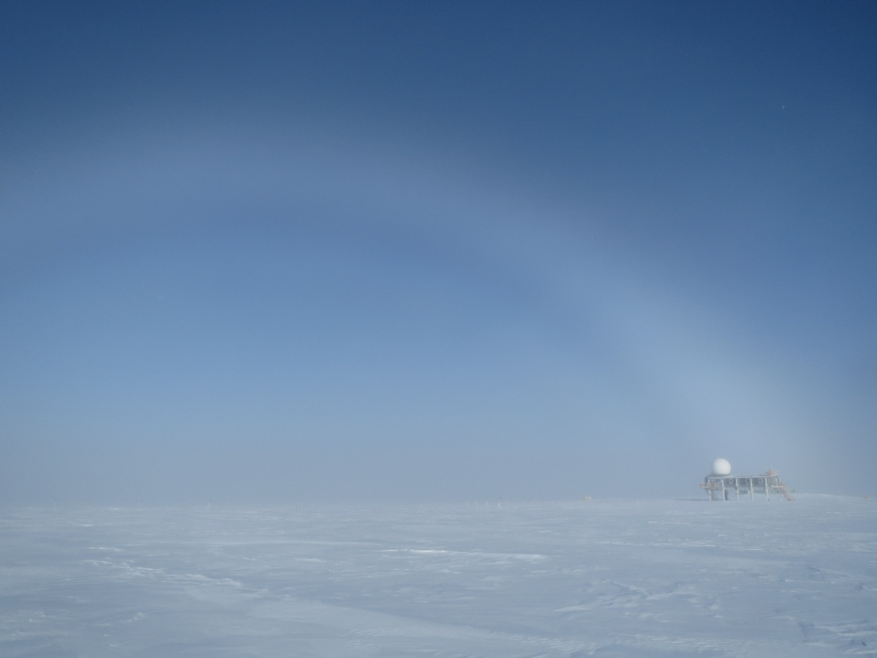

*Fogbow on 9/20/14.*

**Significant Weather Observations:**

* 9/15: Scattered skies, 11kt winds, -25C
* 9/16: Scattered skies, 12kt, -27C
* 9/17: Broken skies, 6kts, -27C
* 9/18: Clear skies, 10kts, -28C
* 9/19: Generally clear with some lingering fog, 11kts, -23C
* 9/20: Freezing fog clearing into sun, 8kts, -22C
* 9/21: Overcast and blowing snow, 17kts, -16C

**Dataman Account:**

* Operating normally.

**MWR:**

* HATPRO: operating normally.
* 150-90: operating normally.

**SODAR:**

* Operating normally.
* 9/16: Sodar cables raised for winter.

**POSS:**

* Operating normally.
* Plans to raise box and cables when weather permits.
* Unscheduled reboot on 9/20 @ 1223Z.

**MMCR:**

* Offline as of 9/6. Plans are to ship out TWTA component on Oct. 9 outgoing Twin Otter for repair. Wooden crate has been pulled off of berm and packing is in process.

**CAPABL:**

* Offsite as of 8/19.
* Continuing to monitor water storage system during winter.

**MPL:**

* Operating normally.
* 9/16: Found frozen at 0538Z from with AMCS timeout. Rebooted computer and software at 1210Z, data collection restarted after Afterpulse calibration at 1250Z.

**VCEIL:**

* Operating normally.

**Hotplate:**

* Operating normally.
* Plans to raise box and cables when weather permits.

**IceCAM:**

* Operating normally

**PAERI:**

* Operating normally

**ASIA-A:**

* Operating normally.
* 9/16: Found screen frozen on 0558Z. Computer rebooted and radiometer cycled at 1215Z. Data collection recommenced at 1220Z.

**TSI:**

* Operating normally.
* 9/15: Lost communication found during rounds. Could not reestablish.
* Taken offline for winterization and removed from roof on 9/16.

**IcePIC:**

* Pics taken on 9/19 and uploaded to ftp.

**MASC:**

* Offsite as of 8/13.

**Radiosonde:**

* Twice daily sondes.