# ICECAPS Weekly Report

Sep 22 – Sep 28, 2014

Jennie Mowatt

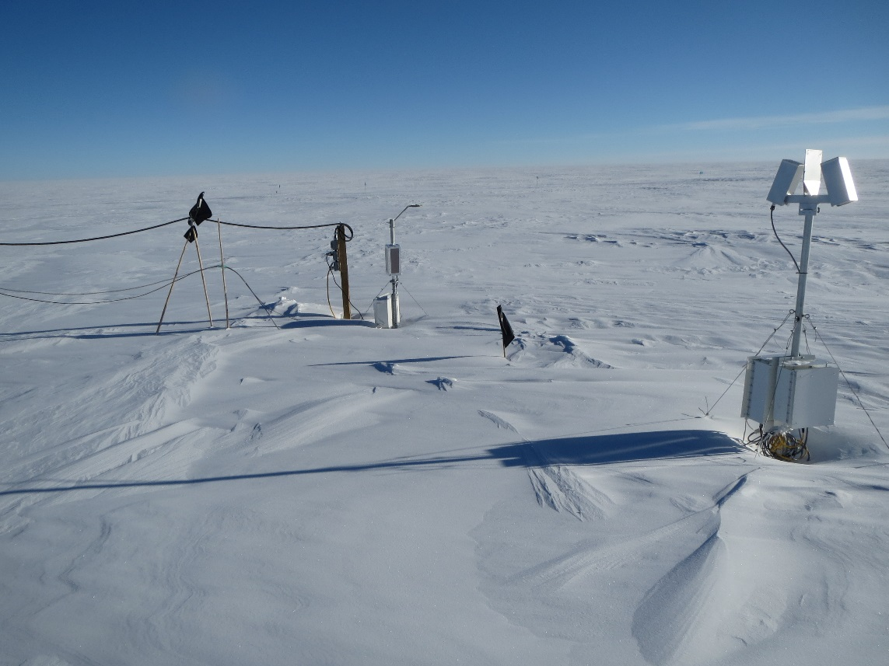

*Before*

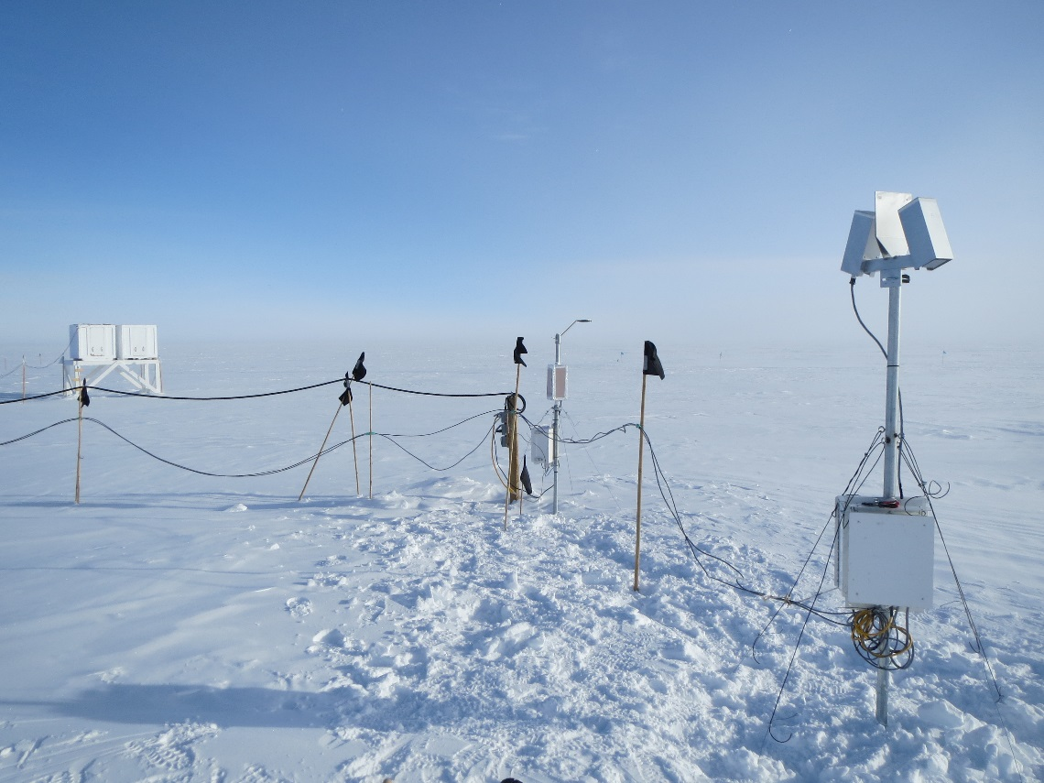

*After*

**Significant Weather Observations:**

* 9/22: Overcast and blowing snow, 14kts, -21C
* 9/23: Clear skies, 11kts, -25C
* 9/24: Broken skies, 25kts, -21C
* 9/25: Scattered skies, 9kts, -26C
* 9/26: Freezing fog, 10kts, -32C
* 9/27: Freezing fog, overcast, 4kts, -30C
* 9/28: Freezing fog, 11kts, -33C

**Dataman Account:**

* Operating normally.

**MWR:**

* HATPRO: operating normally.
* 150-90: operating normally.

**SODAR:**

* Operating normally.

**POSS:**

* Operating normally.
* 9/23: Brief power/data outage occurred from 1739-1850Z due to move of hotplate.
* 9/25: Stand and instrument raised. Data collection was offline from 1353-1413Z during move.

**MMCR:**

* Offline as of 9/6.
* TWTA has been packed in shipping crate and is ready to be shipped out on Oct. 9.

**CAPABL:**

* Offsite as of 8/19.
* Continuing to monitor water storage system during winter.

**MPL:**

* Operating normally.

**VCEIL:**

* Operating normally.

**Hotplate:**

* Operating normally.
* 9/23: Box and instrument stand raised. Brief power/data outage occurred from 1739-1850Z.

**IceCAM:**

* Operating normally

**PAERI:**

* Operating normally

**ASIA-A:**

* Operating normally.
* 9/25: Smaller fan next to blower found blocked with snow. Ran fine once snow was dug out but may need to find a snow deterrent/blockade in the future.

**TSI:**

* Offline and stored in MSF for winter.

**IcePIC:**

* No pics taken this week.

**MASC:**

* Offsite as of 8/13.

**Radiosonde:**

* Twice daily sondes.