# ICECAPS Weekly Report

Sep 29 – Oct 5, 2014

Jennie Mowatt

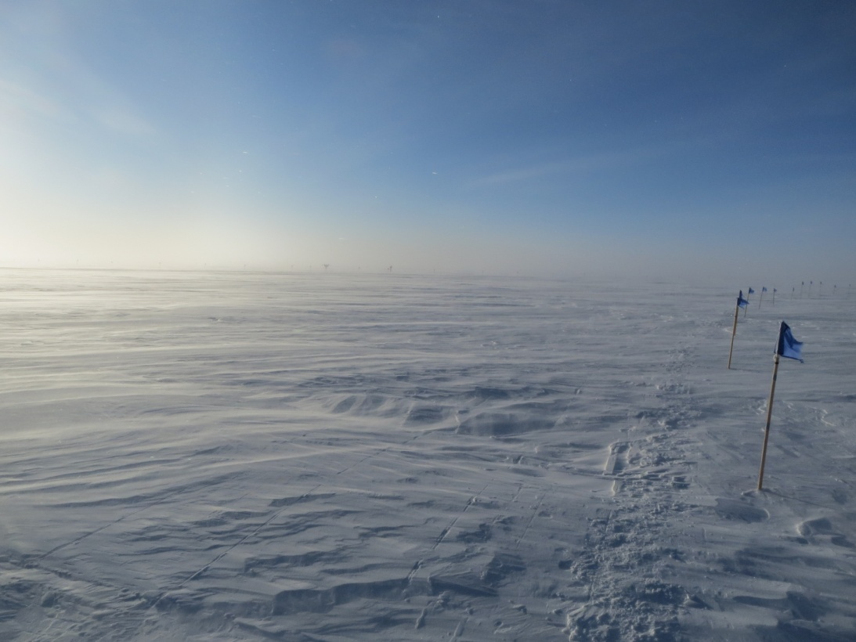

**Significant Weather Observations:**

* 9/29: Clear skies, 4kts, -35C
* 9/30: Scattered skies, light fog, 19kts, -24C
* 10/1: Broken skies and blowing snow, 17kts, -24C
* 10/2: Overcast skies, 15kts, -28C
* 10/3: Freezing fog on the horizon, 13 kts, -38C
* 10/4: Freezing fog, 17kts, -34C
* 10/5: Fog on the horizon, 10 kts, -29C

**Dataman Account:**

* Operating normally.

**MWR:**

* HATPRO: operating normally.
* 150-90: operating normally.

**SODAR:**

* Operating normally.

**POSS:**

* Operating normally.

**MMCR:**

* Offline as of 9/6.
* TWTA is ready to be shipped out on Oct. 9.

**CAPABL:**

* Offsite as of 8/19.
* Continuing to monitor water storage system during winter.

**MPL:**

* Operating normally.
* 10/4: Ground wire installed to combat AMCS card timeouts attributed to built up static.

**VCEIL:**

* Operating normally.

**Hotplate:**

* Operating normally.
* On windy days a timeout error appears. Instrument appears to remain connected during this time though.

**IceCAM:**

* Operating normally

**PAERI:**

* Operating normally

**ASIA-A:**

* Operating normally.
* 9/30: Data collection frozen. Computer and radiometer rebooted at 1215Z. Data collection restarted at 1225Z.

**TSI:**

* Offline and stored in MSF for winter.

**IcePIC:**

* No pics taken this week.

**MASC:**

* Offsite as of 8/13.

**Radiosonde:**

* Twice daily sondes.