ICECAPS Weekly Report

Sep 8 – Sep 14, 2014

Jennie Mowatt

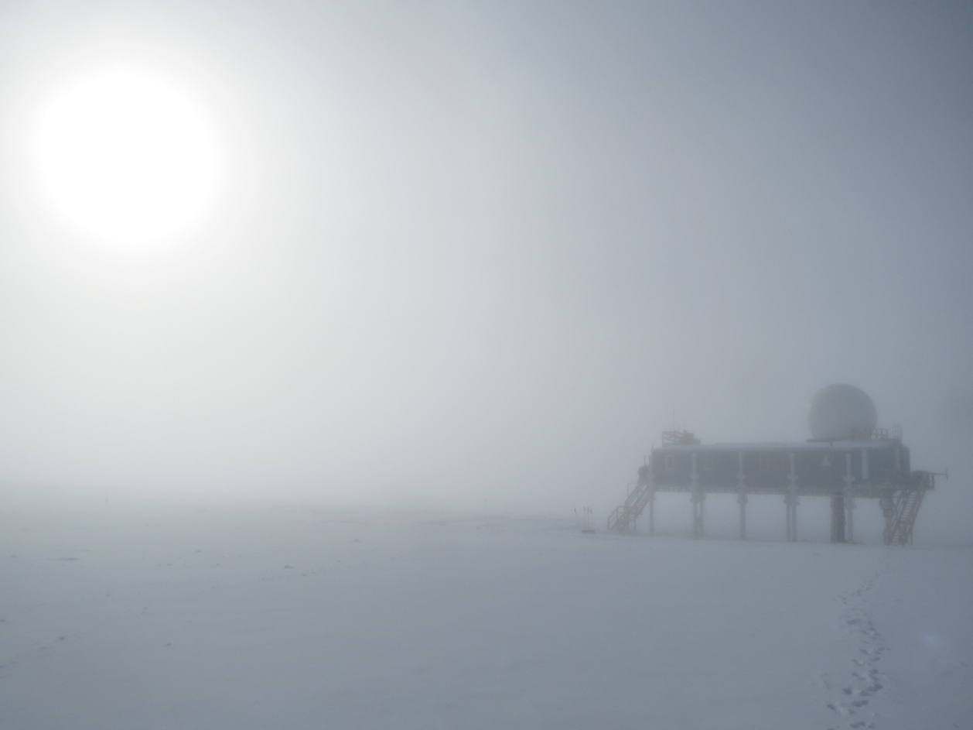

**Significant Weather Observations:**

* 9/8: Broken skies, 10kt winds, -19C
* 9/9: Broken skies, -17C
* 9/10: Freezing fog breaking into afternoon sun, 0kts, -19C
* 9/11: Overcast, drifting snow, 12kts, -19C
* 9/12: Overcast with drifting snow, 20-30kts, -26C
* 9/13: Scattered clouds, 5kts, -29C
* 9/14: Overcast, 14kts, -13C

**Dataman Account:**

* Operating normally.

**MWR:**

* HATPRO: operating normally.
* 150-90: operating normally.

**SODAR:**

* Operating normally.

**POSS:**

* Operating normally.
* Plans to raise box and cables when weather permits.

**MMCR:**

* Offline as of 9/6. PI is currently looking into shipping TWTA out during October turnover for repairs.

**CAPABL:**

* Offsite as of 8/19.
* Continuing to monitor water storage system during winter.

**MPL:**

* Operating normally.
* 9/14: Found frozen at 2220Z from previous day with AMCS timeout. Rebooted computer and software at 1336Z, data collection restarted.

**VCEIL:**

* Operating normally.

**Hotplate:**

* Operating normally.
* Plans to raise box and cables when weather permits.

**IceCAM:**

* Operating normally

**PAERI:**

* Operating normally

**ASIA-A:**

* Operating normally.
* 9/13: Found screen frozen on 1614Z from the day before. Computer rebooted and radiometer cycled at 1215Z. Data collection recommenced at 1234Z.

**TSI:**

* Operating normally.
* Temperatures gradually getting lower, winterization is imminent.

**IcePIC:**

* Pics taken and uploaded to ftp on 9/8.

**MASC:**

* Offsite as of 8/13.

**Radiosonde:**

* Twice daily sondes.