# ICECAPS Weekly Report

April 13 - 19, 2015

Sam Dorsi

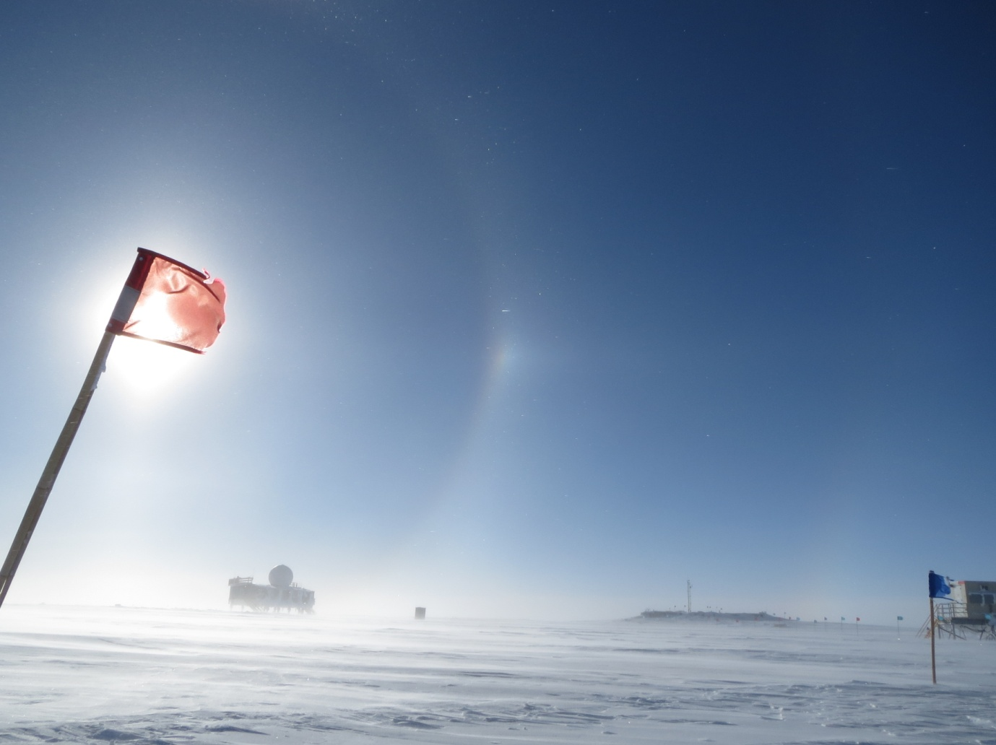

**Halos at 22 and 46 degrees appear during a break in the wind on 4/16. --SWD**

**General:**

* 4/15: Strong winds and low visibility curtailed station operations. Travel on station was limited to Green House and Big House.
* 4/19: Again due to strong winds, travel was limited to Green House and Big House.

**Significant Weather Observations:**

* 4/13: Blowing snow, heavy rime, 14 kts -38C
* 4/14: Blowing snow, 18 kts, -33C
* 4/15: Blowing snow, 31 kts, -17C
* 4/16: Blowing snow, 25 kts, -24C
* 4/17: Blowing snow, 22 kts, -22C
* 4/18: Broken altostratus, 12 kts, -31C
* 4/19: Blowing snow, 35 kts, -14C

**Dataman Account:**

* Operating normally.

**MWR:**

* HATPRO: operating normally.
* 150-90: operating normally.

**SODAR:**

* Operating normally.

**POSS:**

* Operating normally.
* 4/15: POSS data acquisition reporting no data received (13:11z).
* 4/16 Circuit breaker to POSS/hotplate power pole found tripped. External outlet cleaned and power restored at 12:04z. Data acquisition resumed at 12:06z.
* 4/16: POSS acquisition reports “max noise limit” errors, starting at time of reboot and continuing for 7 minutes.
* 4/16: POSS data collection interrupted by an unknown error, simultaneous to error at hotplate, which shares the external power pole. Breaker is not tripped. POSS acquisition software closed and restarted 17:08z.

**MMCR:**

* Operating normally.

**CAPABL:**

* Offsite as of 8/19.
* Continuing to monitor water storage system during winter.

**MPL:**

* Operating normally during low wind periods, but encountering frequent errors during wind
* MPL afterpulse calibration delayed due to instrument instability.
* 4/15: High winds caused repeated AMCS card errors. Errors were triggered at 09:37, 11:59, 12:07, and 12:11z. Instrument left in standby mode to wait for weather to improve.
* 4/16: Continued high winds causing AMCS card errors. Errors were triggered at 12:02, 12:10, 12:15, 12:48, 12:52, 13:03, and 18:33z.
* 4/17: As winds had lessened somewhat (20 kts), tried rebooting MPL at 12:25z. Encountered AMCS card error in less than one minute, and left in standby.
* 4/18: Amid lower morning winds (13 kts), the MPL, which has been on standby, was rebooted at 12:14z, with data collection resuming at 12:16z.

**VCEIL:**

* Operating normally.

**Hotplate:**

* Operating normally.
* 4/15: Hotplate acquisition found with ‘undecipherable string’ error at 11:11z. Data collection resumed 11:57z.
* 4/15: Hotplate acquisition reports ‘timeout expired before operation complete’ error and ceases data collection (likely ~13:11z, when POSS acquisition lost signal as well).
* 4/16: Circuit breaker to POSS/hotplate power pole found tripped. External outlet cleaned and restored (breaker reset) at 12:04z. Data collection resumed at 12:14z.
* 4/16: Hotplate acquisition reports ‘timeout expired before operation complete’ error and ceases data collection (16:11z). POSS has simultaneous issue, but breaker is not tripped. Data collection resumed 17:06z.
* 4/19: Hotplate acquisition reports ‘timeout expired before operation complete’ error and ceases data collection (04:53z). Data collection resumed 14:00z.

**IceCAM:**

* Operating normally.

**PAERI:**

* Operating normally.

**ASIA-A:**

* Offline until summer due to broken radio component.

**TSI:**

* Offline and stored in MSF for winter.

**IcePIC:**

* No photos taken

**Radiosonde:**

* Twice daily sondes.
* 4/16: Sounding at 00z was not attempted due to weather conditions, by request of station manager.
* 4/18: Sounding at 12z contacted surface after release.