# ICECAPS Weekly Report

April 20 - 26, 2015

Sam Dorsi

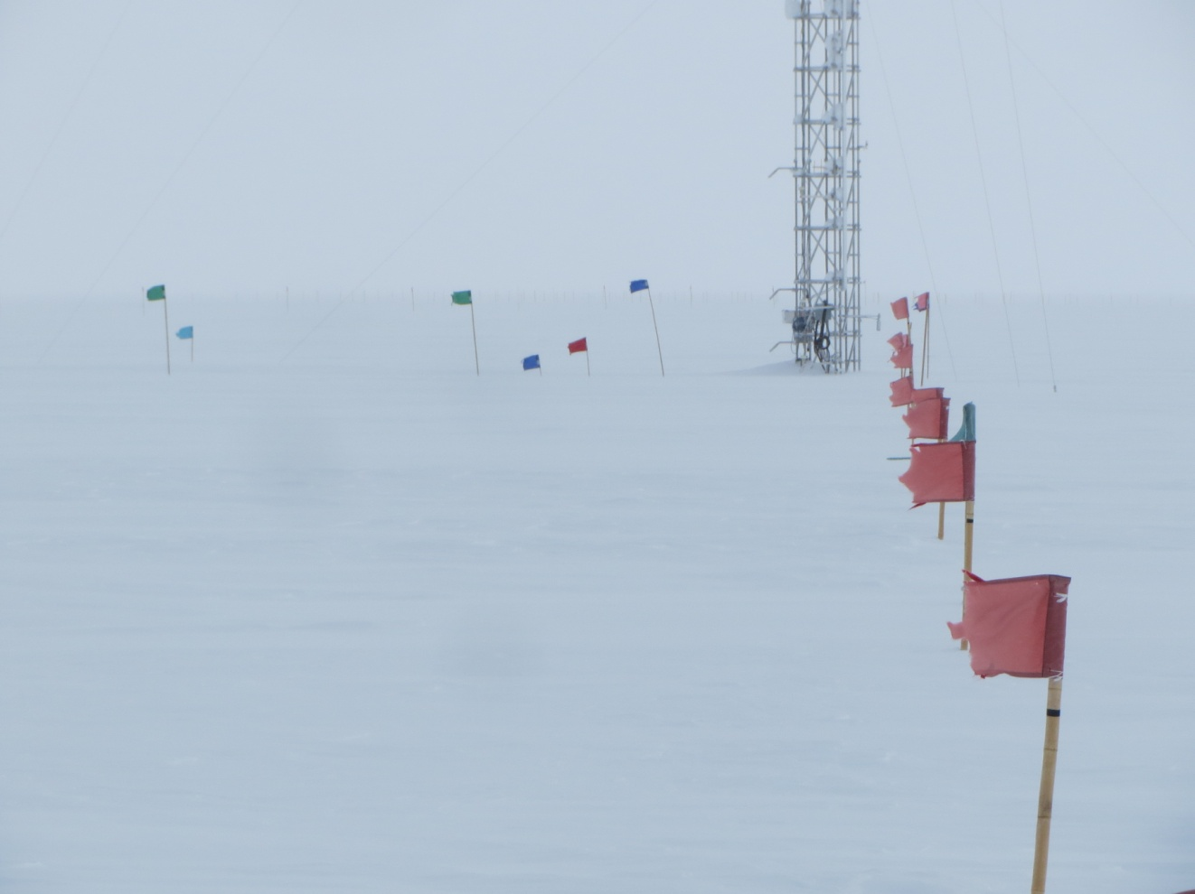

**The flag line from Swiss Solar to Swiss Tower snaps in the east wind. --SWD**

**General:**

* None

**Significant Weather Observations:**

* 4/20: Overcast stratus, 16 kts, -15C
* 4/21: Blowing snow, 19 kts, -30C
* 4/22: Scattered stratus, 10 kts, -36C
* 4/23: Few stratus, 12 kts, -38C
* 4/24: Few stratus, 17 kts, -34C
* 4/25: Blowing snow, 23 kts, -32C
* 4/26: Few stratus, 14 kts, -35C

**Dataman Account:**

* Operating normally.

**MWR:**

* HATPRO: operating normally.
* 150-90: operating normally.
* 4/25: Error message discovered at 12:12z in MWR RGP-HATPRO software: “No Response. Slave elevation mirror does not respond! Timeout period (15 seconds) expired…” Computer time is 5:14 behind true UTC time. Rebooted by PI request. Data collection resumed at 13:11z.

**SODAR:**

* Operating normally.
* 4/20: Updated protocol with photograph and instructions on how to prevent binding of the access hatch.

**POSS:**

* Operating normally.

**MMCR:**

* Operating normally.
* 4/23: At 12z, error log file reports that ‘Could not read calibration table NetCDF file.’
* 4/24: At 12z, error log file reports that ‘Could not read calibration table NetCDF file.’
* 4/25: “File not found” error reported in LabView software during receiver cal. Discovered at 12:20z. Error cleared at 23:00z.
* 4/26: At 12z, error log file reports that ‘Could not read calibration table NetCDF file.’

**CAPABL:**

* Offsite as of 8/19.
* Continuing to monitor water storage system during winter.

**MPL:**

* Operating normally.
* 4/20: AMCS card error; MPL rebooted and data collection resumed at 11:17z.
* 4/20: MPL afterpulse calibration performed from 14:35 to 14:56z. Data collection resumed at 15:00z.

**VCEIL:**

* Operating normally.

**Hotplate:**

* Operating normally.
* 4/25: Error occurred at 12:17z: “Timeout expired before operation completed.” Data collection resumed at 12:42z.
* 4/25: Error occurred again at 15:25z: “Timeout expired before operation completed.” Data collection resumed at 23:08z.

**IceCAM:**

* Operating normally.

**PAERI:**

* Operating normally.
* 4/20: Von had reported evidence of snow on mirror surface on prior day (4/19), but no travel was permitted on station that day. While the problematic snow had cleared itself during the night, the PAERI mirror was cleaned of a small snow spot (area 1 cm^2) at 11:02z.
* 4/22: In response to a message from Von alerting tech to red flags for SW and LW Responsivity, the PAERI mirror was cleaned at 00:15z.
* 4/25: In strong northerly winds, “SW Responsivity“ and “LW Responsivity” errors reported on PAERI; scene mirror cleaned at 12:48z.
* 4/25: Again, “SW Responsivity“ and “LW Responsivity” errors reported on PAERI; scene mirror cleaned at 14:59z.

**ASIA-A:**

* Offline until summer due to broken radio component.

**TSI:**

* Offline and stored in MSF for winter.

**IcePIC:**

* No photos taken

**Radiosonde:**

* Twice daily sondes.
* 4/23-12z and 4/24-0z: Relative humidity in base station was outside of 0.2 % limit, likely due to improperly sealed replacement desiccant jar. Base station humidity returned to within normal limits after desiccant was recharged in oven.
* 4/26: Radiosonde table cleaned with alcohol, protective tarp replaced, and balloon-use-only signs moved to prominent locations.