# ICECAPS Weekly Report

April 27 – May 3, 2015

Sam Dorsi

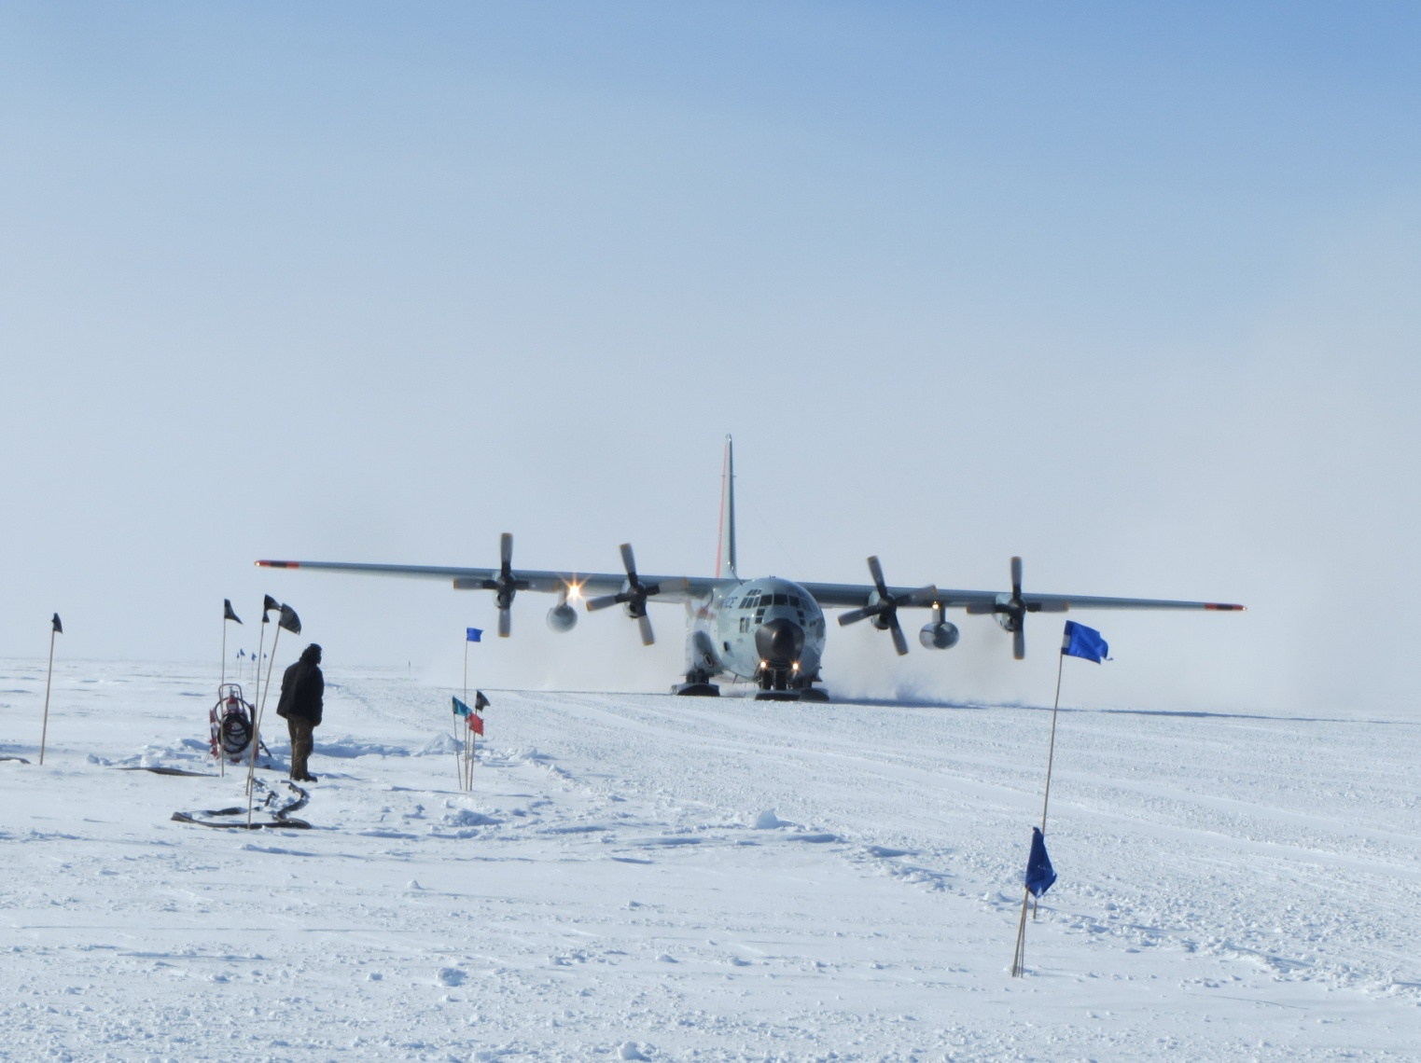

**The first flight of the season arrives at Summit. --SWD**

**General:**

* 4/28: First flight of the season arrived, with ICECAPS passengers Martin-Cocher, Neely, Stillwell and Wilmott. Replacement MPL cable and liquid nitrogen dewar brought in.

**Significant Weather Observations:**

* 4/27: Scattered stratus, 13 kts, -33C
* 4/28: Scattered stratus, 7 kts, -35C
* 4/29: Few stratus, 5 kts, -36C
* 4/30: Few stratus, 10 kts, -34C
* 5/1: Few stratus, 11 kts, -34C
* 5/2: Scattered stratus, 11 kts, -35C
* 5/3: Broken stratus, 12 kts, -35C

**Dataman Account:**

* Operating normally.

**MWR:**

* HATPRO: operating normally.
* 150-90: operating normally.
* 4/28: Communication error registered in MWR HATPRO software: “Communication problem with radiometer detected!” Radiometers were rebooted by PI request, and data collection resumed at 16:59z.
* 4/28: Liquid nitrogen dewar arrived on LC-130 flight
* 4/29: First round of liquid nitrogen calibrations performed of HATPRO, 150/90 and ‘internal-external flop’ batch file. HATPRO calibration completed at 15:11z. Internal-external flop completed at 15:52z. The 150/90 calibration completed at 16:52z.
* 4/30: Second round of liquid nitrogen calibrations performed. HATPRO calibration completed at 16:12z. Internal-external flop completed at 16:33z.
* 5/1: Third round of liquid nitrogen calibrations performed. HATPRO calibration completed at 13:22z. Internal-external flop completed at 13:44z.
* 5/2: Fourth round of liquid nitrogen calibrations performed. HATPRO calibration completed at 16:09z. Internal-external flop completed at 16:30z.

**SODAR:**

* Operating normally.

**POSS:**

* Operating normally.

**MMCR:**

* Operating normally.
* 4/27: Rebooted MMCR at 12:06z, by PI request, to address pulse controller communication errors.

**CAPABL:**

* Offsite 19 Aug 2014 – 28 Apr 2015.
* Stillwell working on re-installation.

**MPL:**

* Operating normally.
* 4/30: AMCS card error at 16:58z. Data collection resumed at 12:04z on 5/1.

**VCEIL:**

* Operating normally.

**Hotplate:**

* Operating normally.

**IceCAM:**

* Operating normally.

**PAERI:**

* Operating normally.

**ASIA-A:**

* Martin-Cocher onsite to disassemble, package and ship ASIA-A to Germany for repair.
* 4/30: ASIA-A shipped out from Summit.

**TSI:**

* Offline and stored in MSF for winter.

**IcePIC:**

* No photos taken

**Radiosonde:**

* Twice daily sondes.
* 5/1: Sounding at 12z was launched with a U. Reading ionization sensor, as the second test requested by Von. For this iteration, metal tape was applied to the extra sensor package, and window cleaner was applied to both the radiosonde and extra sensor packages. PI Nicholls reported that the sounding was a success.

**Doppler Wind Lidar:**

* 4/30: Installed and operational on MSF roof.

**MASC:**

* 5/1: MASC installed and operational on stand near hotplate.