# ICECAPS Weekly Report

April 6 - 12, 2015

Sam Dorsi

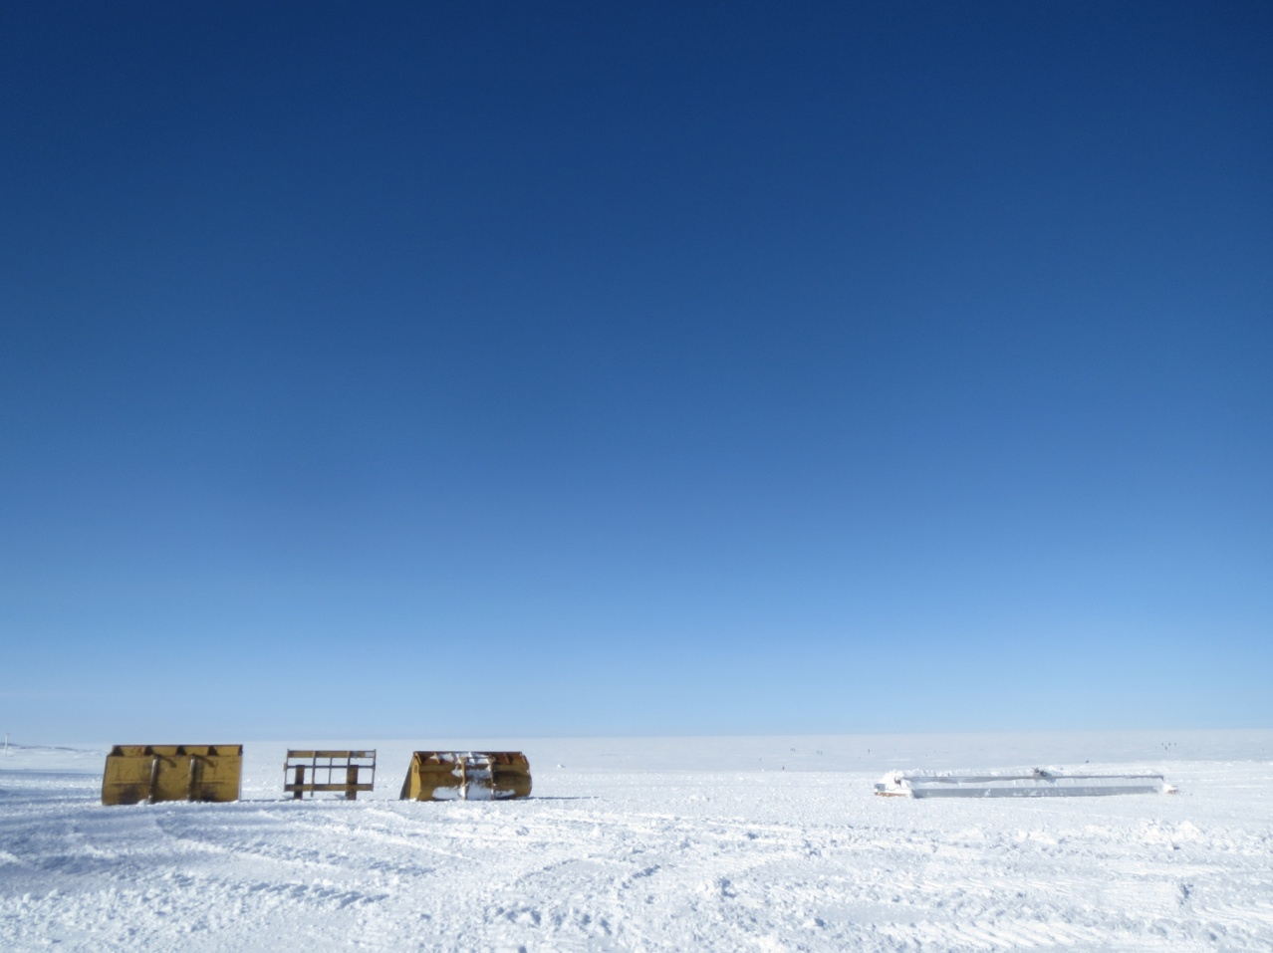

**Brilliant cold spring skies for the U. Reading ion sensor test launch. --SWD**

**General:**

* None.
* 4/6: Network connectivity was lost to MSF during the late afternoon or evening. This outage was discovered at about 23:10z, and affected the connection to the Summit server, connections to the outside world, and the VOIP phone system. At roughly 00:30z, the connectors were reseated at the RF-to-Ethernet modem and at the Poly-Phaser grounding/fuse block. The pitch of the MSF directional antenna was also lowered by about 5 degrees. These changes restored the data connection. Radiosonde messages and data upload to Boulder were unaffected.
* 4/7: The MSF directional antenna was aligned at 17:50z. This was performed by making incremental adjustments in the antenna angle, while over the radio, Phil reported antenna S:N ratios from the radio-modem system. Network connection was uninterrupted.

**Significant Weather Observations:**

* 4/6: Blowing snow, 22 kts, -26C
* 4/7: Broken stratocumulus, 4 kts, -33C
* 4/8: Few stratus, 2 kts, -40C
* 4/9: Scattered altostratus, 10 kts, -42C
* 4/10: Few stratus, 6 kts, -47C
* 4/11: Few stratus, 7 kts, -45C
* 4/12: Scattered stratus, 9 kts, -43C

**Dataman Account:**

* Operating normally.
* 4/6: ‘Lost connection’ errors appeared during nightly download. While a portion of the uploads had completed before this error, data from the MMCR, MPL, hotplate, PAERI, POSS, SODAR and IceCam were not successfully uploaded.

**MWR:**

* HATPRO: operating normally.
* 150-90: operating normally.

**SODAR:**

* Operating normally.

**POSS:**

* Operating normally.

**MMCR:**

* Operating normally.

**CAPABL:**

* Offsite as of 8/19.
* Continuing to monitor water storage system during winter.

**MPL:**

* Operating normally.
* 4/6: At 22:46z, an AMCS card error was found to have occurred at 16:26z. Rebooted. Data collection resumed at 22:51z.

**VCEIL:**

* Operating normally.

**Hotplate:**

* Operating normally.

**IceCAM:**

* Operating normally.

**PAERI:**

* Operating normally.
* 4/10: Warm spike in PAERI observations at roughly 14:00z from tech entering instrument field of view.

**ASIA-A:**

* Offline until summer due to broken radio component.

**TSI:**

* Offline and stored in MSF for winter.

**IcePIC:**

* No photos taken

**Radiosonde:**

* Twice daily sondes.
* 4/6: During high-wind launches at 0z and 12z, the radiosonde contacted the ice surface after release.
* 4/8: Successful test launch of U. Reading ion sensor package at 15:01z. Additional sensor data sent to Keri Nicoll.