# ICECAPS Weekly Report

August 10-16, 2015

Clair Von Handorf

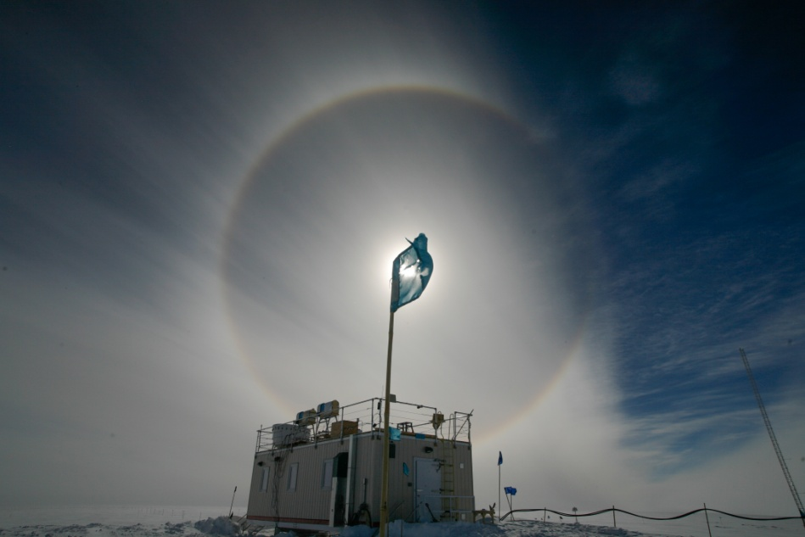

A sun halo over the MSF on 8/13. –CVH

**General:**

* 8/10: 12:00z-13:15z There was heavy equipment operations near MSF for drift maintenance of north side of building.
* 8/15: Flight Period 6 began. Von Walden and Sarah Murphy arrived.

**Significant Weather Observations:**

* 8/10: broken cirrus, 11kts, -16C
* 8/11: broken cirrus, 15kts, -13.6C
* 8/12: scattered cirrus, 7kts, -17C
* 8/13: scattered cirrostratus, 19kts, -10.4C
* 8/14: broken altostratus, 12kts, -14.4C
* 8/15: broken stratus, 9kts, -14.8C
* 8/16: scattered cirrus, 11kts, -15.8C

**Dataman Account:**

* Operating normally.

**MWR:**

* HATPRO: operating normally.
* 150-90: operating normally.
* 8/16: LN2 Calibrations began. HATPRO and 150-90 were calibrated between 12:58z-14:00z. Data was sent to Dave Turner and Erik Olson.

**SODAR:**

* Operating normally, dishes cleaned.
* 8/10: 12:00z-13:30z Heavy equipment running near MSF, log updated.

**POSS:**

* Operating normally.

**MMCR:**

* Operating normally.
* 8/10: MMCR shut down several times between 16:42z and 20:15z for troubleshooting. Resistor from J1-14 to J1-16 removed. Results were both +5V reading at +5V. Outdoor temperature reading is very sporatic, between -20C and +5C. Pitch is ~0.15.
* 8/11: MMCR shut down from 16:10z to 17:09z. A 0.1 microfarad capacitor was installed between J1-16 and J1-12. Wires were tracked and information was reported back to Duane. Results at reboot were the same as on 8/10.
* 8/13: MMCR shut down from 15:55z to 16:10z. The 0.1 microfarad capacitor was removed and a 1.0 microfarad capacitor was installed from J1-14 to J1-16. Upon restart, Outdoor temperature reading at -7.32C, +5V #1 and #2 are at ~+5V, and pitch is 0.15-0.2. Results were reported to Duane and Matt.
* 8/14: Initial daily checks were normal, but after the 1230Z calibration cycle the Outdoor Temperature was reading between +70C to +200C. This was reported to Duane and Matt.

**CAPABL:**

* Operating normally.
* 8/15: During daily checks at 10:40z, "Shots" were not incrementing. Polarization was at 1 and not changing. Voltage was at 5V on the licel box, while on the monitor it still reads 800. I/O and Run lights were not on or flashing. This information was reported to Ryan Neely and Robert Stillwell. Per Ryan Neely, CAPABL shut down at 12:30z, restarted at 12:32z. All readings were normal after restart.

**MPL:**

* Operating normally.
* 8/11: 18:04-18:20z Performed monthly after-pulse calibration.
* 8/15-16: Work began to replace the current MPL with a newer model.

**VCEIL:**

* Operating normally.

**Hotplate:**

* Operating normally.

**IceCAM:**

* Operating normally.

**PAERI:**

* Operating normally.
* 8/15-16: Von Walden and Sarah Murphy began work on calibration of PAERI for the S-NPP2 NASA project, and general maintenance of the instrument.

**ASIA-A:**

* Offsite for repair since 4/30.

**TSI:**

* Operating normally.

**IcePIC:**

* No photos taken.

**Radiosonde:**

* Twice daily sondes.
* 8/14-15: Empty helium cylinders in the SOB were prepared for shipment. Full cylinders were moved into the SOB.

**Doppler Wind Lidar:**

* Offsite on 6/29/15.

**MASC:**

* Operating normally.