# ICECAPS Weekly Report

August 17-23, 2015

Clair Von Handorf

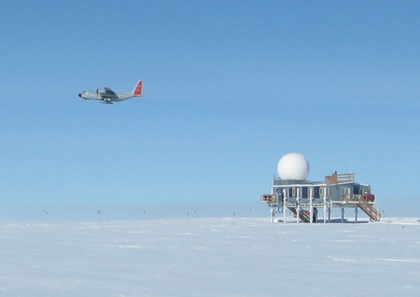

On 8/20, the last LC-130 of 2015 left Summit. And then there were six. –CVH

**General:**

* Inventory of ICECAPS crate of shipping containers completed.

**Significant Weather Observations:**

* 8/17: broken stratus, 14kts, -13.3C
* 8/18: scattered cirrus, 13kts, -13.3C
* 8/19: broken altostratus, 5kts, -15.0C
* 8/20: scattered cirrostratus, 6kts, -19.2C
* 8/21: few cirrocumulus, 11kts, -19.5C
* 8/22: few cirrostratus, 9kts, -20.5C
* 8/23: broken stratus, 8kts, -11.7C

**Dataman Account:**

* Operating normally.
* 8/18: During daily checks, no files transferred to Boulder. ArchiveToBoulderManual.bash was begun at 12:22z and Matt Shupe was notified.
* 8/18: 17:05z Switched out hard drives, from #3 to #1. #3 was given to Matt Okraszewski.
* 8/19 and 8/20: During daily checks, no data transferred to Boulder. Matt Shupe was notified.

**MWR:**

* HATPRO: operating normally.
* 150-90: operating normally.
* 8/18: 16:20z-17:57z HATPRO LN2 calibration #2. Data was sent to Dave Turner and Erik Olson.
* 8/19: 12:27-13:30z HATPRO LN2 calibration #3. Data was sent to Dave Turner and Erik Olson.

**SODAR:**

* Operating normally.

**POSS:**

* Operating normally.

**MMCR:**

* Operating normally.
* 8/21: MMCR shut down from 11:45z-12:05z. 100K Ohm resistor installed from J1-14 to J1-16. Results upon restart: Outdoor Temperature was reading +200C and +5V #1 and #2 were in the red at 0.0V and +2.95V respectively. Roll is reading at 5.75. Duane and Matt were notified.
* 8/23: MMCR shut down from 12:56z-13:22z. 100K resistor removed and 470 ohm resistor installed from J1-14 to J1-16. Results upon successful reboot: Outdoor Temp: +90C, +5V: both in the green at ~+5V, Pitch: 0.15, Roll: -0.08. Duane and Matt were notified.

**CAPABL:**

* Operating normally.

**MPL:**

* Operating normally.
* 8/17-19: Finished work on networking and mounting new MPL 108 and computer.

**VCEIL:**

* Operating normally.

**Hotplate:**

* Operating normally.

**IceCAM:**

* Operating normally.

**PAERI:**

* Operating normally.
* 8/17-20: Von Walden and Sarah Murphy finished working on PAERI. Exterior fan fuse was replaced with a 500mA. Incorporated exterior fan amps check into daily tasking.

**ASIA-A:**

* Offsite for repair since 4/30.

**TSI:**

* Operating normally.

**IcePIC:**

* Photos taken on 8/23.

**Radiosonde:**

* Twice daily sondes.
* 8/20: Delayed launch of 11:15z flight due to LC-130 activities. Von Walden and Matt Shupe were notified.

**Doppler Wind Lidar:**

* Offsite on 6/29/15.

**MASC:**

* Operating normally.