# ICECAPS Weekly Report

August 24-30, 2015

Clair Von Handorf

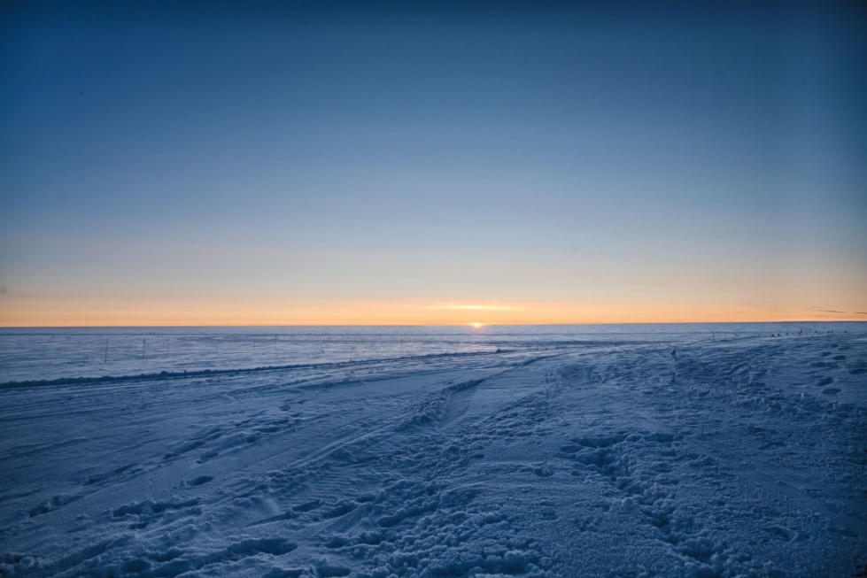

A slow sunset on 8/25–CVH

**General:**

* None.

**Significant Weather Observations:**

* 8/24: broken stratus, 10kts, -16.5C
* 8/25: broken stratus, 5kts, -16.0C
* 8/26: broken stratus, 7kts, -18.6C
* 8/27: freezing fog in the morning, few stratus, 1kt, -24.3C
* 8/28: scattered cirrus, 10kts, -22.6C
* 8/29: broken stratus, drifting snow, 12kts, -8.7C
* 8/30: broken stratus, drifting snow, 16kts, -9.7C

**Dataman Account:**

* Operating normally.

**MWR:**

* HATPRO: operating normally.
* 150-90: operating normally.

**SODAR:**

* Operating normally.

**POSS:**

* Operating normally.

**MMCR:**

* Operating normally.
* Ongoing issue with display of Outdoor Temperature not reading accurately. Duane and Matt are aware of this.

**CAPABL:**

* Operating normally.

**MPL:**

* Operating normally.
* 8/24: 16:05z-16:20z Afterpulse calibration performed.

**VCEIL:**

* Operating normally.

**Hotplate:**

* Operating normally.

**IceCAM:**

* Operating normally.

**PAERI:**

* Operating normally.

**ASIA-A:**

* Offsite for repair since 4/30/15.

**TSI:**

* Operating normally.
* 8/29: 12:49z-13:01z TSI shut down. Due to warm temperatures on 8/29, cables on roof were unwound from stand to enable safer removal when TSI is removed.

**IcePIC:**

* No photos taken.

**Radiosonde:**

* Twice daily sondes.
* 8/30: The plastic on the balloon table was replaced.

**Doppler Wind Lidar:**

* Offsite on 6/29/15.

**MASC:**

* Operating normally.