# ICECAPS Weekly Report

August 3-August 9, 2015

Clair Von Handorf

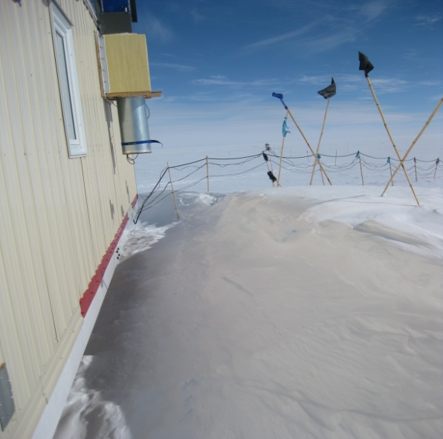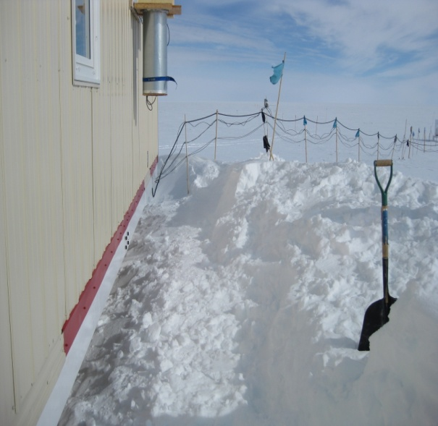

South MSF drift maintenance. –CVH

**General:**

* First sunset was on 8/7.
* Manual drift maintenance on the south side of the MSF.

**Significant Weather Observations:**

* 8/3: scattered cirrus, 4kts, -9.6C
* 8/4: scattered cirrus, 5kts, -14.7C
* 8/5: broken stratus, 19kts, -14.4C
* 8/6: scattered cirrus, 15kts, -12.3C
* 8/7: scattered cirrus, 12kts, -12.9C
* 8/8: broken cirrus, 6kts, -20.0C
* 8/9: scattered cirrus, freezing fog in the morning, 4kts, -24.8C

**Dataman Account:**

* Operating normally.
* 8/4: During daily checks at 11:40z, no data transferred from 8/3. ArchiveToBoulderManual executed and Matt Shupe was notified.

**MWR:**

* HATPRO: operating normally.
* 150-90: operating normally.

**SODAR:**

* Operating normally.
* 8/4: 12:03z Dishes cleaned and leveled.
* 8/9: 9:56z Dishes cleaned.

**POSS:**

* Operating normally.

**MMCR:**

* Operating normally.
* 8/4: Continued trouble shooting on inaccurate monitor readings. MMCR was shut down from 17:15z to 18:56z. The requested information was reported back to Duane Hazen.
* 8/6: Continued trouble shooting. MMCR was shut down from 15:18z to 15:32z.
* 8/7: Continued trouble shooting. MMCR was shut down from 15:09z to 15:33z.

**CAPABL:**

* Operating normally.

**MPL:**

* Operating normally.

**VCEIL:**

* Operating normally.

**Hotplate:**

* Operating normally.

**IceCAM:**

* Operating normally.

**PAERI:**

* Operating normally.
* 8/6: During daily checks at 10:31z, outside fan was not working. Fan was brought inside the MSF and 250V 1A fuse was replaced with a 250V 750mA fuse. Upon installation, fan only ran for 2 minutes. Fan was completely replaced. 750mA fuse remains installed. Von Walden was notified.

**ASIA-A:**

* Offsite for repair since 4/30.

**TSI:**

* Operating normally.

**IcePIC:**

* Photos taken on 8/4.

**Radiosonde:**

* Twice daily sondes.

**Doppler Wind Lidar:**

* Offsite on 6/29/15.

**MASC:**

* Operating normally.