# ICECAPS Weekly Report

August 31-September 6, 2015

Clair Von Handorf

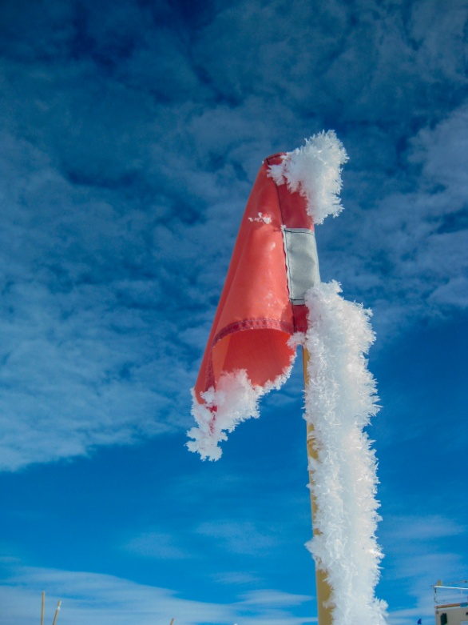

What happens when Clair doesn’t take good pictures all week. A flag.

–CVH

**General:**

* None.

**Significant Weather Observations:**

* 8/31: broken stratus, 20kts, -7.8C
* 9/1: scattered altostratus, freezing fog, 19kts, -15.8C
* 9/2: scattered cirrus, 9kts, -17.8C
* 9/3: broken cirrostratus, 11kts, -17.6C
* 9/4: broken stratus, 17kts, -18.0C
* 9/5: scattered cirrostratus, 9kts, -17.1C
* 9/6: broken altostratus, 10kts, -15.2C

**Dataman Account:**

* Operating normally.
* 9/6 Daily checks at 12:25z, no data transferred to Boulder. ArchiveToBoulderManual started at 12:49z.

**MWR:**

* HATPRO: operating normally.
* 150-90: operating normally.
* 9/1: 15:40z-16:30z Replaced tape around insulation of the 150-90, and readjusted insulation to remove gaps around edges.

**SODAR:**

* Operating normally.

**POSS:**

* Operating normally.
* 9/3: Shut down from 15:19z-16:31z for Hotplate raise. Guy lines on POSS were tightened.

**MMCR:**

* Operating normally.
* Ongoing issue with display of Outdoor Temperature not reading accurately. Duane and Matt are aware of this.
* 9/5 Daily checks at 11:57z, the +5V #1 was in the red reading at +4V. Duane and Matt were notified.

**CAPABL:**

* Operating normally.

**MPL:**

* Operating normally.

**VCEIL:**

* Operating normally.

**Hotplate:**

* Operating normally.
* 9/3: Shut down at 15:18z. Hotplate instrument was raised out of the accumulating snow. Restarted at 16:35z.

**IceCAM:**

* Operating normally.

**PAERI:**

* Operating normally.

**ASIA-A:**

* Offsite for repair since 4/30/15.
* 9/2: Cables on roof were removed to be stored inside the MSF for the winter.
* 9/5: ASIA-A camera was removed from roof.

**TSI:**

* Operating normally.

**IcePIC:**

* No photos taken.

**Radiosonde:**

* Twice daily sondes.
* 9/6: Files did not transfer to GTS for the morning balloon. Possible server issues on station were the cause and SRI was notified.

**Doppler Wind Lidar:**

* Offsite on 6/29/15.

**MASC:**

* Operating normally.
* 9/3: Elena Willcott reported that MASC was not taking pictures.
* 9/4: Settings were adjusted on camera remotely. At 15:15z, per Ralf’s request, objects were dropped through MASC. No images were recorded.
* 9/5: Per Ralf’s request, 11:36z MASC software stopped, 11:42z MASC and Heater unplugged from instrument, 11:46z restarted software, 11:48z dropped snowball and harmonica. Flashes fired and images were captured. Findings were reported back to PIs.