# ICECAPS Weekly Report

Dec 29- Jan 4, 2014

Jennie Mowatt

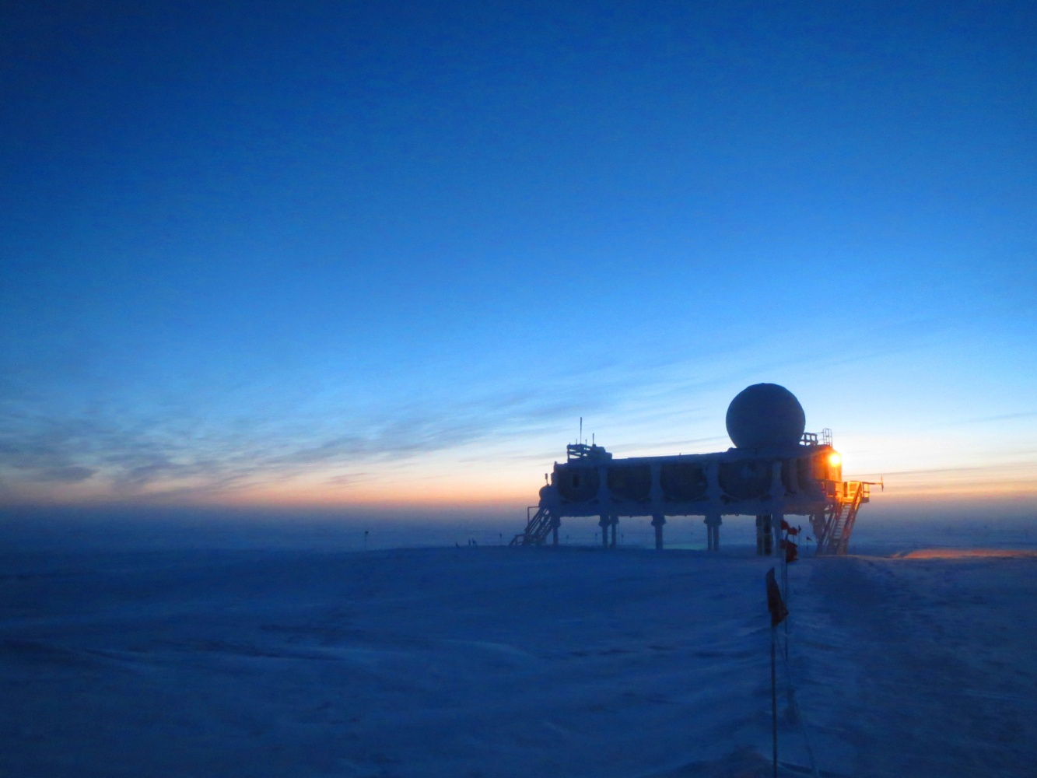

*Days are slowly getting brighter as we work towards a sunrise on Jan. 28th. JM*

**General:**

* 12/29: Ventilation system found not working (wall panel dead, air not moving). Got restarted but “Service” message present on panel readout.
* 1/1: Service message cleared by tech.

**Significant Weather Observations:**

* 12/29: Overcast, 18 kts, -19C
* 12/30: Few clouds, 3 kts, -38C
* 12/31: Freezing fog, 11 kts, -43C
* 1/1/15!: Broken clouds, 5 kts, -38C
* 1/2: Broken clouds, 10 kts, -38C
* 1/3: Few clouds, 14 kts, -44C
* 1/4: Broken clouds, 2 kts, -48C

**Dataman Account:**

* Operating normally.
* 12/29: PAERI mount down due to computer issue. Back up the next day.
* 1/1: 5 files failed to transfer overnight.
* 1/2: 101 files did not transferred. Manual transfer started at 1315Z to no success.
* 1/3: Icecam data did not transfer two days in a row. Restarted Dataman at 1330Z.
* 1/4: Reboot did not solve issue, data is currently stacked up from Jan. 1 on.

**MWR:**

* HATPRO: operating normally.
* 150-90: operating normally.

**SODAR:**

* Operating normally.

**POSS:**

* Operating normally.
* 1/3: Dataman computer rebooted at 1330Z.

**MMCR:**

* Operating normally.
* 12/29: Error message still present.
* 1/1: Computers rebooted at 1400Z. Fixed error issue.

**CAPABL:**

* Offsite as of 8/19.
* Continuing to monitor water storage system during winter.

**MPL:**

* Operating normally.

**VCEIL:**

* Operating normally.

**Hotplate:**

* Operating normally.

**IceCAM:**

* Operating normally.
* Data files stopped transferring as of 1/1. Running manual scripts did not have any effect.

**PAERI:**

* Operating normally.
* 12/29: Found off during rounds (Stirling cooler still on). Data appears to have transferred overnight but PAERI mount was missing during Dataman checks. Problem resolved by hitting red Reset button on PAERI computer tower.

**ASIA-A:**

* Operating normally.
* 12/30: Small fan next to blower working again.
* 1/4: Rebooted computer due to frozen time.

**TSI:**

* Offline and stored in MSF for winter.

**IcePIC:**

* 12/30, 1/2: Pictures taken and uploaded for transfer.

**Radiosonde:**

* Twice daily sondes.
* 1/4: Balloon inflated outside due to broken SOB door.