# ICECAPS Weekly Report

December 07-December 13, 2015

Mike Finnegan

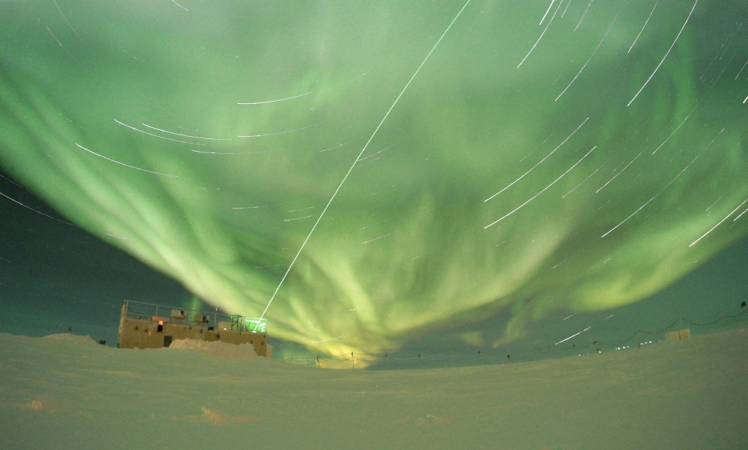

MSF Aurora and Startrails, 12Dec2015. - MOF

**General:**

* Monthly generator power test, 12/09/15 1300-1330z

**Significant Weather Observations:**

* 12/07: sct altostratus, 14.6kts, -44.3C
* 12/08: ovc altostratus, 17.2kts, -33.6C
* 12/09: blsn, ovc stratus, 29.6kts, -32.4C
* 12/10: few altocumulus, sct cirrostratus, 16.6kts, -32.1C
* 12/11: blsn ovc007, stratus, 13.4kts, -29.6C
* 12/12: sct altocumulus, 9.2kts, -48.6C
* 12/13: sct altocumulus, 9.2kts, -55.0C

**Dataman Account:**

* Operating normally.

**MWR:**

* HATPRO: operating normally.
* 150-90: operating normally.
* Removed rime from 150-90 and HATPRO on 12/7 and 12/11. Uploaded photos and updated log.

**SODAR:**

* Operating normally.
* Cleaned transceiver dish on 12/7 from 1410-1425z. A piece of foam (~1’x2’) detached from door backing. This was repaired on 12/10 (1654-1721z) with favorable low winds as well as snow cleared from transceiver dish. Updated log.

**POSS:**

* Operating normally.

**MMCR:**

* Operating normally.

**CAPABL:**

* Operating normally.

**MPL:**

* Operating normally

**VCEIL:**

* Operating normally.

**Hotplate:**

* Operating normally.

**IceCAM:**

* Operating normally.

**PAERI:**

* Operating normally.
* Red LW/SW Responsivities during evening of 12/08. Cleared by 0z and green by morning.
* Mirror Motor Temp yellow on 12/13, but Encoder Scene Confirm remained green.

**TSI:**

* Shutdown and removed from the roof for the winter.

**IcePIC:**

* No Photos Taken

**Radiosonde:**

* Twice daily sondes.
* Failed launch on evening of 12/08 due to 35-40 kt winds. K-sonde was used.

**MASC:**

* Operating normally.
* Cleaned flashes of rime at 1248z on 12/07.
* Found MASC PC frozen during daily checks on 12/09. A Force Quit of RDC and warm start fixed the problem. Seems to have frozen around 20z on 12/08, right around the time we were hitting 35-40 kts.
* MASC Mount Down reported in Icecaps.20151209.log file on 12/10, but everything else appears to be functioning correctly and mount seems actually to be up. Working properly by afternoon of 12/10.