# ICECAPS Weekly Report

December 14-December 20, 2015

Mike Finnegan

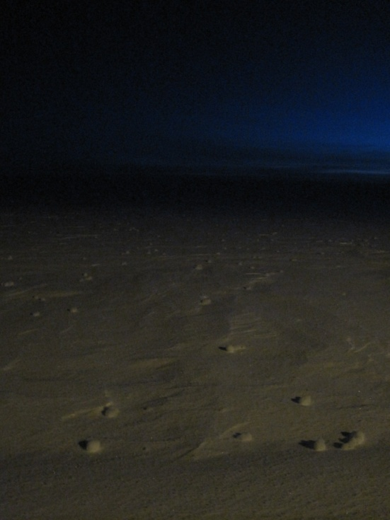

Yukimarimo During the Cold Spell. - MOF

**General:**

* Summit lost Internet/Phones on afternoon of 12/19, reestablished on afternoon of 12/20.

**Significant Weather Observations:**

* 12/14: few080, altocumulus, 6.4kts, -57.9C
* 12/15: few000, BR IC, 9.0kts, -53.2C
* 12/16: few060, altocumulus, 5.8kts, -60.4C
* 12/17: SKC, 6.0kts, -43.7C
* 12/18: few050, altocumulus, 17.0kts, -46.5C
* 12/19: SKC, 13.0kts, -58.7C
* 12/20: SKC, 12.6kts, -51.9C

**Dataman Account:**

* Operating normally.

**MWR:**

* HATPRO: operating normally.
* 150-90: operating normally.
* Removed rime from 150-90 and HATPRO on 12/16. Uploaded photos and updated log.

**SODAR:**

* Operating normally.

**POSS:**

* Operating normally.

**MMCR:**

* Operating normally.
* Received “Could not read calibration table” error on 12/18-19 at 12z. The 1230Z calibration passed however.
* Rebooted MMCR Radar on 12/19, which solved the issue.

**CAPABL:**

* Operating normally.
* Found a Boot Disk Failure error on 12/14. Restarting the CAPABL PC brought Windows back up and after a proper reboot, everything came back online. Now operating Laser 1 with Licel at 900. I took this opportunity to adjust the iris size from 4 to 8 as well.

**MPL:**

* Operating normally

**VCEIL:**

* Operating normally.
* Very low temperatures (< -60C) caused the ceilometer’s blower and outheater to be turned off and outside temperature to go out of range on 12/16. By morning of 12/17, everything recovered.

**Hotplate:**

* Operating normally.
* LED is blinking red, but no faults or errors reported in software. Data looks reasonable. (12/15-12/17, 12/19-12/20). Temperatures warmed to > -50C by 12/18 and light began blinking green.

**IceCAM:**

* Operating normally.

**PAERI:**

* Operating normally.
* Encoder Scene Confirm went Red on 12/14. Due to Con1 conditions (Windchill < -100F, actual was -110F at least) the fan was not removed until morning of 12/15. This allowed for the instrument to warm and good data to be taken after a software reboot.
* Reinstalled fan on 12/18 as temperatures were > -50C.
* Encoder Scene Confirm went Red around 6z on 12/20. Fan removed during daily checks. Reinstalled during afternoon and scene mirror cleaned due to LW/SW Responsivities going red.

**TSI:**

* Shutdown and removed from the roof for the winter.

**IcePIC:**

* No Photos Taken

**Radiosonde:**

* Twice daily sondes.
* Noticed the RH cycling over a range of 10-30 % on mornings of 12/16 and 12/17, evening 12/18. Sonde data seems good.

**MASC:**

* Operating normally.