# ICECAPS Weekly Report

December 21-December 27, 2015

Mike Finnegan

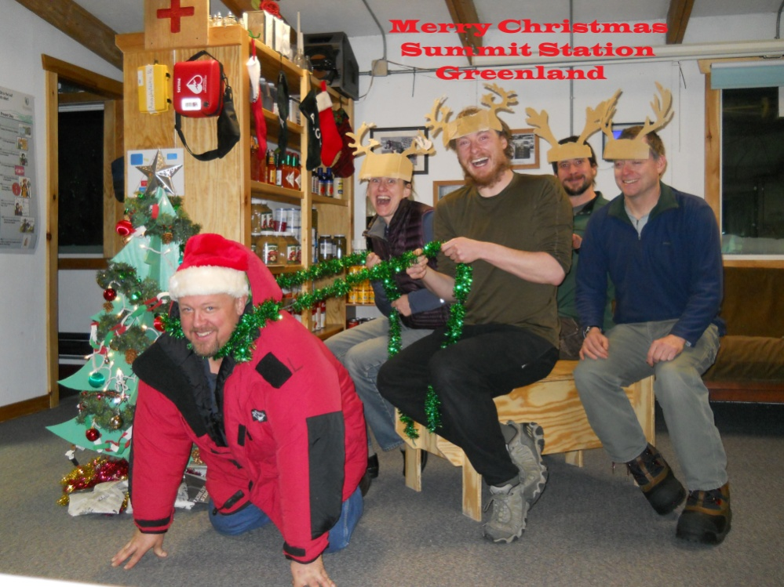

Summit Christmas Card. - MOF

**General:**

**Significant Weather Observations:**

* 12/21: sct080, altostratus, 14.6kts, -43.2C
* 12/22: br sct000 sct008 stratus, 13.2kts, -41.6C
* 12/23: few altocumulus, 10.4kts, -54.2C
* 12/24: ovc altostratus, 9.6kts, -50.2C
* 12/25: blsn ovc, 20.0kts, -34.9C
* 12/26: ovc altostratus, 24.4kts, -29.2C
* 12/27: bkn altocumulus, ovc cirrostratus, 8.4kts, -36.5C

**Dataman Account:**

* Operating normally.
* Monitor died and was replaced, 12/23.

**MWR:**

* HATPRO: operating normally.
* 150-90: operating normally.
* Removed rime from 150-90 and HATPRO on 12/21 and 12/22. Uploaded photos and updated log.
* Found measurements halted on 12/26 – restarted MWRs which brought them back online, but Noise Diode Rec.1 is reporting red. This persisted on 12/27 daily checks. Another reboot did not fix the problem.

**SODAR:**

* Operating normally.
* Cleaned transmitter and receiver dishes of snow on 12/21, 14:50z.

**POSS:**

* Operating normally.

**MMCR:**

* Operating normally.

**CAPABL:**

* Operating normally.

**MPL:**

* Operating normally
* Afterpulse calibration completed on 12/27.

**VCEIL:**

* Operating normally.

**Hotplate:**

* Operating normally.
* Found error 85 on 12/20 daily checks saying the input string was not in the expected format. I pressed “continue”, went through the startup procedure, and data began feeding in.
* Found error “VISA: Timeout expired before operation completed” on 12/26. Clicking continue and the regular startup procedure fixed this.

**IceCAM:**

* Operating normally.

**PAERI:**

* Operating normally.

**TSI:**

* Shutdown and removed from the roof for the winter.

**IcePIC:**

* No Photos Taken

**Radiosonde:**

* Twice daily sondes.
* Failed sonde on morning of 12/26 in 27kt winds. Balloon travelled at ground level until out of sight.

**MASC:**

* Operating normally.