# ICECAPS Weekly Report

Feb 16-22, 2015

Sam Dorsi

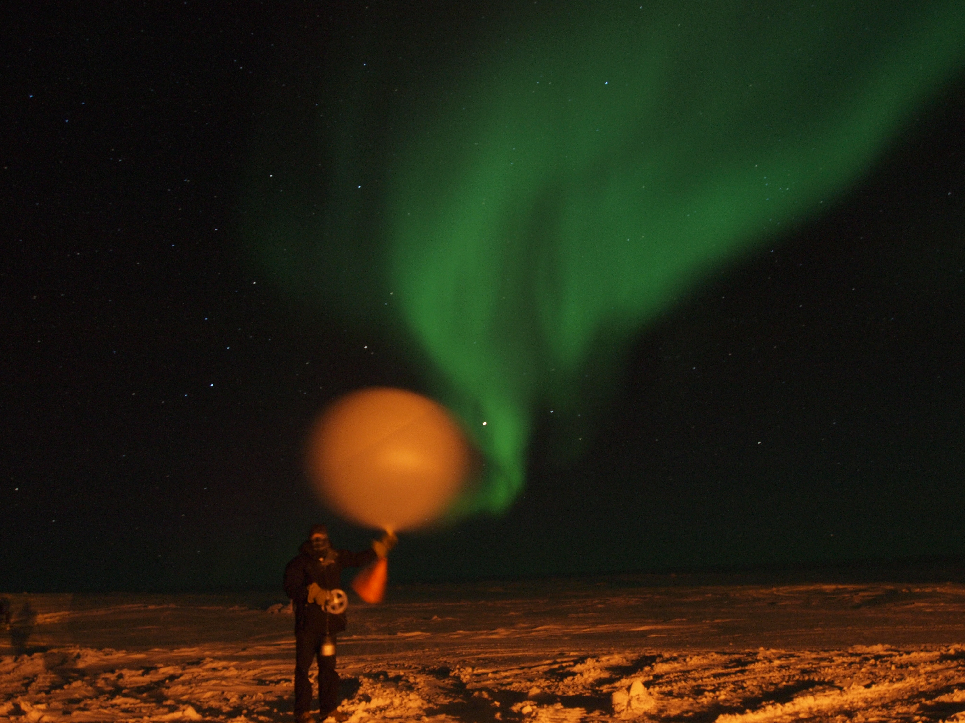

**Releasing the nightly 00z sounding under the aurora on 2/18.**

**General:**

* 2/17: Jennie and winter crew depart!

**Significant Weather Observations:**

* 2/16: Scattered stratus and freezing fog, 5 kts, -54C
* 2/17: Few stratus, 13 kts, -54C
* 2/18: Few stratus, 14 kts, -50C
* 2/19: Few thin altostratus, 10 kts, -42C
* 2/20: Broken thin altostratus, 12 kts, -49C
* 2/21: Few stratus, 10 kts, -56C
* 2/22: Few stratus, 10 kts, -55C

**Dataman Account:**

* Operating normally.
* 2/19: Radiosonde mount was down overnight, and these data were not uploaded.
* 2/20: Radiosonde data from previous day automatically transferred successfully.
* 2/21: MMCR mount was down overnight, and these data were not uploaded.
* 2/22: MMCR data from previous day automatically transferred successfully. The Sodar netCDF and the IceCam JPGs did not transfer overnight. Their mounts were up, and the data queued in the ToBoulder folder, but the transfer never appears to have occurred.

**MWR:**

* HATPRO: operating normally.
* 150-90: operating normally.

**SODAR:**

* Operating normally.
* 2/17: Starting at 1600z, no screenshot data was collected due to Sam leaving computer folder obscuring SODAR window.
* 2/18: Data collection resumed at 1600z.

**POSS:**

* Operating normally.

**MMCR:**

* Operating normally.
* 2/20: At 18:50z, powered down MMCR to replace adapter, as requested by Duane Hazen. The repair was completed at 19:55z and the MMCR resumed operation at 20:35z.

**CAPABL:**

* Offsite as of 8/19.
* Continuing to monitor water storage system during winter.

**MPL:**

* Operating normally.

**VCEIL:**

* Operating normally.

**Hotplate:**

* Offline due to technical issues.
* 2/17: Restored data connectivity to hotplate though a serial command (‘/FU’) that changed format of data sent from instrument. While data are being logged, instrument is in standby mode due to a fault: ‘bottom plate current too low,’ and data are not usable.
* 2/20: Turned hotplate off, and brought inside to warm up for bench diagnostics.

**IceCAM:**

* 2/16: IceCAM had reverted to factory settings and was offline since Feb 3. Used default password (ubnt:ubnt) to restore previous login information and configuration. Operation resumed 19:10z.

**PAERI:**

* Operating normally.
* 2/19: At 14:42z, initiated repair of PAERI exterior temperature probe; completed repair at 15:55z. Upon return at 17:50z, PAERI application had closed of its own accord, however Von reported that instrument was still operating.

**ASIA-A:**

* Operating normally.

**TSI:**

* Offline and stored in MSF for winter.

**IcePIC:**

* No pictures taken.

**Radiosonde:**

* Twice daily sondes.
* 2/17: Morning sounding was initiated 40 minutes early, to avoid conflict with Twin Otter flights. As a result, it was not integrated into Met Office system.