# ICECAPS Weekly Report

Feb 2-8, 2014

Jennie Mowatt

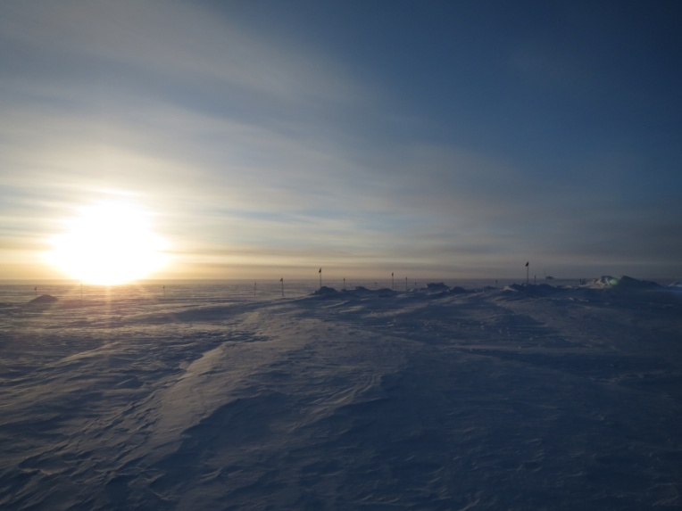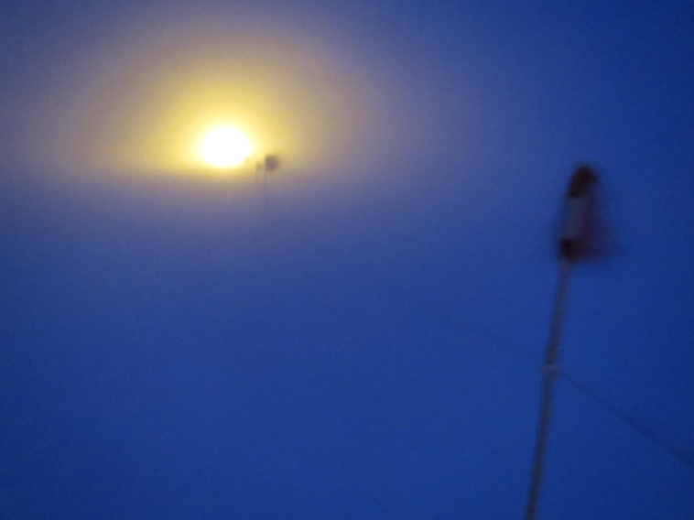

*Weather at Summit was mixed this week (these pictures were taken 24 hours apart). Weather over the Strait remains horrible so we’re still awaiting initial turnover flights. JM*

**Significant Weather Observations:**

* 2/2: Overcast, 14 kts, -39C
* 2/3: Blowing snow, 29 kts, -16C
* 2/4: Few clouds, 8 kts, -48C
* 2/5: Freezing fog, 15 kts, -42C
* 2/6: Scattered clouds and fog on the horizon, 7 kts, -46C
* 2/7: Blowing snow, 16 kts, -36C
* 2/8: Overcast, 10 kts, -37C

**Dataman Account:**

* Operating normally.

**MWR:**

* HATPRO: operating normally.
* 150-90: operating normally.
* 2/5: Slave elevation mirror not responding error message. Time also frozen. Time reset via internet and both radiometers power cycled. Data collection restarted at 1335Z.
* 2/8: Slave elevation mirror not responding error message. Time also frozen. Time reset via internet and both radiometers power cycled. Data collection restarted at 1328Z.

**SODAR:**

* Operating normally.

**POSS:**

* Operating normally.
* 2/3: Errored out due to high winds. Continued erroring out upon reboot. Instrument shut down at 1251Z until winds subside.
* 2/4: Attempted restart of POSS but power does not seem to be getting to the hotplate, therefore the POSS is out as well. Breaker was found popped so pole was not getting power. Power restored at 1710Z, data collection resumed at 1715Z.
* 2/5: Data files did not transfer overnight due to lost connection.
* 2/6: Remaining files transferred fine.
* 2/8: Errored out due to high winds and a popped breaker. Reset breaker, data collection resumed at 1322Z.

**MMCR:**

* Operating normally.

**CAPABL:**

* Offsite as of 8/19.
* Continuing to monitor water storage system during winter.

**MPL:**

* Operating normally.
* 2/2: Afterpulse calibration performed starting at 1320Z. Data collection resumed at 1342Z.
* 2/3: Restarted computer and program due to AMCS card timeout starting on 2/2 at 1821Z. Data collection resumed at 1239Z.
* 2/4: Restarted computer and program due to AMCS card timeout starting on 2/3 at 1714Z. Data collection resumed at 1232Z.
* 2/8: Restarted computer and program due to AMCS card timeout starting on 2/7 at 1645Z. Data collection resumed at 1329Z.

**VCEIL:**

* Operating normally.

**Hotplate:**

* Offline due to technical issues.
* 2/4: Power does not seem to be getting to the hotplate. Breaker was found popped so pole was not getting power. Power restored at 1710Z.

**IceCAM:**

* Operating normally.

**PAERI:**

* Operating normally.
* 2/5: Outside Air Temp flag red. Probe damaged in wind.

**ASIA-A:**

* Operating normally.
* 2/3: Restarted computer due to comm error caused by high winds. Data collection resumed at 1241Z.
* 2/7: Restarted computer due to comm error caused by high winds. Data collection resumed at 1244Z.
* 2/8: Restarted computer due to comm error caused by high winds. Data collection resumed at 1330Z.

**TSI:**

* Offline and stored in MSF for winter.

**IcePIC:**

* No pictures taken.

**Radiosonde:**

* Twice daily sondes.
* Sondes missed on 2/2 pm, 2/3 am, 2/3 pm, 2/4 am, 2/7 pm, 2/8 am due to high winds and a blocked SOB door.